**Annual Activity Report 2017**

**Women with Disabilities Development Foundation (WDDF)**

**Women with Disabilities Development Foundation (WDDF)**

**House-712/1, Road-10, Baitul Aman housing Society,**

**Mohammadpur, Adabor, Dhaka-1207.**

**Annual Activity Report 2017**

Women with Disabilities Development Foundation (WDDF)

House-712/1, Road-10, Baitul Aman housing Society,

Mohammadpur, Adabor, Dhaka-1207.

List of accomplished activities of WDDF

On the basis of analysis of the existing projects as well as in accordance with the felt need of grassroot Women with Disabilities (WWDs) all the activities of WDDF for the reporting period of 2017 have been divided in to two parts.

Part A: List of activities performed by WDDF.

Part B: List of activities/events participated on behalf of WDDF in order to in corporate Women with Disabilities in the development process of the country.

**Brief Discription of the accomplished activities:**

We are concluded the following activities, during the period of 01 January to 31 December 2017 are as follows:

1. Seminar:

Five seminars on different emerging issues of Women with Disabilitieswere being organized with the initiative of WDDF in this reporting year (From 01 January to 31 December 2017). 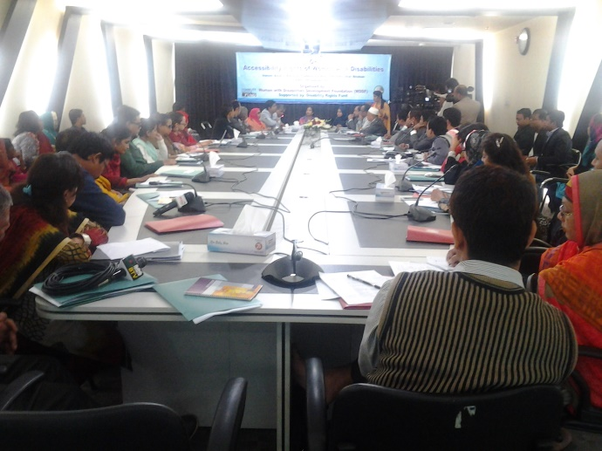

A) The first seminar on “**Accessibility Rights of Women with Disabilities**” is being organized with the initiative of Women with Disabilities Development Foundation (WDDF), at **AzimurRahman conference hall, the Daily Star Bhaban,** on Thursday, 5th January 2017from 10 AM to 2 PM. in order to discuss the scenario of the accessibility right of Women With Disabilities and how their advancement is being interrupted due to depriving them from this momentous right. We urge for an inclusive, anti discriminatory and Women with Disabilities friendly society for all. WDDF run and led by Women with Disabilities has been working as collective force with the Government, policy makers, representatives of civil society and media for the inclusion of Women with Disabilities in mainstream development process through reducing their challenges and discrimination in the issue of accessibility. The seminar was being moderated and keynote paper was being presented by AshrafunNahar, Executive Director, Women with Disabilities Development Foundation (WDDF). In this paper she mentioned that most of Women with Disabilities (WWDs) is suffering from inaccessible environment and deprived from their equal citizen rights.

This large number of girls and Women with Disabilities in Bangladesh are one of the most vulnerable and disadvantaged segment of the society. They are always discriminated based on gender, disabled and all too often, poorest of the poor. They are frequently subjected to discrimination both directly and indirectly and also negative attitudes. In spite of having arrived in the 21st Century, there is no accessible road and public transport for Persons with Disabilities. So, the scenario of the movement of Women with disabilities is extremely vulnerable in the existing situation. Though UNCRPD Article-9 ’Accessibility noted that, enable persons with disabilities to live independently and participate fully in all aspects of life, States Parties shall take appropriate measures to ensure to persons with disabilities access, on an equal basis with others, to the physical environment, to transportation, to information and communications, including information and communications technologies and systems, and to other facilities and services open or provided to the public, both in urban and in rural areas. In the consequence of our continuous advocacy and voice raising, ‘National Action Plan’ on ‘Women Advancement Policy2011’ has been mentioned Two reserve seats for WWDs in National Parliament but no initiative has been adopted to implement or actualize this decision.

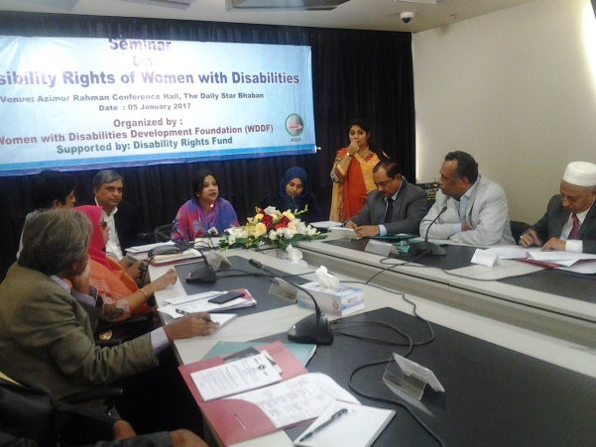In the light of realizing this situation, WDDF has organized this seminar due to advancing forward with this issue.

The participants of the open discussion have clearly been stated that, Without having been enjoyed basic rights including accessibility right in road, public transport and public buildings along with equal participation, all types of Women With Disabilities haven’t been included in the mainstream of development and in this consequence, national development will extremely be interrupted.

Begum Tarana Halim MP, Honourable State Minister, Ministry of Posts, Telecommunication and Information Technology were attended as Chief Guest in the seminar. Besides, KhandakarAtiarRahman, Additional Secretary, Ministry of Social Welfare,

**Kamal Krishna Bhattacharyya, Additional Secretary,** Ministry of Railways, Md. Abdul Malek, Additional Secretary, Ministry of Road, Transport, Bridge, Bangladesh Secretariat, Dr. Abu Sayeed M Ahmed**, Immediate past President, Institute of Architect Bangladesh and** Mr. Iqbal Habib, City and Environment Specialist were present as special Guests.

Welcome Speech was being delivered by ShirinAkhter, Chairperson, Women with Disabilities Development Foundation (WDDF) and vote of thanks was being delivered by Reshma Akter, Project Officer, WDDF.

B) The Second seminar on “**Access to Justice for Women with Disabilities**” is being organized with the initiative of Women with Disabilities Development Foundation (WDDF), at **AzimurRahman conference hall, the Daily Star Bhaban,** on Saturday, 29th April 2017, from 10 AM to 2 PM. in order to discuss the scenario of access to justice for Women With Disabilities and how their human rights are being violated due to inaccessible and long procedures in justice system. So, we urge for an inclusive, anti discriminatory and Women with Disabilities friendly society for all. WDDF run and led by Women with Disabilities has been working as collective force with the Government, policy makers, representatives of civil society and media for the inclusion of Women with Disabilities in mainstream development process through reducing their challenges and discrimination in the issue of infrastructural and informational accessibility in all aspects including justice system. The seminar was being moderated and keynote paper was being presented by Ashrafun Nahar, Executive Director, Women with Disabilities Development Foundation (WDDF). In this paper she mentioned about the constitutional and legal rights of Girls and Women with disabilities. Most of the litigations, at the time of witness adopting procedures in Court, sign language interpreter aren’t being used for the victim girls or women with Speech and Hearing or intellectual impairments. Police officers and medical officers aren’t cooperative to file the litigations of victim girls or women with Disabilities and legal institutions aren’t disabled friendly.Most of Women with Disabilities (WWDs) are suffering from inaccessible justice system and deprived from their equal citizen rights. In spite of having been arrived in the 21st Century, there are no accessibilityin Judge courts, District courts, even in Supreme Court for Persons with Disabilities. Most of the laws are formulated and enacted without the inclusion and participation of Persons with Disabilities.So, the scenario of the sufferings of Women with disabilities in the ongoing legal support and services is extremely vulnerable in the existing situation. Though UNCRPD Article-13 ’Access to justice’ noted that, States Parties shall ensure effective access to justice for persons with disabilities on an equal basis with others, including through the provision of procedural and age-appropriate accommodations, in order to facilitate their effective role as direct and indirect participants, including as witnesses, in all legal proceedings, including at investigative and other preliminary stages. The panel discussants of this seminar shared their challenging experiences and complexity to get justice of Women with Disabilities. They also stated that, though ‘Persons With Disabilities Rights and protection Act 2013 and UNCRPD mentioned the issue of getting justice for Persons with Disabilities with very significance, With the strong advocacy and voice raising of Women with disabilities Rights activists, only Three legal aid support providing organizations BLAST, BRAC and BNWLA have come forward with their extensive hand to provide legal services for Women with Disabilities. Without having been enjoyed basic human rights including accessibility right in justice system along with participation, SDGs won’t be achieved properly.In the light of realizing this situation, WDDF has organized this seminar due to advancing forward with this issue.

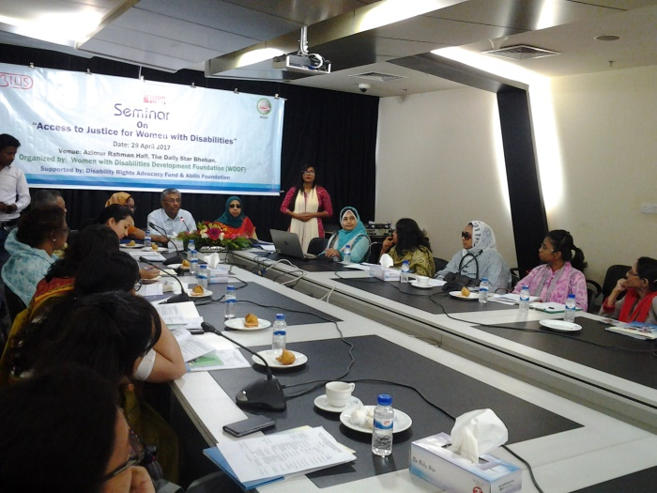The participants of the open discussion have clearly been stated that, Without having been enjoyed basic rights including accessibility right in justice system along with equal participation, all types of Women With Disabilities haven’t been included in the mainstream of development and in this consequence, national development will extremely be interrupted.

Kazi Reazul Hoque, Chairman of National Human Rights Commission (NHRC), was present as Chief Guest in the program. Besides, Nurun nahar Osmani (Former District Judge), Honorary Member National Human Rights Commission (NHRC), Salma Ali Advocate, Executive Director, Bangladesh National Women Lawyers Association (BNWLA) were present as special guests, Dr. Zobaida Nasreen, Assistant Professor, Anthropology Department, Dhaka University was present as Honorable Guest as well as a number of lawyers of Judge Court and Supreme Court were present as discussants in the abovementioned seminar. This seminar is being presided over ShirinAkhter, Chairperson, Women with Disabilities Development Foundation (WDDF).

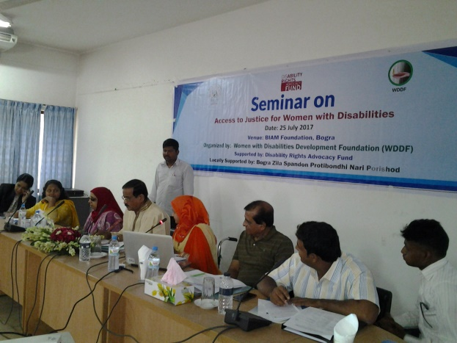C) The Third seminar on “**Access to Justice for Women with Disabilities**” is being organized with the initiative of Women with Disabilities Development Foundation (WDDF),at Rajonigandha hall, Biam Foundation Bogra**,** Locally Supported by Bogra Zila Spandon Protibandhi Nari Parisad,on Tuesday, 25th July 2017 from 10 AM to 2 PM. in order to discuss the scenario of access to justice for Women With Disabilities and how their human rights are being violated due to inaccessible and long procedures in justice system. So, we urge for an inclusive, anti discriminatory and Women with Disabilities friendly society for all. WDDF run and led by Women with Disabilities has been working as collective force with the Government, policy makers, representatives of civil society and media for the inclusion of Women with Disabilities in mainstream development process through reducing their challenges and discrimination in the issue of infrastructural and informational accessibility in all aspects including justice system. The seminar was being moderated and keynote paper was being presented by AshrafunNahar, Executive Director, Women with Disabilities Development Foundation (WDDF). In this paper she mentioned about the constitutional and legal rights of Girls and Women with disabilities. Most of the litigations, at the time of witness adopting procedures in Court, sign language interpreter aren’t being used for the victim girls or women with Speech and Hearing or intellectual impairments. Police officers and medical officers aren’t cooperative to file the litigations of victim girls or women with Disabilities and legal institutions aren’t disabled friendly. Most of Women with Disabilities (WWDs) are suffering from inaccessible justice system and deprived from their equal citizen rights. In spite of having been arrived in the 21st Century, there are no accessibilityin Judge courts, District courts, even in Supreme Court for Persons with Disabilities. Most of the laws are formulated and enacted without the inclusion and participation of Persons with Disabilities. So, the scenario of the sufferings of Women with disabilities in the ongoing legal support and services is extremely vulnerable in the existing situation. Though UNCRPD Article-13 ’Access to justice’ noted that, States Parties shall ensure effective access to justice for persons with disabilities on an equal basis with others, including through the provision of procedural and age-appropriate accommodations, in order to facilitate their effective role as direct and indirect participants, including as witnesses, in all legal proceedings, including at investigative and other preliminary stages. The panel discussants of this seminar shared their challenging experiences and complexity to get justice of Women with Disabilities. They also stated that, though ‘Persons With Disabilities Rights and protection Act 2013 and UNCRPD mentioned the issue of getting justice for Persons with Disabilities with very significance, With the strong advocacy and voice raising of Women with disabilities Rights activists, only Three legal aid support providing organizations BLAST, BRAC and BNWLA have come forward with their extensive hand to provide legal services for Women with Disabilities. Without having been enjoyed basic human rights including accessibility right in justice system along with participation, SDGs won’t be achieved properly.In the light of realizing this situation, WDDF has organized this seminar due to advancing forward with this issue.

The participants of the open discussion have clearly been stated that, Without having been enjoyed basic rights including accessibility right in justice system along with equal participation, all types of Women With Disabilities haven’t been included in the mainstream of development and in this consequence, national development will extremely be interrupted.

Md. Habibar Rahman MP, Honorable Member of Parliament, National Parliament was present as Chief Guest in the program. Besides, Md. Najmul Haque, Chief of Admin (Former Secretary Ministry), Thengamara Mohila Sabuj Sangha (TMSS) was present as special guest as well as a number of lawyers of Judge Court and Supreme Court were present as discussants in the abovementioned seminar. This seminar is being presided over ShirinAkhter, Chairperson, Women with Disabilities Development Foundation (WDDF).

D) Fourth seminaron “**Analysis of the situation of Women with Disabilities in different law and policy**” is being organized with the initiative of Women with Disabilities Development Foundation (WDDF), at Azimur Rahman conference hall, the Daily Star Bhaban,on Wednesday, 23rd August 2017, from 10 AM to 2 PM. in order to discuss the situation of Women With Disabilities in different law and policy and how their human rights are being violated due to excluding their rights in different laws and policy. So, we urge for an inclusive, anti discriminatory and Women with Disabilities friendly society for all. WDDF run and led by Women with Disabilities has been working as collective force with the Government, policy makers, representatives of civil society and media for the inclusion of Women with Disabilities in mainstream development process through reducing their challenges and discrimination in the issue of infrastructural and informational accessibility in all aspects including justice system. The seminar was being moderated and keynote paper was being presented by AshrafunNahar, Executive Director, Women with Disabilities Development Foundation (WDDF). In this paper she mentioned that, 96% Women with Disabilities become victim of physical, mental torture and sexual harassment as well as less than 1% female children with Disabilities get opportunity of going to school.

Effective initiatives have yet not been adopted for their skill development and creating employment. Though the issue of stopping social discrimination and torture to the Persons with Disabilities in law and policy has been mentioned but specific initiative hasn’t been adopted to actualize these law and policy. Most of Women with Disabilities (WWDs) are suffering from inaccessible justice system and deprived from their equal citizen rights. In spite of having been arrived in the 21st Century, there are no accessibilityin Judge courts, District courts, even in Supreme Court for Persons with Disabilities. Most of the laws are formulated and enacted without the inclusion and participation of Persons with Disabilities. So, the scenario of the sufferings of Women with disabilities in the ongoing legal support and services is extremely vulnerable in the existing situation. Though UNCRPD Article-13 ’Access to justice’ noted that, States Parties shall ensure effective access to justice for persons with disabilities on an equal basis with others, including through the provision of procedural and age-appropriate accommodations, in order to facilitate their effective role as direct and indirect participants, including as witnesses, in all legal proceedings, including at investigative and other preliminary stages. The panel discussants of this seminar shared their challenging experiences and complexity to get justice of Women with Disabilities. They also stated that, though ‘Persons With Disabilities Rights and protection Act 2013 and UNCRPD mentioned the issue of getting justice for Persons with Disabilities with very significance, With the strong advocacy and voice raising of Women with disabilities Rights activists, only Three legal aid support providing organizations BLAST, BRAC and BNWLA have come forward with their extensive hand to provide legal services for Women with Disabilities. Without having been enjoyed basic human rights including accessibility right in justice system along with participation, SDGs won’t be achieved properly. 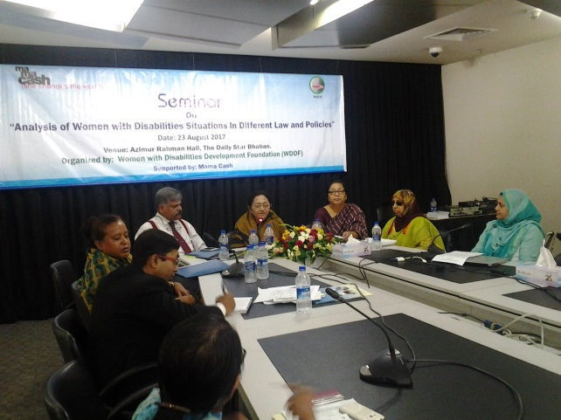In the light of realizing this situation, WDDF has organized this seminar due to advancing forward with this issue.

In the open discussion, representatives of different organizations have clearly stated that, Since Women with Disabilities have to face regular discrimination and challenges due to inaccessibility in road, public transport and public buildings of this country. So, due to disability and gender, considering religious and social perspective Women with Disabilities can’t participate in social development activities equally and in this consequence, it is seen that, 99% Women with Disabilities are living under poverty line. Besides, Women with Disabilities are also deprived from the right of obtaining equal rights due to not having proper consciousness of relevant authorities about the rights of Persons with Disabilities.

Ms. Shirin Akhter, Member of National Parliament, the peoples Republic of Bangladesh was present as Chief Guest in the program.

Besides, Dr. Md. Mizanur Rahman (Former Chairman NHRCB),,Professor, Law Department, Dhaka University, Adv Salma Ali, Executive Director, Bangladesh National Women Lawyers Association (BNWLA), Zakia K Hassan, President Women for Women, Syeda Ferdows Akter, Additional Director, Program-2, Department of Social Services were present as special Guests as well as National Consultant Web Accessibility, A To I, Prime Minister Office, representative from human rights based and donor organization along with a number of lawyers of Supreme Court were present as discussants in the abovementioned seminar.

This seminar is being presided over Shirin Akhter, Chairperson, Women with Disabilities Development Foundation (WDDF).

E) Fifth seminar on “**Access to Justice for Women with Disabilities**” is being organized with the initiative of Women with Disabilities Development Foundation (WDDF), at Conference hall, PCCS Bazar,Police Line,Pabna,Locally Supported by Protik Mohila O Sheshu Sangstha (PMSS) Pabna,on Wednesday, 27th September 2017 from 10 AM to 2 PM. in order to discuss the scenario of access to justice for Women With Disabilities and how their human rights are being violated due to inaccessible and long procedures in justice system. So, we urge for an inclusive, anti discriminatory and Women with Disabilities friendly society for all. 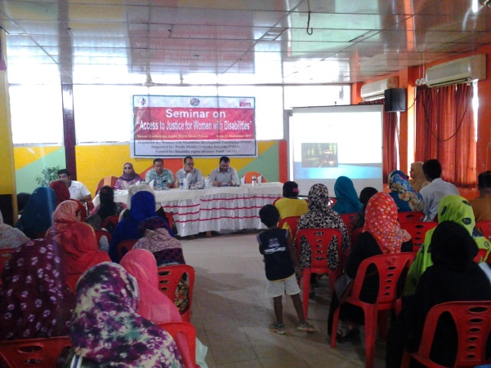WDDF run and led by Women with Disabilities has been working as collective force with the Government, policy makers, representatives of civil society and media for the inclusion of Women with Disabilities in mainstream development process through reducing their challenges and discrimination in the issue of infrastructural and informational accessibility in all aspects including justice system. The seminar was being moderated and Welcome speech is being delivered by S.M Saifur Rahman, Executive Director, Protik Mohila O Sheshu Sangstha (PMSS), Pabna. Keynote paper was being presented by AshrafunNahar, Executive Director, Women with Disabilities Development Foundation (WDDF). In this paper she mentioned about the constitutional and legal rights of Girls and Women with disabilities. Most of the litigations, at the time of witness adopting procedures in Court, sign language interpreter aren’t being used for the victim girls or women with Speech and Hearing or intellectual impairments. Police officers and medical officers aren’t cooperative to file the litigations of victim girls or women with Disabilities and legal institutions aren’t disabled friendly. Most of Women with Disabilities are suffering from inaccessible justice system and deprived from their equal citizen rights. In spite of having been arrived in the 21st Century, there are no accessibilityin Judge courts, District courts, even in Supreme Court for Persons with Disabilities. Most of the laws are formulated and enacted without the inclusion and participation of Persons with Disabilities. So, the scenario of the sufferings of Women with disabilities in the ongoing legal support and services is extremely vulnerable in the existing situation. Though UNCRPD Article-13 ’Access to justice’ noted that, States Parties shall ensure effective access to justice for persons with disabilities on an equal basis with others, including through the provision of procedural and age-appropriate accommodations, in order to facilitate their effective role as direct and indirect participants, including as witnesses, in all legal proceedings, including at investigative and other preliminary stages. They also stated that, though ‘Persons With Disabilities Rights and protection Act 2013 and UNCRPD mentioned the issue of getting justice for Persons with Disabilities with very significance, With the strong advocacy and voice raising of Women with disabilities Rights activists, only Three legal aid support providing organizations BLAST, BRAC and BNWLA have come forward with their extensive hand to provide legal services for Women with Disabilities. Without having been enjoyed basic human rights including accessibility right in justice system along with participation, SDGs won’t be achieved properly. In the light of realizing this situation, WDDF has organized this seminar due to advancing forward with this issue.

The participants of the open discussion have clearly been stated that, Without having been enjoyed basic rights including accessibility right in justice system along with equal participation, all types of Women With Disabilities haven’t been included in the mainstream of development and in this consequence, national development will extremely be interrupted.

Md. Kaysarul Islam, Union Nirbahi Officer (UNO), Pabna Sadar Upazila, was present as Chief Guest in the program. Besides, Nadira Yesmin Jolly, Chairman, Jatiya Mohila Sangstha Pabna branch, Md. Munsur Ali, Disability Officer, Service and help Centre of Persons with Disabilities Pabna and Imdadul Haque, Assistant Director, Non Formal education Bureau Pabna were present as special guests in the abovementioned seminar. On the basis of demands of two participants, UNO expressed his commitment to take necessary initiatives to fulfill these demands E.G:

* To manage disability allowance for an orphan Girl with multiple (Visual and Intelectual) Disabilities named Munni Khatun and
* To discuss with judge about a divorce litigation of a Woman with Physical Disability and request to supervice this litigation with importance.

This seminar is being presided over ShirinAkhter, Chairperson, Women with Disabilities Development Foundation (WDDF).

**2.** **Orientation program of Volunteers for conducting baseline survey:**

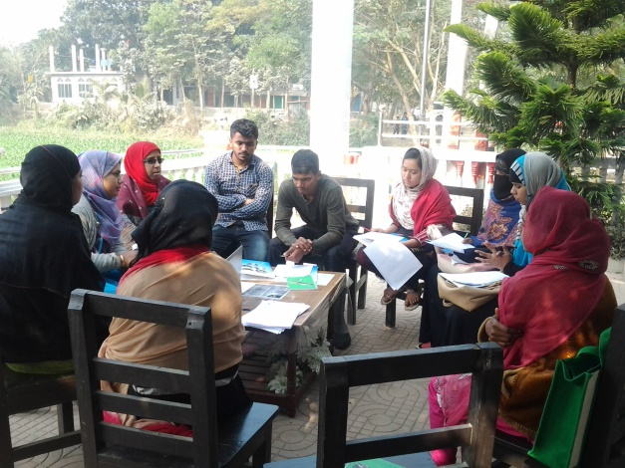An Orientation program of volunteers in order to conducting baseline survey with a view to identify Women with Disabilities of Three unions ‘Gouripur’, ‘Baropara’ and ‘Daudkandi Uttar’ of D’audkandi Subdistrict, was being organized by Women with Disabilities Development Foundation (WDDF), in Mukul Niketan, on 18th January 2017.

Six volunteers were participated in this orientation program; they’ve been appointed to collect the information of Women with Disabilities from door to door. These volunteers are divided in to three groups and two volunteers in each group for each union. Welcome speech is being delivered by Shirin Akhter, Chairperson, WDDF. Simultaneously she described briefly about the process of data collection, preparation of daily result sheet and accumulates information in the final result sheet of each group. Key presentation including guideline of orientation is being delivered by Ashrafun Nahar, Executive Director, WDDF. In this presentation she mentioned about the definition and types of disability in accordance with the ‘Persons with Disabilities Rights and Protection Act 2013’, process of identifying Persons/Women with Disabilities as well as elaborate information about the characteristics of their disabilities and assistive devise .

In the question answer session, the volunteers reviewed the whole survey form and inquired many questions on disability issue and WDDF representatives answers all the questions for their proper understanding. Finally, two survey forms are being filled up by the volunteers for their practice. The survey of Women with Disabilities is being continued with the close supervision of Masuma Akter, Vice-Chairperson, WDDF. So, it is instructed to all the volunteers that, they’ve to complete the survey forms accurately, with responsibility and sincerity as well as they is accountable for their regular activities to the superviser Masuma Akter. Shirin Akhter, Chairperson, Masuma Akter, Vice-Chairperson, Ashrafun Nahar, Executive Director, Md. Hasanuzzaman, Accounts Officer and Habiba Khatun, Project Officer of WDDF were present in this orientation program.

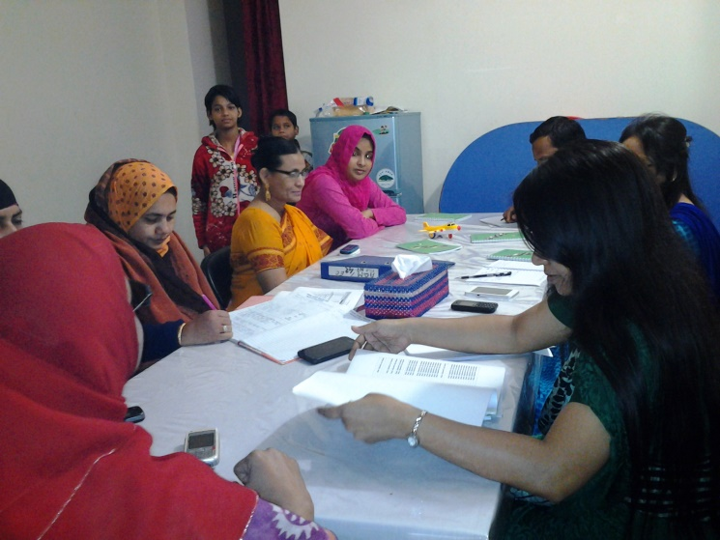**3. National Executive Council Meeting:**

Five National Executive Council (NEC) meetings were held during this reporting year (From 01 January to 31 December 2017).

1. The First Executive Council (EC) meeting was held on 6th February 2017. There were almost ten participants including office staffs. Six agenda have been discussed including miscellaneous in this meeting.
2. The Second Executive Council (EC) meeting was held on 18th May 2017. There were almost ten participants including office staffs. Five agenda have been discussed including miscellaneous in this meeting.
3. The Third Executive Council (EC) meeting was held on 1st June 2017. There were almost ten participants including office staffs. Two agenda have been discussed including miscellaneous in this meeting.
4. The Forth Executive Council (EC) meeting was held on 18th August 2017. There were miscellaneous in this meeting.
5. The Fifth Executive Council (EC) meeting was held on 19th November 2017. There were almost ten participants including office staffs. Five agenda have been discussed including miscellaneous in this meeting.

**4. Annual General meeting (AGM):**

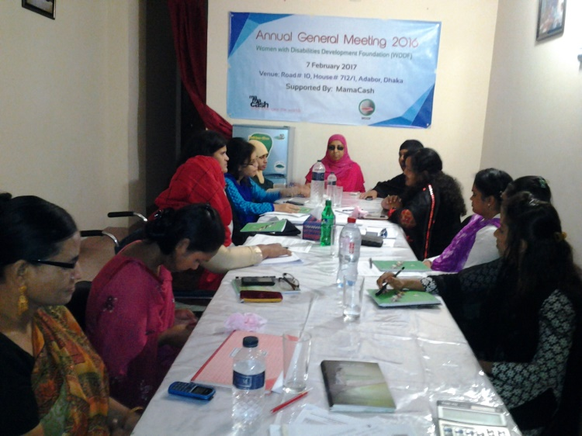Annual General Meeting (AGM)of WDDF was being organized on 7th February 2017 at WDDF office. Forteen General Members were participated in the abovementioned meeting but the total number of participants of this meeting including volunteers, sguides and support staffs were almost twenty. The meeting has started at 10 am. ShirinAkhter, Chairperson, WDDF presided over the meeting. Masuma Akter, Vice Chairperson, WDDF presented the agenda of the Annual General Meeting (AGM) by expressing heartiest sorrowfulness due to the sickness of Ashrafun Nahar, Executive Director, WDDF and heartiest gratitude and thanks on behalf of WDDF to all the members for their presence. There were Eight agenda including miscellaneous and in accordance with the opinion of all the NEC members, a few agenda have also been incorporated in miscellaneous of this meeting. The presented agenda of this meeting were as follows:

**1. Discussion of last meeting minutes and approved.**

**2. Discussion about Annual Activity Report and approved.**

**3. Discussion about annual financial statement and approved.**

**4. Submission of Action Plan along with budget of 2017 and approved.**

**5.** **Submission of Audit report of 2016, and approved as well as discussion of Auditor appointment and approved,**

**6. Discussion about Human Resource manual along with Accounts manual and approved,**

**7. Discussion about development of organization,**

**8. Miscellaneous :**

A) In the absence of Member Secretary, Tahseen Showkat, General Council Member of WDDF submitted the last meeting minutes and in accordance with the opinions of all the GC members the last meeting minutes is being approved.

B) The Vice-Chairperson of WDDF Submitted the Annual Activity Report of 2016, in accordance with the opinions of all the GC members the submitted Annual Activity Report is being approved.

C) The Treasurer of WDDF submitted the annual financial report of 2016, in accordance with the opinions of all the GC members the submitted annual financial report is being approved.

D) The Treasurer of WDDF submitted the Action plans along with the budget of 2017, in accordance with the opinion of all the NC members the submitted Action plan along with the budget of 2017 is being approved.

E) The Treasurer of WDDF submitted the Audit report of 2017 to all the GC members and in accordance with the opinion of all the GC members, the submitted audit report has been approved.

F) In accordance with the opinion of all the GC members it is decided that the responsibility of appointing auditor has been handed over the Chairperson and treasurer of WDDF.

G) The Chairperson of WDDF with the cooperation of Accounts Coordinator discussed about the draft Human Resource manual along with the financial manual with the General Council members and in accordance with the opinion of all the GC members the proposed Human Resource manual along with the financial manual of WDDF has been approved.

Finally, Chairperson expressed the optimism that, Women with Disabilities will lead their lives with self dignity, self independence along with contributive citizens for the state through the activities of WDDF. Simultaneously, she expressed heartiest gratitude on behalf of her self to the General Council Members for their continuous suggestion, support and cooperation for the advancement of WDDF and declared the closing of the Annual General Meeting for that day.

**5. Project Coordination meeting:**

Four Project Coordination meetings of the Mid Level Coalition Project of WDDF in collaboration with Protik Mohila O Sheshu Sangstha (PMSS) of Pabna and Bogra Zila Spandon Protibondhi Nari Parisad of Bogra were being organized by WDDF in this reporting year.

A) 1stProject Coordination meeting in order to signing an agreement among Three organizations: I) Women with Disabilities Development Foundation (WDDF),

II) Protik Mohila O Sheshu Sangstha (PMSS) and

III) Bogra Zila Spondon Protibandhi Nari Parisad

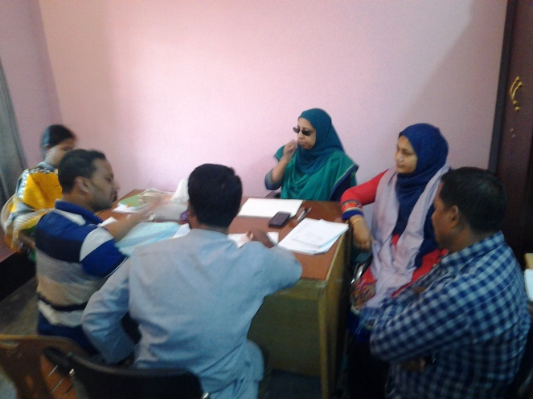For implementing a mid level coalition project of Disability Rights Fund (DRF) in join collaboration entitled “To access justice and sustainable development for Women with Disabilities at all levels through inclusive building nstitutions” in Dhaka, Pabna Sadar and Bogra Sadar was being organized by Women with Disabilities Development Foundation (WDDF) on 24th February 2017, in the office of Bogra Zila Spondon Protibandhi Nari Parisad, Bogra. S.M Saifur Rahman, Executive Director, Protik Mohila O Sheshu Sangstha (PMSS ) and Executive Council members along with Wadilur Rahman, Coordinator of Bogra Zila Spondon Protibandhi Nari Parisad including the representatives of WDDF

At first an introductory session was held and all the representatives of Three organizations were introduced with each other in this session. After having been completed the introductory session, the purpose of coordination meeting and the agreement paper of mid level coalition project are being discussed elaborately. Terms and conditions of agreement and the process of working in join collaboration are being discussed by Ashrafun Nahar, Executive Director, WDDF. Accounts operation and record keeping process for implementation of this mid level project is being discussed by Md. Hasanuzzaman, Project Officer, WDDF as well as Shirin Akhter, Chairperson, WDDF. Project activities and how these activities will be done in join collaboration are being discussed by Shirin Akhter, Chairperson, WDDF.

Finally, with the opinion of all the representatives of three organizations the agreement has been signed and the Project Coordination meeting is being closed.

B) 2nd Project Coordinationmeeting in order to monitor and review the plan and programs according to the signing agreement on 24th February 2017, among Three organizations: I) Women with Disabilities Development Foundation (WDDF),

II) Protik Mohila O Sheshu Sangstha (PMSS) and

III) Bogra Zila Spondon Protibandhi Nari Parisad

For implementing a mid level coalition project of Disability Rights Fund (DRF) in join collaboration entitled “To access justice and sustainable development for Women with Disabilities at all levels through inclusive building institutions” in Dhaka, Pabna Sadar and Bogra Sadar was being organized by Women with Disabilities Development Foundation (WDDF) on 10th May 2017, in the office of Bogra Zila Spondon Protibandhi Nari Parisad, Bogra. At first the purpose of coordination meeting and 4 Months action plan of Three organizations according to the agreement paper of mid level coalition project are being discussed by Ashrafun Nahar, Executive Director, WDDF elaborately. After that, the report and challenges of 4 months activities has submitted by Rebeka Akter, General Secretary, sBogra Zila Spondon Protibandhi Nari Parisad. Accounts operation and record keeping process of accomplished activities is being discussed by Wadilur Rahman, Coordinator, Bogra Zila Spondon Protibandhi Nari Parisad. The gaps and solution are being discussed by Ashrafun Nahar, Executive Director, WDDF along with S.M Saifur Rahman, Project Manager of this Mid Level Coalition project and representatives of Bogra Zila Spondon Protibandhi Nari Parisad are agreed to follow the suggestions. Secondly, the report along with challenges of 4 months activities and Accounts operation including record keeping process are being discussed by S.M Saifur Rahman, Executive Director, Protik Mohila O Sheshu Sangstha (PMSS). It is mentioned in the report that, this partner organization couldn’t complete the activities within this reporting period according to the action plan of the project but S.M Saifur Rahman, Executive Director, Protik Mohila O Sheshu Sangstha (PMSS) assured that, he will complete the rest of activities of the last reporting period including all the activities of next reporting period.

Thirdly, the report along with challenges of 4 months activities has been shared by Ashrafun Nahar, Executive Director, WDDF and give emphasize on the importance of completing all the activities according to the action plan within the time frame.

Finally, with the opinion of all the representatives of Three organizations the action plan for the next reporting period (Till to the next Coordination meeting) has been approved and the Project coordination meeting is being closed.

C) 3rdProject Coordination meeting in order to monitor and review the plan and programs according to the signing agreement on 24th February 2017, among Three organizations: I) Women with Disabilities Development Foundation (WDDF),

II) Protik Mohila O Sheshu Sangstha (PMSS) and

III) Bogra Zila Spondon Protibandhi Nari Parisad

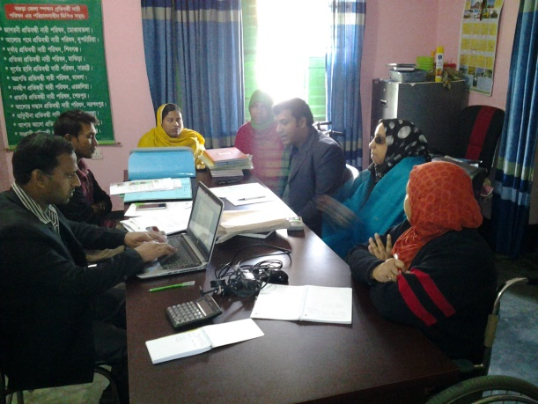For implementing a mid level coalition project of Disability Rights Fund (DRF) in join collaboration entitled “To access justice and sustainable development for Women with Disabilities at all levels through inclusive building institutions” in Dhaka, Pabna Sadar and Bogra Sadar was being organized by Women with Disabilities Development Foundation (WDDF) on 27th September 2017, in Hotel Prabashi International, Pabna. At first the purpose of coordination meeting and 4 Months (From June-September 2017) action plan of Three organizations according to the agreement paper of mid level coalition project are being discussed by Ashrafun Nahar, Executive Director, WDDF elaborately. After that, the report and challenges of 4 months activities as well as Accounts operation and record keeping process of accomplished activities has been discussed by Md. Abdul Based, Coordinator, WDDF responsible for the programs of Bogra Zila Spondon Protibandhi Nari Parisad. The gaps and solution are being discussed by Ashrafun Nahar, Executive Director, WDDF along with S.M Saifur Rahman, Project Manager of this Mid Level Coalition project of WDDF, responsible for the programs of Pabna along with supervising the programs of Bogra. Ashrafun Nahar said that, the process of preparing bills and voutures isn’t accurate; Using Red pen in bills and voutures is completely prohibited and according to the process of WDDF, there must be correction for proper record keeping. So, you’ve to prepare all bills and voutures including accounts related documents accurately and submit to WDDF within October 2017.

The representative of Bogra Zila Spondon Protibandhi Nari Parisad is agreed to follow the suggestions. Secondly, the report along with challenges of 4 months (June-September 2017) activities and Accounts operation including record keeping process are being discussed by S.M Saifur Rahman, Executive Director, Protik Mohila O Sheshu Sangstha (PMSS). It is mentioned in the report that, this partner organization couldn’t complete the activities within this reporting period according to the action plan of the project but Saifur Rahman, Executive Director, Protik Mohila O Sheshu Sangstha (PMSS) assured that, he will complete the rest of activities of the last reporting period including all the activities of next reporting period. Shirin Akhter, Chairperson, WDDF mentioned that, Nine months of this year already have passed but You’ve complete only One third activities of the assigned project activities of your organization. It will be very complicated for your organization to accomplish two third activities within the last quarter of the reporting year and it may be create negative impact for beneficiaries and also for the donor that, we couldn’t handle this project properly. However, it is our responsibility to complete all activities within this reporting year and you should complete all activities within 20th December 2017. S.M Saifur Rahman expressed sorrowfulness on behalf of PMSS for this situation and assured us that, he will be able to complete all activities within the time frame.

Finally, with the opinion of all the representatives of Three organizations the action plan for the next reporting period (October-December 2017) (Till to the next Project Coordination meeting) has been approved and the Project coordination meeting is being closed.

D) 4th Project Coordination meeting in order to monitor and evaluate the implemented programs according to the plan of signing agreement on 24th February 2017, among Three organizations: I) Women with Disabilities Development Foundation (WDDF),

II) Protik Mohila O Sheshu Sangstha (PMSS) and

III) Bogra Zila Spondon Protibandhi Nari Parisad

For implementing a mid level coalition project of Disability Rights Fund (DRF) in join collaboration titled “To access justice and sustainable development for Women with Disabilities at all levels through inclusive building institutions” in Dhaka, Pabna Sadar and Bogra Sadar was being organized by Women with Disabilities Development Foundation (WDDF) from 20 to 21st December 2017, in the office of Bogra Zila Spandon Protibandhi Nari Parisad, Bogra. At first the purpose of coordination meeting and yearly (From January to December 2017) action plan of Two organizations according to the agreement paper of mid level coalition project are being reviewed by Ashrafun Nahar, Executive Director, WDDF elaborately. It is also notified that, this coordination meeting is being considered as an evaluation meeting of One year implemented programs and this evaluation will be completed in to Two parts: I) Accounts and II) Programs.

Then on behalf of the respective organizations required documents are being submitted by Md. Abdul Based, Coordinator, WDDF responsible for the programs of Bogra Zila Spondon Protibandhi Nari Parisad and S.M Saifur Rahman, Executive Director, PMSS. After that, Shirin Akhter, Chairperson, WDDF discussed about the report, strength, challenges and experiences of the implemented activities with Rebeka Akter, President, Bogra Zila Spandon Protibandhi Nari Parisad. Rebeka Akter mentioned that, Women with Disabilities of Three unions have become conscious about their rights and dignity. Simultaneously, due to having members of Grassroot Women with Disabilities committee and through organizing regular meeting of these groups, the group members are sharing their problems as well as solving arising problems along with conflicts of their family with the cooperation of group leaders.

Chairman and Members of Union Parisads are becoming sensitize on Women with Disabilities issue through organizing Local Government meetings and they expressed their commitment to be cooperative to Women with Disabilities.

family members of Women with Disabilities and School teachers have started to understand the importance and process of education for Students with Disabilities. Simultaneously, they’ve come to know about Government facilities and services, legislation along with policy for Persons with Disabilities through organizing yard meetings with their presence. So, they’ve also assured us that, they will become cooperative to include the Students with Disabilities in education. For example, she said that, A Girl with Intelectual Disability of Lahiripara Union has started to improve her intellectual capacity with the strong and continuous cooperation of her school Head Mistress.

Mentioning the challenges she said that, working unions are so far from their office and most of the group members are illiterate or partially literate. So, most of them are totally unaware about Government facilities and services for Persons with Disabilities including legislation and policies. Even they don’t know about their accurate type of disabilities and needs and their parents thinks that, as their daughters have disability so they can do nothing. Most of the group members expected that they will get financial help for participating in these activities.

Rebeka also said that, it is very difficult for them to understand the grassroot Women with Disabilities that they will become conscious about their own basic rights and learn how to obtain Government facilities and services as a Citizen with Disability through participating in these activities. They suggested the illiterate aged group members to involve with IGA and young Girls/Students with Disabilities to continue their education. Simultaneously, Women with Disabilities have to become self confident about their capability.

Followed by the discussion, Accounts operation and record keeping process of accomplished activities has been discussed by Md. Abdul Based, Coordinator, WDDF responsible for the programs of Bogra Zila Spondon Protibandhi Nari Parisad. The gaps and solutions are being discussed by Ashrafun Nahar, Executive Director, WDDF along with S.M Saifur Rahman, Project Manager of this Mid Level Coalition project of WDDF, responsible for the programs of Pabna along with supervising the programs of Bogra. Ashrafun Nahar said that, the process of preparing bills and voutures isn’t accurate; Using Fluid in Cash book, Ledger book, bills and voutures is completely prohibited and according to the process of WDDF, there must be correction for proper record keeping. So, you’ve to prepare a Cash book and a Ledger book including accounts related documents accurately and submit to WDDF within 27th December 2017. Besides, you’ve to manage and maintain separate files for separate documents accurately; you’ve to prepare organizational documents, activity and financial report within the time frame as well as all types of documents should be documented properly.

The representatives of Bogra Zila Spondon Protibandhi Nari Parisad are agreed to follow the suggestions.

Secondly, the report, challenges and achievements of the implemented programs and Accounts operation including record keeping process are being discussed by S.M Saifur Rahman, Executive Director, Protik Mohila O Sheshu Sangstha (PMSS).

The achievements of this organization through implementing this project are as follows:

1. PMSS has formed Three Grassroot Women with Disabilities groups in Three Unions for the first time and Forty five (45) Women with Disabilities have become self confident and conscious about their rights and dignity.
2. II) Bangladesh Rural Development Board (BRDB) has enlisted Forty five (45) members of Grassroot Women with Disabilities committees in order to provide loan in easy condition.
3. III) A number of Women with Disabilities have got opportunity to receive (6 months) computer training in ‘Path Finder’ Computer Centre, without any cost and with Seven hundred (700) Taka as monthly training allowance .
4. IV) Union Nirrbahi Officer (UNO) of Pabna Sadar Upazila has allocated an accessible toilet for Persons with Disabilities in the Ground Floor of BRDB.
5. V) Two Women with Disabilities have admitted in Honors, National University, following Disability Quota.
6. VI) Lawyers of BLAST expressed their commitment to provide legal support to the Women with Disabilities when ever they need.
7. VII) PMss has got a project from Actionaid Bangladesh at the time of running this project of WDDF.

Discussing the challenges of implementing this project he mentioned that, I) This is the first time experience of PMSS to work in Two project together. So, we’ve to face difficulties to some extent but we will overcome these difficulties in next time.

II) As we couldn’t complete the planned activities within time frame so, it was complicated for us to actualize most of the programs within Three monts rapidly. But we’ve to utilize these learnings.

Finally, It is suggested that, Two partner organizations have to collect Testimonial from their respective UNOs as soon as possible and submit to WDDF as well as with the concluding speech of Chairperson of WDDF the Project coordination meeting is being closed.

**6. Press conference:**

A press Conference entitled “Unexpected Death of Person with Disability and Violation of Human Rights”, focusing an unexpected and a heartbroken death of a Visual impaired Person, was being organized with the initiative of Three organizations Women with Disabilities Development Foundation (WDDF), Access Bangladesh Foundation and Visually Impaired Peoples Society (VIPS) in join collaboration at 11.00 AM, on Thursday, 16th March 2017, at Roundtable Auditorium, Dhaka reporters Unity, in order to discuss the scenario of the accessibility right of Persons With Disabilities and how their advancement is being interrupted due to depriving them from this momentous right. The representatives of General Council (GC) and Executive Council (EC) of WDDF were participated in this Press Conference. 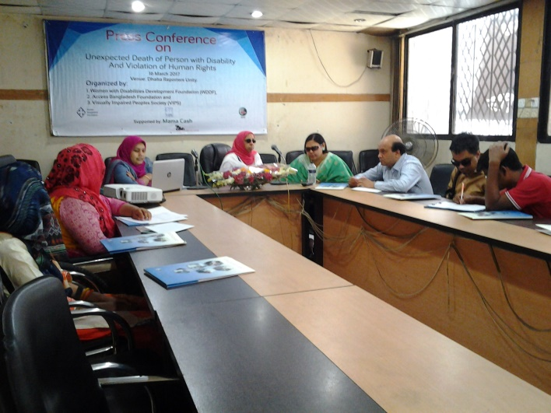

The main purpose of organizing the press conference is to urge to the Government for an “Inclusive, antidiscriminatory and Persons with Disabilities friendly society for all” through building accessible road, public transport and public buildings. Simultaneously, to notify Government and the relevant authorities of the City Corporation that, the situation of the roads of Dhaka City are extremely dangerous along with insecured for the mobility of Persons with Disabilities.

These Organizations of Persons and Women with Disabilities having united & working as collective force with the Government, policy makers, representatives of civil society and media for the inclusion of People with Disabilities in mainstream development process through reducing their challenges and discrimination in the issue of accessibility. The keynote paper was being presented by Nazma Ara Begum Popy, General Secretary, Visually Impaired Peoples Society (VIPS) In this paper she mentioned that Sanu mia A visual impaired person is a symbol of the society who passed away for the ignorance and silent violations of PWDs human rights. Persons with Disabilities are suffering from inaccessible environment and deprived from their equal citizen rights. The large number of population in Bangladesh is one of the most vulnerable and disadvantaged segment of the society. Roads, footpaths, Underpass, over bridge, public transport and public buildings are inaccessible for them. Besides, manholes of the cities and rural-urban areas are often uncovered and it is tremendously risky for the movement of Persons with Disabilities. We’re trying our best to visualize this issue again and again but nevertheless, due to the negligence of the relevant authorities, a visual impaired man fell in an uncovered manhole of Paltan and died within one hour unexpectedly last 6th March 2017. Isn’t it Human rights violation? We don’t want any more human rights violation, any more death! We want to live together, contribute in building golden Bangladesh and prosperous nation together. So, it is noted that, Persons with Disabilities are always subject of discrimination including human rights violation and without having been enjoyed accessibility rights, all types of Persons With Disabilities haven’t been included in the mainstream of development and in this consequence, national development will extremely be interrupted. This Press conference is moderated by Ashrafun Nahar, Executive Director and Welcome Speech is delivered by Shirin Akhter, Chairperson, Women With Disabilities Development Foundation (WDDF). Closing speech is delivered by Mohua Paul, Vice Chairperson, Access Bangladesh Foundation.

The representatives of DPOs expressed their high optimism that, the flight of steps of establishing the rights and dignity of 15 millions of disabled people would be easier and they will be able to play a contributive role as human resource not rather being treated as a burden of society in the development of society and nation and in the consequence of achieving their needs and demands through the proper implementation and actualization of “UN Convention on Rights of Persons With Disabilities”. So, the representatives of Women with Disabilities led organizations call vigorously for the rapid implementation of the convention to actualize the development process of the country. Vashkar Vatta Chariya, National Consultant, Web Accessibility, AToI, Prime Minister office, urged that, the Government of Bangladesh, Bangladesh mass Medias, Disabled Persons Organizations (DPOs), representatives of civil society including all classes to work together to create a friendly environment by ensuring their full and equal participation in all aspects including employment in order to improve the living standard of PWDs. Hawa Akter, Woman leader with Speech and Hearing Impairment said that, As Women with Speech and Hearing Impairments, they’ve to face multifaceted challenges due to inaccessible roads and transport. So, they are optimistic that, 15 million Persons With Disabilities will enjoy the equal opportunity similar to all citizen’s, it will be easy to eliminate all forms of barriers to fulfill the demands of Persons With Disabilities and will ensure there full participation in the development activities of the state. Besides them, National Executive Members and representatives of DPOs also delivered their speech in this press conference. All the speakers in the press conference expressed their optimism that, successful implementation and actualization of national and international instruments including “UN Convention on Rights of Persons With Disabilities” will eradicate all kinds of discrimination between Persons With Disabilities & non disabled people & will be able to build a happy & anti discriminatory nation.

The press conference was conducted with the leadership of Chairperson, Shirin Akhter, Member Secretary, Ashrafun Nahar, Executive Council Members and General Council Members, Women with Disabilities Development Foundation (WDDF), Vice Chairperson, Mohua Paul, Access Bangladesh Foundation, General Secretary, Nazma Ara Begum Popy, and Executive Council Members of Visually Impaired Peoples Society (VIPS).

The Press Conference, which was being organized by WDDF, Access Bangladesh Foundation and VIPS, was a very time required and effective initiative. A large number of reporters and photo journalists of Electronic and Print Media were present in this Press Conference. A number of folders along with related documents were being distributed among the participants on behalf of these Organizations. Besides, a press release was being published at the end of the Press Conference.

7. Discussion/Advocacy Meeting with Government and Non-Government Organizations:

The main purpose of organizing these meetings is to ensure the inclusion of Women with Disabilities (WWDs) in all newly adopted policies and plan, which had not been happened before as well as for the implementation of Government along with international rules and regulations including “UN CONVENTION ON RIGHTS OF PERSONS WITH DISABILITIES”.

Twenty five Discussion/Advocacy Meetings were organized in various purposes in this reporting year (From 01 January to 31 December 2017).

* **1st Advocacy Meeting with the representatives of Disabled Peoples Organizations (DPOs):**

**An advocacy meeting was being organized with the representatives of WDDF as well as the representatives of DPOs, on 14 January 2017, in NADPO office.** 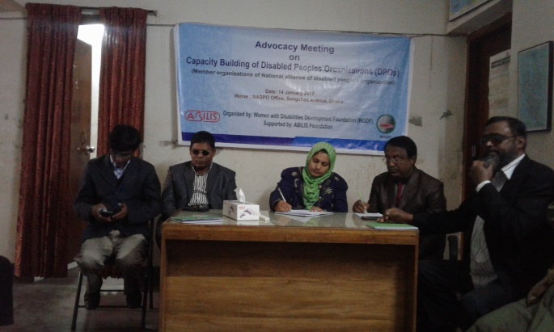

Ashrafun Nahar, Executive Director and Mst. Habiba Khatun, Project Officer of WDDF were participated in this advocacy meeting. Ashrafun Nahar, Executive Director, WDDF submitted a number of proposals to the representatives, about the duties of DPOs on skill development of Women with Disabilities of grass root level through enhancing their leadership, their inclusion in Income Generating Activities (IGA) as well as proactive participation of Women with Disabilities in the process of decision making including implementation along with actualization of policy and action plan in local level in order to leading their torture free and dignified lives. She also mentioned that, the activities of DPOs should be executed considering the improvement of Women with Disabilities and Women with Disabilities right based. Otherwise, proper improvement will be interrupted. The representatives of DPOs were very cordial and cooperative to us. Conveying their full support and solidarity to our proposals, The representatives of DPOs expressed their firm commitment to adopt required initiatives to actualize the submitted proposals for the improvement of Women with Disabilities in future.

* **2nd Advocacy** Meeting with the representatives of National Disabled Grassroot Organization (NGDO) and National Council of Disabled Women (NCDW):

An advocacy meeting was being organized with the representatives of WDDF as well as the representatives of National Disabled Grassroot Organization (NGDO) and National Council of Disabled Women (NCDW), on 24th January 2017, in the office of NGDO along with NCDW.

Shirin Akhter, Chairperson, Ashrafun Nahar, Executive Director, Md. Hasanuzzaman, Accounts Officer and Mst. Habiba Khatun, Project Officer of WDDF were participated in this advocacy meeting. Ashrafun Nahar, Executive Director, WDDF submitted a number of proposals to the representatives, about the duties of DPOs on skill development of Women with Disabilities of grass root level through enhancing their leadership, their inclusion in Income Generating Activities (IGA) as well as proactive participation of Women with Disabilities in the process of decision making including implementation along with actualization of policy and action plan in local level in order to leading their torture free and dignified lives. She also mentioned that, the activities of DPOs should be executed considering the improvement of Women with Disabilities and Women with Disabilities right based. Otherwise, proper improvement will be interrupted. Shirin Akhter emphasized on the unity of DPOs specially, Women with Disabilities led DPOs. She mentioned that, as Women with Disabilities are still now extremely vulnerable due to gender and disability, so we have to work unitedly and we’ve to raise united and strong voice for their advancement through achieving their basic human rights.

The representatives of DPOs were very cordial and cooperative to us. Conveying their full support and solidarity to our proposals, the representatives of DPOs expressed their firm commitment to adopt required initiatives to actualize the submitted proposals for the improvement of Women with Disabilities in future.

* 3rdDiscussion Meeting with the Managing Director (MD) of Jatiya Protibandhi Unnayan Foundation (JPUF):

A discussion meeting was held with the representatives of WDDF as well as the Managing Director of Jatiya Protibandhi Unnayan Foundation (JPUF) on 25th January 2017, at 3 PM, in the office of JPUF.

The representatives of EC including the officials of WDDF attended in the above mentioned meeting. Kamrun Nahar Begum, Managing Director, Jatiya Protibandhi Unnayan Foundation (JPUF) expressed her heartiest thanks to the representatives of WDDF.

Afterwards, Ashrafun Nahar, Executive Director of WDDF, on behalf of the representatives of WDDF, submitted a paper including the accomplishmentn, objectives along with a few proposals and Shirin Akhter, Chairperson of WDDF, submitted a brief report on the activities for the promotion and protection of the rights along with dignity of WWDs to the Managing Director and call upon to express the solidarity on behalf of JPUF to these issues.

The Managing Director was very cordial and cooperative to us. She expressed Her full support and solidarity to our proposals and she is agreed with us that, a focal person will be appointed in JPUF in order to discuss the important, emergency issue and to solve the problems of Persons specially Women with Disabilities, JPUF will completely be accessible for all types of Persons with Disabilities as well as 25% of JPUF donation will be allocated for the Women with Disabilities led Organizations. She also said that, present Government is very compassionate to the Persons with Disabilities and very much committed to fulfill their demands.

Above all, it is said that, in the present perspective, the adopted initiative by WDDF, of organizing this dialogue between the representatives of WDDF and the authority of JPUF in order to include the Women with Disabilities in the mainstream of development by ensuring their equal rights along with dignity is really very time required and effective. At the end of the discussion meeting, the representatives after having been attended in the above mentioned meeting expressed their satisfactory feelings and positive remarks.

* 4th Discussion meeting with the Upazila Nirbahi Officer (UNO)of Bogra Sadar:

A Discussion meeting with the Upazila Nirbahi Officer (UNO)of Bogra Sadar on the occasion of launching a Mid Level Coalition project entitled “To access justice and sustainable development for Women with Disabilities at all levels through inclusive building institutions” was being organized by Women with Disabilities Development foundation (WDDF), at 4.00 PM, on 22nd February 2017, in the office of UNO. Ashrafun Nahar, Executive Director, WDDF submitted the activities of the coalition project which will be implemented in Three unions of Bogra Sadar Upazila with the cooperation of Bogra Zila Spondon Protibandhi Nari Parisad and expects all types of cooperation on behalf of UNO for actualizing these activities properly.

Akterun Nahar, Upazila Nirbahi Officer (UNO)of Bogra Sadar was very cordial and cooperative to us. She expressed her full support and solidarity to our activities and agreed with us to provide all types of necessary cooperation to actualize these activities in Bogra Sadar Upazila.

Shirin Akhter, Chairperson, Ashrafun Nahar, Executive Director, Khadija Akter, General Council Member, Md. Hasanuzzaman, Accounts Officer of WDDF and Rebeka Akter, General Secretary, Bogra Zila Spondon Protibandhi Nari Parisad were present in this discussion meeting.

* 5th Discussion meeting with the Deputy Commissioner (DC) of Pabna:

A Discussion meeting with the Deputy Commissioner (DC) of Pabna on the occasion of launching a Mid Level Coalition project entitled “To access justice and sustainable development for Women with Disabilities at all levels through inclusive building institutions” was being organized by Protik Mohila O Sheshu Sangstha (PMSS), at 11.00 AM, on 23rd February 2017, in the office of Deputy 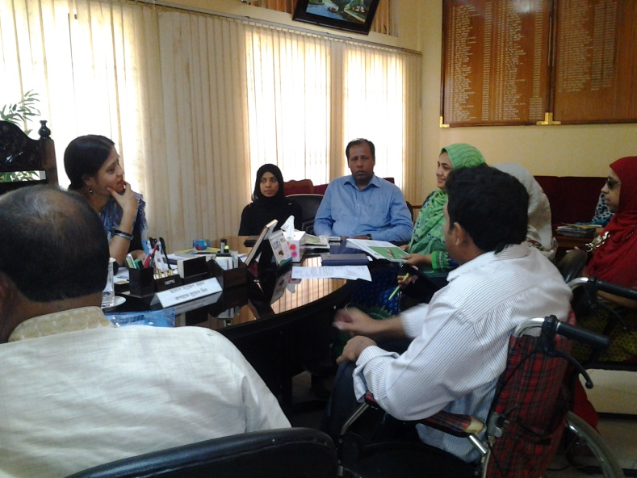Commissioner (DC). Ashrafun Nahar, Executive Director, WDDF and S. M. Saifur Rahman, Executive Director, PMSS jointly facilitated the program as well as Shirin Akhter, Chairperson, WDDF, submitted the activities of the coalition project which will be implemented in Three unions of Pabna Sadar Upazila with the cooperation of PMSS and expects all types of cooperation on behalf of Government for actualizing these activities properly.

Rekha Rani Balo, Deputy Commissioner (DC), Pabna was very cordial and cooperative to us. She expressed her full support and solidarity to our activities and agreed with us to provide all types of necessary cooperation to actualize these activities in Pabna Sadar Upazila.

Shirin Akhter, Chairperson, Ashrafun Nahar, Executive Director, Khadija Akter, General Council Member, Md. Hasanuzzaman, Accounts Officer of WDDF were present in this discussion meeting.

* 6th Discussion meeting with the Upazila Nirbahi Officer (UNO)of Pabna Sadar:

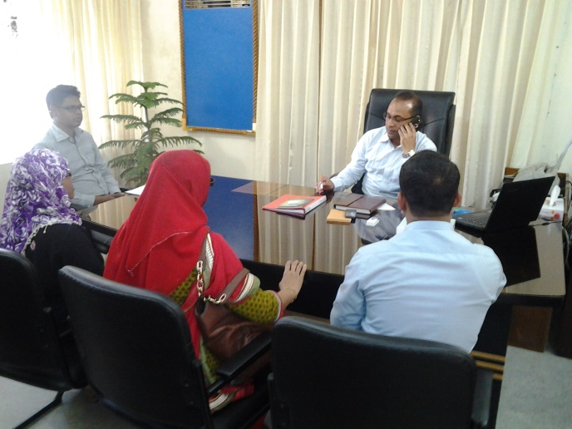A Discussion meeting with the Upazila Nirbahi Officer (UNO)of Pabna Sadar on the occasion of launching a Mid Level Coalition project entitled “To access justice and sustainable development for Women with Disabilities at all levels through inclusive building institutions” was being organized by Women with Disabilities Development Foundation (WDDF), at 4.00 PM, on 23rd February 2017, in the office of UNO. Shirin Akhter, Chairperson, WDDF , submitted the activities of the coalition project which will be implemented in Three unions of Pabna Sadar Upazila with the cooperation of PMSS and expects all types of cooperation on behalf of UNO for actualizing these activities properly.

Cawserul Islam, Upazila Nirbahi Officer (UNO)of Pabna Sadar was very cordial and cooperative to us. He expressed His full support and solidarity to our activities and agreed with us to provide all types of necessary cooperation to actualize these activities in Pabna Sadar Upazila.

Shirin Akhter, Chairperson, Ashrafun Nahar, Executive Director, Khadija Akter, General Council Member, Md. Hasanuzzaman, Accounts Officer of WDDF were present in this discussion meeting.

* 7th Discussion meeting of Women led organizations:

A discussion meeting of women led organizations was being organized by Women with Disabilities Development Foundation (WDDF) in its office, at 3 PM, on 27th February 2017. The representatives of Five Women led organizations were present in this meeting and this meeting was presided over Mohua Paul, Vice Chairperson, Access Bangladesh Foundation, facilitated by Ashrafun Nahar, Executive Director, WDDF. The main agenda of this discussion meeting was to organize a Roundtable Conference on “Political Rights and Participation” of Women with Disabilities by Seven Women led organizations in join collaboration. The responsibilities and activities of the abovementioned program are being discussed and distributed among the seven organizations.

* 8th Discussion meeting with the Chairman of Jatiya Mahila Sangstha:

A discussion meeting was held with the representatives of WDDF as well as the Chairman including the representatives of Jatiya Mahila Sangstha on 9th March 2017, at 12 PM, in the office of Jatiya Mahila Sangstha. The representatives of EC including the officials of WDDF attended in the above mentioned meeting. Prof. Momtaz Begum Advocate, (Former MP) Chairman Jatiya Mahila Sangstha expressed her heartiest thanks to the representatives of WDDF.

Afterwards, Ashrafun Nahar, Executive Director of WDDF, on behalf of the representatives of WDDF, submitted a paper including the accomplishmentn, objectives along with a few proposals and Shirin Akhter, Chairperson of WDDF, submitted a brief report on the activities for the promotion and protection of the rights along with dignity of Women with Disabilities to the Chairman and call upon to express the solidarity on behalf of Jatiya mahila Sangstha to these issues.

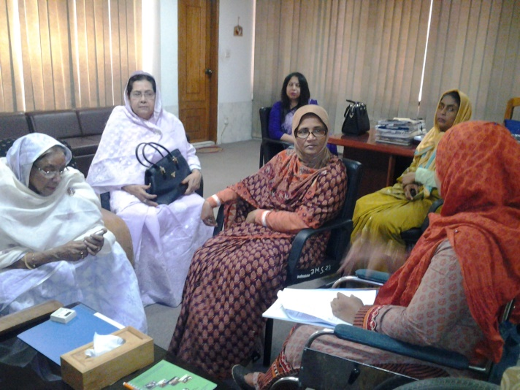The Chairman was very cordial and cooperative to us. She expressed Her full support and solidarity to our proposals and she is agreed with us that, all district offices including head office of Jatiya Mahila Sangstha should be accessible for Women with Disabilities and all tuypes of Women with Disabilities should be included in its training programs as well as WDDF will submit some ideas in order to designing a project specially for Women with Disabilities on the basis of considering their capacity and needs. She also said that, present Government is very compassionate to the Persons with Disabilities and very much committed to fulfill their demands.

Above all, it is said that, in the present perspective, the adopted initiative by WDDF, of organizing this dialogue between the representatives of WDDF and the authority of Jatiya Mahila Sangstha in order to in corporate Women with Disabilities in the mainstream of development by ensuring their equal rights along with dignity is really very time required and effective. At the end of the discussion meeting, the representatives after having been attended in the above mentioned meeting expressed their satisfactory feelings and positive remarks.

* 9th Discussion meeting on Survey report analysis and Grassroot Women with Disabilities Committee formation:

A Discussion meeting on Survey report analysis and Grassroot Women with Disabilities Committee formation was being organized by Women with Disabilities Development Foundation (WDDF) in Hasanpur Boys and Girls Vocational Training Centre, Daudkandi Comilla, on 20th March 2017. Almost Sixty participants including Women with Disabilities and their parents of Three Union ‘Daudkandi Uttar’, ‘Baropara’, ‘Gouripur’, representatives of WDDF, representatives of the training centre and Social Service Department were participated in this discussion meeting.

Welcome speech is being delivered by Shirin Akhter, Chairperson, WDDF. The mission and activities of WDDF as well as the adopted activities for the grassroot Women with Disabilities of Daudkandi under the project of Mamacash are being discussed in her welcome speech.

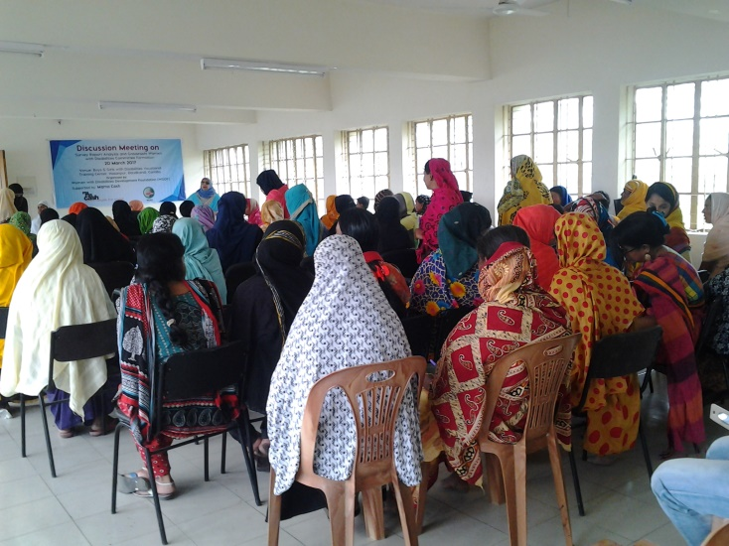After that, an introductory session of all the participants is being conducted by Ashrafun Nahar and all the participants are introduced with each other in this session. After having the introductory session been finished, Ashrafun Nahar, Executive Director of WDDF present a survey report on the survey conducted in order to identify Women with Disabilities of Three unions ‘Gouripur’, ‘Baropara’ and ‘Daudkandi Uttar’ of D’audkandi Subdistrict. After that, Two Grassroot Women with Disabilities Committees are being formed and both committees select their president, Vice-President and Secretary. After that, in the open discussion, the participants discussed about the barriers to obtain Government services and facilities for Persons with Disabilities, as Women with Disabilities.

Sufiya Haque, Deputy Director Daudkandi, Department of Social Service and General Manager, Hasanpur Boys and Girls Vocational Training Centre was present as Chief Guest and Shibli Jaman, Officer, Department of Social Service, Daudkandi and Assistant General Manager, Hasanpur Boys and Girls Vocational Training Centre was present as Special Guest in the discussion meeting. Both the Chief Guest and Special Guest expressed their commitment to cooperate these Women with Disabilities to obtain Government services and facilities as well as to cooperate WDDF to continue their activities smoothly. This discussion meeting is being moderated by Ashrafun Nahar, Executive Director, WDDF. Closing speech and vote of thanks is delivered by Masuma Akter, Chairperson of Discussion meeting and Vice Chairperson of WDDF.

* 10th Advocacy meeting with media representatives:

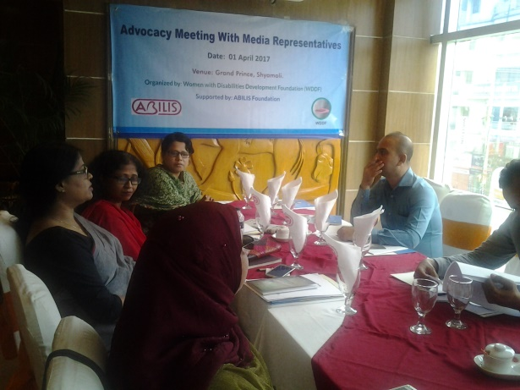An Advocacy meeting on **“Making an Inclusive Society: Searching rights to Universal Accessibility, Justice and livelihood” of Women with Disabilities** with media representatives was being organized by Women with Disabilities Development Foundation (WDDF), at Prince restaurant, Shyamali, Dhaka-1207,on Saturday, 1st April 2017. This advocacy meeting was being organized in order to share multifaceted challenges of Women with disabilities in family and society to lead their lives as citizen; specially, inaccessibility in roads, public transport and public buildings, violence against Women with Disabilities and inaccessibility to justice with the representatives of media as well as how media can cooperate to reduce these challenges through media campaign. GC and EC Members of WDDF, Shirin Akhter, Chairperson, Ashrafun Nahar, Executive Director and Hasanuzzaman, Program Officer, WDDF share their real and bitter experience about the sufferings of persons and Women with Disabilities in different aspects of lives as well as expect their continuous cooperation to condense the sufferings of Women with Disabilities. A number of representatives from electronic and print media as well as representatives from DPOs were participated in this discussion meeting. All the media representatives are more or less aware about the sufferings of Persons with Disabilities in their daily lives but they’ve no logical conception about these types of challenges specially the challenges of Women with Disabilities in every step of their lives. They couldn’t think that, how the diminutive but technical initiatives of the relevant authorities and their proper accountability of actualizing the activities with responsibility will not only be helpful to make the lives easy of a large number of marginalized population through reducing their regular challenges but also make them contributive to their family and society.

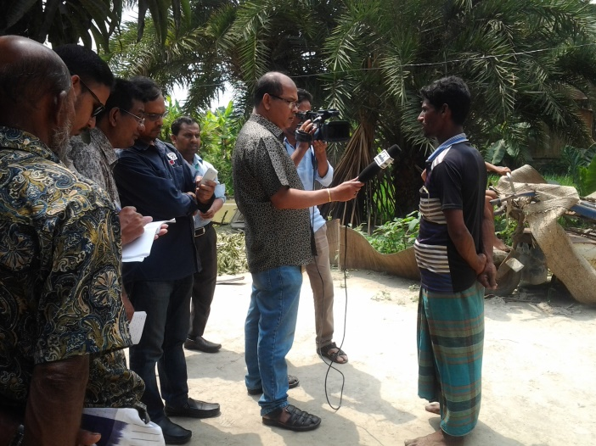Hence, the media representatives stated that, this advocacy meeting is immensely helpful for them to realize these issues seriously as well as they’ve expressed their firm commitment to raise their cooperative hands to work with us together in order to reduce the challenges of Persons specially Women with Disabilities in their daily lives which will immensely be helpful to enjoy their basic human rights.

* 11th Discussion meeting with the lawyers of BLAST:

A discussion meeting was being organized with the representatives of WDDF as well as the lawyers of BLAST at 3.00 PM, on 2nd April 2017. Shirin Akhter, Chairperson and Ashrafun Nahar, Executive Director, WDDF on behalf of the representatives of WDDF were discussed about the overall situation of Takiya and her family including their extreme sufferings and torture by Union Parisad Chairman and village people due to filing litigation about the heinous offence of raping Takiya as well as collected update information of this litigation. The lawyers of BLAST, Mr. Ashok Banerjee, Coordinator, BLAST Khulna Celland Fatema Khondokar Rima, BLAST Staff Lawyer informed about the present situation of Takiya’s rape case, another litigation of torturing Takiya’s mother on 26th March and provides the papers of two litigations. The lawyers were very cordial and cooperative to us. They’re determined and committed to continue these litigations with responsibility and sincerity. They’re also committed to provide their continuous cooperation to complete our tasks in Khulna.

* 12th Discussion meeting with media representatives:

A discussion meeting was being organized with the representatives of WDDF as well as the representatives of media, such as Ittefaq, Dailyprobaha and others at 5.00 PM, on 2nd April 2017. Shirin Akhter, Chairperson and Ashrafun Nahar, Executive Director, WDDF on behalf of the representatives of WDDF were discussed about the raping incident of Takiya along with the overall situation of her family including their extreme sufferings and torture by Union Parisad Chairman and village people due to filing litigation about the heinous offence of raping Takiya as well as expect their all types of cooperation on behalf of print media in this regard.

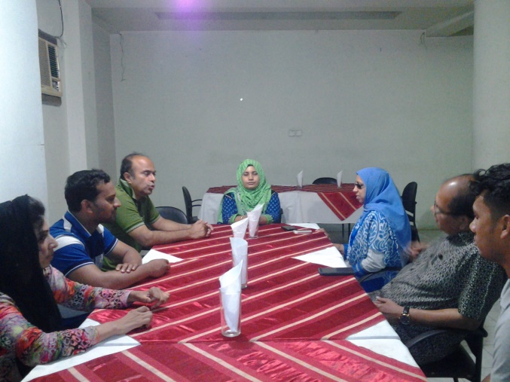The representatives of media became shocked and surprised listening these heartrending incidents and expressing their solidarity with us. They stated that, it is an extreme violation of human rights so; they’re committed to provide their possible cooperation to come forward with this issue.

* 13th Discussion meeting with SM Habib, President, Khulna Press club, Regional Head, ATN Bangla:

A Discussion meeting was being organized with the representatives of WDDF as well as SM Habib, President, Khulna Press club, Regional Head of ATN Bangla, at 10.00 AM, on 3rd April 2017, in the office of ATN Bangla, Khulna.

SM Habib, President, Khulna Press club, Regional Head of ATN Bangla expressed his heartiest thanks to the representatives of WDDF. Afterwards, Shirin Akhter, Chairperson and Ashrafun Nahar, Executive Director, WDDF on behalf of the representatives of WDDF were discussed about the raping incident of Takiya along with the overall situation of her family including their extreme sufferings and torture by Union Parisad Chairman and village people due to filing litigation about the heinous offence of raping Takiya, the progress of rape case and call upon to express the solidarity on behalf of ATN Bangla to this issue. The representative of ATN Bangla was very cordial and cooperative to us and he expressed his farm commitment to adopt any type of initiative to support and highlight the issue But he suggested that, as the legal process of the rape case is going on, so, for the grater interest of litigation, we should move forward in accordance with the suggestion of this litigation supervicing lawyers. Hence, After having discussed with lawyers, SM Habib decided that, the representatives of ATN Bangla, representatives of print media including representatives of WDDF and lawyers would visit Takiya’s house, offender Barik Mollah’s house, organize meeting with Upazila Chairman, Union Nirbahi Officer (UNO), OC of Terokhada thana in order to notifying them the issue of rape case properlyand collect direct interview with VDO of Takiya, her family, Barik Mollah’s family, representatives of WDDF and the representatives of Local Government. So, The representatives of WDDF were agreed to organize this visit and on the basis of discussion it is decided that, this visit is going to be organized on 5th April 2017.

* 14th Discussion meeting with the Public Prosecutor (PP) of Khulna:

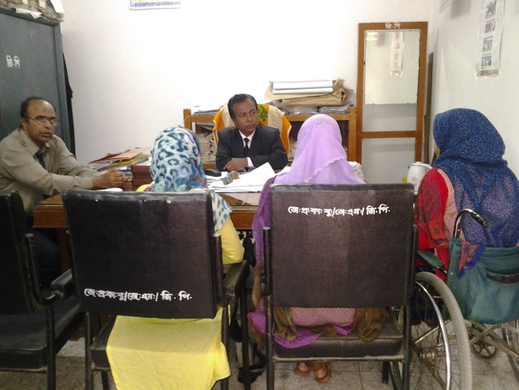A Discussion meeting was being organized with the representatives of WDDF as well as Sultana Rahman Shilpi, Public Prosecutor (PP) of Khulna at 3.00 PM, on 3rd April 2017 in Court building. Ashrafun Nahar, Executive Director, WDDF on behalf of the representatives of WDDF discussed about the complexity of Women with Disabilities in access to justice along with the inaccessibility in Court building and call upon her solidarity to this issue.

Sultana Rahman Shilpi, PP of Khulna was very cordial and cooperative to us and she expressed her commitment to adopt required initiative to reduce these challenges of Women with Disabilities.

* 15th Discussion meeting with Deputy Commissioner (DC) of Khulna:

A Discussion meeting was being organized with the representatives of WDDF as well as Najmul Ahasan, Deputy Commissioner (DC) of Khulna at 5.00 PM, on 3rd April 2017 in DC office. Najmul Ahasan, Deputy Commissioner (DC) of Khulna expressed his heartiest thanks to the representatives of WDDF. Afterwards, Shirin Akhter, Chairperson and Ashrafun Nahar, Executive Director, WDDF on behalf of the representatives of WDDF were notified about the raping incident of Takiya along with the overall situation of her family including their extreme sufferings and torture by Union Parisad Chairman and village people due to filing litigation about the heinous offence of raping Takiya, the progress of rape case, the incident of in humanitarian torture has been happened to Takiya’s mother on 26th March simultaneously, request to adopt required initiative for getting justice and taking security measures for Takiya and her family through calling upon to express the solidarity on behalf of Government to this issue. Najmul Ahasan, DC of Khulna was very cordial and cooperative to us. He told us to meet with UNO and to inform the whole incident with his reference. He also told that, he discussed with UNO and ordered to take required initiative for ensuring security for Takiya along with her family as much as possible.

* 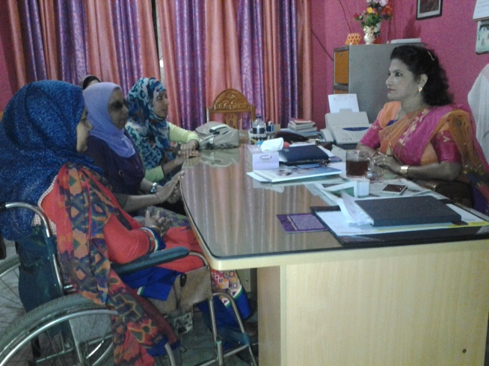16th Discussion meeting with District Women Affairs Officer:

A Discussion meeting was being organized with the representatives of WDDF as well as Ms Nargis Fatema Jemin, District Women Affairs Officer of Khulna at 11.00 AM, on 4th April 2017 in her office. Ms Nargis Fatema Jemin, District Women Affairs Officer of Khulna expressed her heartiest thanks to the representatives of WDDF. Though she has already been informed about the situation of Takiya and her family through Shirin Akhter, Chairperson of WDDF over phone briefly and helped the victim girl and her family to accommodate in Women Shelterhome of Khulna, but as this is the first meeting of WDDF representatives with the officer, Shirin Akhter, Chairperson and Ashrafun Nahar, Executive Director, WDDF on behalf of the representatives of WDDF were expressed their sincere gratitude for her time required cooperation as well as notified about the raping incident of Takiya along with the overall situation of her family including their extreme sufferings and torture by Union Parisad Chairman and village people due to filing litigation about the heinous offence of raping Takiya, the progress of rape case, the incident of in humanitarian torture has been happened to Takiya’s mother on 26th March and call upon to express the solidarity on behalf of Government to this issue. Ms Nargis Fatema Jemin of Khulna was very cordial and cooperative to us and she expressed her commitment to provide all types of cooperation to Takiya and her family.

* 17th Discussion meeting with Police super of Khulna:

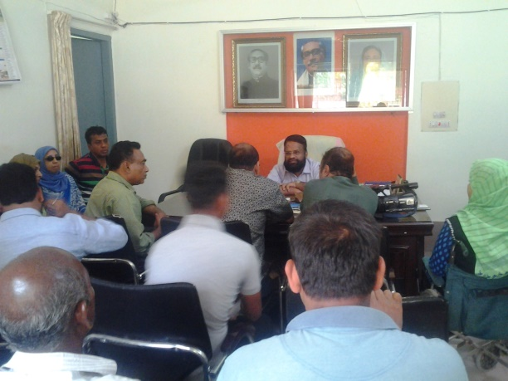A Discussion meeting was being organized with the representatives of WDDF as well as Police Super (SP) of Khulna at 12.00 PM, on 4th April 2017 in his office. Police Super (SP) of Khulna expressed his heartiest thanks to the representatives of WDDF. Afterwards, Shirin Akhter, Chairperson and Ashrafun Nahar, Executive Director, WDDF on behalf of the representatives of WDDF notified about the raping incident of Takiya along with the overall situation of her family including their extreme sufferings and torture by Union Parisad Chairman and village people due to filing litigation about the heinous offence of raping Takiya, the progress of rape case, the incident of in humanitarian torture has been happened to Takiya’s mother on 26th March simultaneously, request to adopt required initiative for getting justice and taking security measures for Takiya and her family through calling upon to express the solidarity on behalf of Law Inforcement Agency to this issue. SP of Khulna was very cordial and cooperative to us. He instantly ordered to the Assistant Police Super along with OC of Terokhada Thana to investigate these incidents with seriousness and to take required initiative to ensure security for Takiya along with her family as much as possible.

* 18th Discussion meeting with Upazila Chairman:

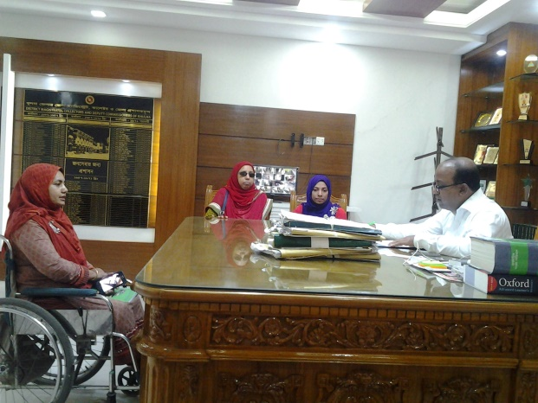A Discussion meeting was being organized with the representatives of WDDF as well as Md. Sarfuddin Biswas Bachchu, Upazila Chairman of Khulna at 12.00 PM, on 5th April 2017 in his office. Md. Sarfuddin Biswas Bachchu, Upazila Chairman of Khulna expressed his heartiest thanks to the representatives of WDDF. Afterwards, Shirin Akhter, Chairperson and Ashrafun Nahar, Executive Director, WDDF on behalf of the representatives of WDDF notified about the raping incident of Takiya along with the overall situation of her family including their extreme sufferings and torture by Union Parisad Chairman and village people due to filing litigation about the heinous offence of raping Takiya, the progress of rape case, the incident of in humanitarian torture has been happened to Takiya’s mother on 26th March simultaneously, request to adopt required initiative for getting justice and taking security measures for Takiya and her family through calling upon to express the solidarity on behalf of Government to this issue. Upazila Chairman of Khulna was very cordial and cooperative to us. and he expressed his commitment to provide all types of cooperation to Takiya and her family. Media representatives have collected his interview regarding this issue as well as his commitment to take security measures for Takiya and her family.

* 19th Discussion meeting with Upazila Nirbahi Officer (UNO) and OC of Terokhada Thana:

A Discussion meeting was being organized with the representatives of WDDF as well as Upazila Nirbahi Officer (UNO) of Terokhada at 1.00 PM, on 5th April 2017 in his office. Upazila Nirbahi Officer (UNO) of Terokhada expressed his heartiest thanks to the representatives of WDDF. Afterwards, Ashrafun Nahar, Executive Director, WDDF on behalf of the representatives of WDDF notified about the raping incident of Takiya along with the overall situation of her family including their extreme 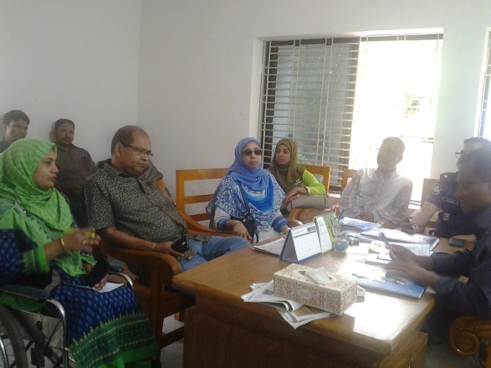sufferings and torture by Union Parisad Chairman and village people due to filing litigation about the heinous offence of raping Takiya, the progress of rape case, the incident of in humanitarian torture has been happened to Takiya’s mother on 26th March simultaneously, request to adopt required initiative for getting justice and taking security measures for Takiya and her family through calling upon to express the solidarity on behalf of Government to this issue. Upazila Nirbahi Officer (UNO) of Terokhada was very cordial and cooperative to us and he has responsed with very seriousness along with sincerety in this issue. He called OC of Terokhada at once and ordered to investigate these incidents with seriousness and to take required initiative to ensure security for Takiya along with her family as much as possible. Besides, he informed us that, he and OC of Terokhada would go to visitTakiya’s home at evening to investigate these incidents directly simultaneously to inform them that they’re out of risk as well as law inforcement agency will always try to provide all types of cooperation to them through observing their security measures.

* 20th Discussion meeting with Pollice Super Bogra:

A Discussion meeting was being organized with the representatives of WDDF along with Bogra Zila Spandon Protibandhi Nari Parisad as well as Police Super (SP) of Bogra at 11.00 AM, on 9th May 2017 in his office. Police Super (SP) of Bogra expressed his heartiest thanks to the representatives of WDDF and Bogra Zila Spandon Protibandhi Nari Parisad. Afterwards, Ashrafun Nahar, Executive Director, WDDF on behalf of all the representatives submitted a paper including the accomplishmentn, objectives along with a few proposals including a brief report on the activities for the promotion and protection of the rights along with dignity of Women with Disabilities to the Police Super and call upon to express his solidarity on behalf of Police force to these issues. 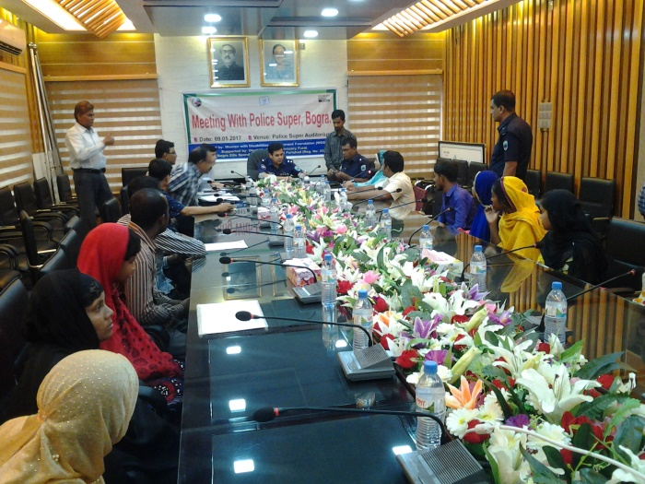

The Police Super of Bogra was very cordial and cooperative to us. He expressed His full support and solidarity to our proposals and he is agreed with us that, all Thanadistrict including the offices of Police Super should be accessible for Women with Disabilities and Disability issue should be included in the training curriculum of police. He also proposed that, WDDF may take initiative to organize a training session on disability issue for Police force in every police training program of Bogra. Ashrafun Nahar, Executive Director, WDDF discussed about the rape case of Ayesha Siddika Shammi, a Girl with intellectual Disability of Bogra and the sufferings of her family. The Police Super expressed his firm commitment that, there won’t be any settlement about this rape case without court and he him self will investigate this litigation. He also said that, present Government is very compassionate to the Persons with Disabilities and very much committed to fulfill their demands.

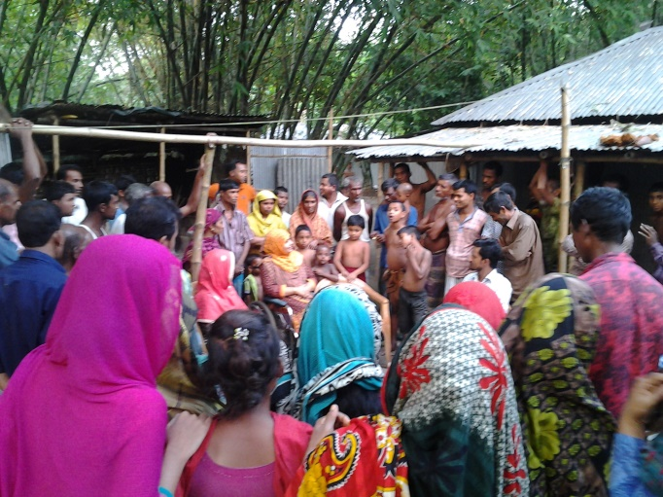Above all, it is said that, in the present perspective, the adopted initiative by WDDF, of organizing this dialogue between the representatives of WDDF including Bogra Zila Spandon Protibandhi Nari Parisad and the Police Super of Bogra in order to in corporate Women with Disabilities in the mainstream of development by ensuring their equal rights along with dignity is really very time required and effective. At the end of the discussion meeting, the representatives after having been attended in the above mentioned meeting expressed their satisfactory feelings and positive remarks.

* 21st Visit and discussion meeting with the village people of Sonatala:

A discussion meeting and visit Sonatala village was being organized with the initiative of WDDF in order to observe the situation of Shammi and her family including existing torture is continuously happening to them along with counseling Shammi’s family and neighbours through notifying them the real incident. The representatives of WDDF and Bogra zila Spandon nari parisad were participated in this visit. It is noted that,

We visited Shammi’s village and noticed that, most of the village people are blaming against offender and they’re waiting for his punishment for this heinous offence. They’ve also accused that, most of the young girls and women become victim of rape by this offender and they’re always scared of him. So, this offender must be punished. Besides, Shammi’s family members are scared and frustrated due to threaten and torture of offender; witnesses of this incident have to face regular threats and they’re scared. We discussed the whole issue with Shammi’s family members simultaneously counseling their neighbours to cooperate them continuously. Besides, we on behalf of WDDF assured that, we’ll be always with Shammi and her family to get justice.

* 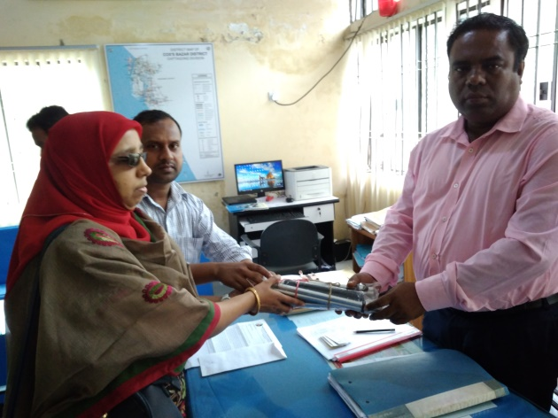22nd Discussion meeting with Assistant District Commissioner (ADC) General of Coxesbazar: A discussion meeting was being organized with the representatives of WDDF as well as the Assistant District Commissioner (ADC) General of Coxesbazar at 11.00 AM, on 18th September 2017.

Shirin Akhter, Chairperson, WDDF submitted the recommendations and discussed about the challenges have to face by the women, aged Rohingya refugees and specially Rohingya refugees with Disabilities as well as the ADC General expressed his commitment that, they will take special measures to bring women and aged Rohingya refugees including refugees with disabilities under relief distribution on the basis of privilege. Besides, the representatives of WDDF handed over some assistive devices for the Rohingya refugees with Disabilities.

* 23rd Discussion/**Welcome meeting with MamaCash and NPL Team Members**:

A **Welcome meeting** was held between the representatives of WDDF and a deligation team including seven members of MamaCash, Netherland, at 3.00 PM, on 19th November 2017, in WDDF office. The representatives of GC and EC members including the officials of WDDF participated in the above mentioned meeting.

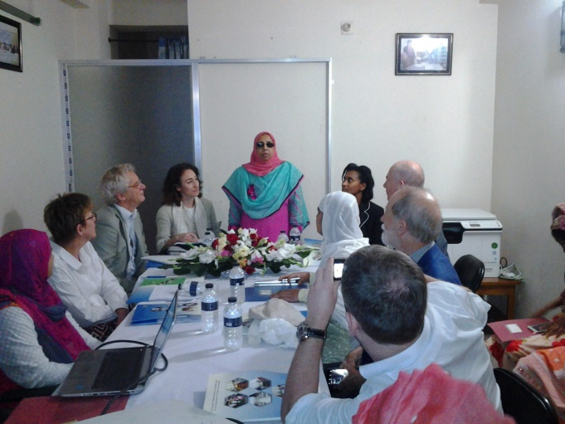Welcome speech is being delivered by Shirin Akhter, Chairperson, WDDF. After welcome speech, an introductory session of all the participants is being conducted by Ashrafun Nahar and all the participants are introduced with each other.

After having introductory session been finished, Ashrafun Nahar, Executive Director of WDDF, on behalf of the representatives of WDDF, submitted a brief presentation about WDDF including objectives, activities, challenges, future plan along with accomplishment. Followed by the presentation of Ashrafun Nahar, Open discussion is being moderated by Amanda Gigler, Director, Pertnerships and Communications, MamaCash.

In this open discussion, most of the participants shared discriminatory experiences and challenges of their lives flexibly.

Suraiya Akter Bably, Treasurer, WDDF shared that, at the time of starting her visual limitation, she dropped out from education. At that time, with the cooperation of WDDF, her father has been motivated, discussed and motivated the teachers and then again she admitted in to the school. After that, at the time of getting admission in Higher Secondary Certificate (HSC), in Begum Bodrunnesa Government College, College authority didn’t agree to accommodate her in College Hostel due to Visual limitation. Then again Shirin Akhter, Chairperson and Ashrafun Nahar, Executive Director of WDDF made advocacy and motivated College authority. Then Bably was allowed to accommodate in college hostel. After having completed HSC, she got admit in Jahangir Nagar University and completed Masters in Philosophy as well as she has got marry; now she has a boy baby. Simultaneously, she is striving for higher education in an international University and WDDF is always extending its cooperative hands to build my carrier. So, I also would like to contribute to build the carrier of Women with Disabilities through WDDF.

Mst. Farhana Khatun, General Member of WDDF enlightening real experience of her life mentioned that, “While I dropped out of my life, WDDF stood beside me as a shadow tree”.

I got marry with my Non Disabled colleague; He lived together with me in his relatives house or guest house but didn’t allow me in his own house and after Two years he denied to accept me as his wife due to my disability and divorced me. At that extreme crisis moment, WDDF adopt required initiative, rescued my life and cooperate me to start my life again. A small publication about me and the crisis moment of my life has been published by WDDF and distributed to all of you in your folder. So, you will come to know the discriminatory story of my life along with the contribution of WDDF for my advancement through reading this publication. Besides, Chairperson and Executive Director of WDDF shared multifaceted challenges and experiences of members along with beneficiaries of WDDF.

The team members were very cordial and cooperative to us. They expressed their full support and solidarity to our activities and presentation.They’re very satisfied notifying about the activities of WDDF as well as they also said that, the adopted initiatives by WDDF, in order to include the Women With Disabilities in the mainstream of development by ensuring their equal rights along with dignity is really very time required and effective. At the end of the discussion meeting, they visited the office. the representatives of WDDF after having been attended in the welcome meeting, recommended that, all members should share their challenging experiences from their own interest otherwise it won’t be possible to understand the advancement of Women with Disabilities through WDDF. Finally, it is said that, the welcome meeting was very positive, satisfactory and effective.

* 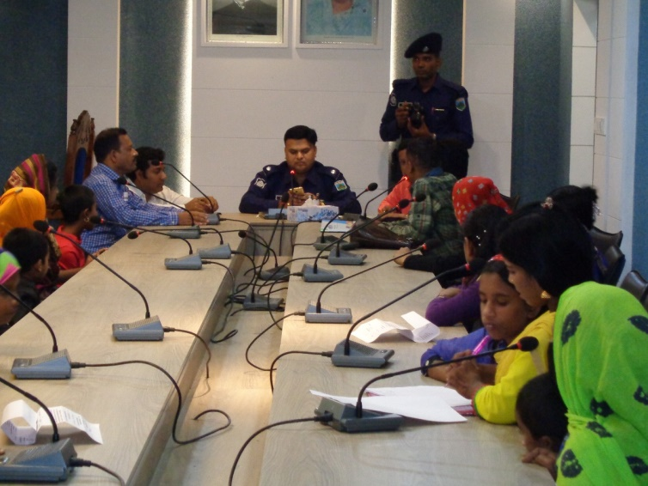 **24th Discussion meeting with Pollice Super of Pabna:**

A Discussion meeting was being organized with the representatives of WDDF along with Protik Mohila O Sheshu Sangstha (PMSS) as well as Police Super (SP) of Pabna at 11.00 AM, on 20th November 2017 in the Conference room of SP office. Police Super (SP) of Pabna expressed his heartiest thanks to the representatives of WDDF and Protik Mohila O Sheshu Sangstha (PMSS). Afterwards, S.M Saifur Rahman, Project Manager, WDDF and Executive Director, Protik Mohila O Sheshu Sangstha (PMSS) on behalf of all the representatives submitted a paper including the accomplishmentn, objectives along with a few proposals including a brief report on the activities for the promotion and protection of the rights along with dignity of Women with Disabilities to the Police Super and call upon to express his solidarity on behalf of Police force to these issues.

The Police Super of Pabna was very cordial and cooperative to us. He expressed His full support and solidarity to our proposals and he is agreed with us that, all Thana, district including the offices of Police Super should be accessible for Women with Disabilities and Disability issue should be included in the training curriculum of police. Simultaneously, he instantly ordered to the Chief of the District Trafic Police over phone, to provide direct cooperation Persons with Disabilities at the time of crossing road and getting on transport specially bus.

Besides, S.M Saifur Rahman, Project Manager, WDDF and Executive Director, Protik Mohila O Sheshu Sangstha (PMSS) discussed about Two incidents of violence against Women with Disabilities of Pabna and the sufferings of their family. 1st incident: Mamataj Parvin, a Girl with Physical Disability (One leg short due to Polio), is studying in Bachelor of Arts (B.A Final year), got marry while she studied in HSC and she has a Five years boy baby but after giving birth the baby, her husband hasn’t taken any responsibility of her wife and baby and subsequently he left them. After that, Mamataj Parvin filed litigation but she hasn’t got any judgement yet.

The 2nd incident: Mst. Selina Khaton, a Short hight Girl, no Fingers in Hands and Toes in Legs, student of Masters, got marry in 2011 but after Six month her husband left her and he married a Non Disabled Woman without permission of his wife.

The Police Super expressed his firm commitment that, he will cooperate to solve the litigation of Mamataj Parvin as much as possible. He mentioned that, the Office Incharge (OC) of Pabna Sadar Thana, who issued the charge sheet of this litigation, has been transferred in Noakhali and without his witness the procedure of this litigation will be lengthy. So, he suggested to PMSS representatives let him know the hearing date of litigation before Two or Three days ago then he will ensure the presence of that OC.

In order to solving the incident of Mst. Selina Khaton, SP suggested her to file a litigation and after having been filed the litigation, he will take the responsibility to arrest the accused person as well as obligate him to provide compensation (Monthly maintainance cost as his wife) from 2011.

He also said that, present Government is very compassionate to the Persons with Disabilities and very much committed to fulfill their demands.

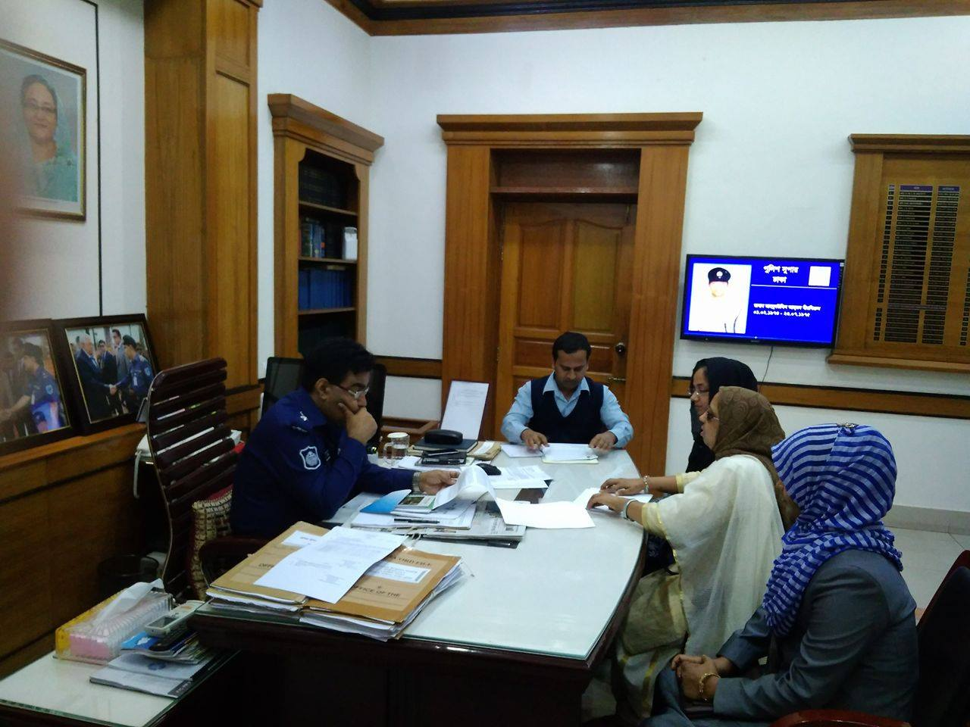Above all, it is said that, in the present perspective, the adopted initiative by WDDF, of organizing this discussion meeting between the representatives of WDDF including Protik Mohila O Sheshu Sangstha (PMSS) and the Police Super of Pabna in order to in corporate Women with Disabilities in the mainstream of development by ensuring their equal rights along with dignity is really very time required and effective. At the end of the discussion meeting, the representatives after having been attended in the above mentioned meeting expressed their satisfactory feelings and positive remarks.

* 25th Discussion meeting with Pollice Super of Dhaka:

A Discussion meeting was being organized with the representatives of WDDF as well as Police Super (SP) of Dhaka at 12.00 PM, on 11th December 2017 in his office. Police Super (SP) of Dhaka expressed his heartiest thanks to the representatives of WDDF. Afterwards, Shirin Akhter, Chairperson, WDDF on behalf of all the representatives submitted a paper including the accomplishmentn, objectives along with a few proposals including a brief report on the activities for the promotion and protection of the rights along with dignity of Women with Disabilities to the Police Super and call upon to express his solidarity on behalf of Police force to these issues.

The Police Super of Dhaka was very cordial and cooperative to us. He expressed His full support and solidarity to our proposals and he is agreed with us that, all Thana, districts including the offices of Police Super should be accessible for Women with Disabilities and Disability issue should be included in the training curriculum of police. He mentioned that, police force is going to take initiatives according to these proposals but it is difficult for them to adopt initiative on policy related issue. He also said that, present Government is very compassionate to the Persons with Disabilities and very much committed to fulfill their demands.

Above all, it is said that, in the present perspective, the adopted initiative by WDDF, of organizing this dialogue between the representatives of WDDF and the Police Super of Dhaka in order to in corporate Women with Disabilities in the mainstream of development by ensuring their equal rights along with dignity is really very time required and effective. At the end of the discussion meeting, the representatives after having been attended in the above mentioned meeting expressed their satisfactory feelings and positive remarks.

* 8. Shelter home visit:

WDDF representatives visited Two shelter homes in this reporting year.

A) Khulna Divisional shelter home Visit:

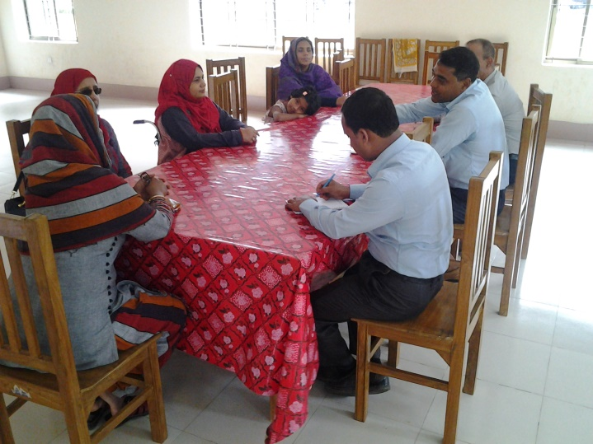WDDF representatives visited Khulna divisional shelter home on 2nd April 2017 and organized a discussion meeting with MM Shafiqur Rahman, Assistant Director of this shelter home. Actually, it was a follow up visit of WDDF. In 2014, at the time of shelter home construction, WDDF made strong advocacy with the relevant authorities of Government in order to making this shelter home infrastructurally accessible through attaching ramp, accessible toilet for wheele chair users and other essential facilities to ensure accessibility for Women with Disabilities. Simultaneously, to accommodate victim Women with Disabilities through providing their need based services. So, after having been constructed this shelter home, it was the first time visit of the representatives of WDDF in order to follow up the accessibility of the shelterhome and whether victim Women with Disabilities are getting services or not. After having been completed the shelterhome visit, it would be noted that, this shelter home is infrastructurally accessible and Women with mild Disabilities are geting services. Besides, this visit will also be helpful for us to disseminate the information about Government facilities for victim Women with Disabilities and victim Women with disabilities from the remote areas of Khulna will get opportunity to accommodate here along with taking services on the basis of requirement.

It is also noted that, Takiya, a Girl with Intellectual Disability of Terokhada Thana, after having raped and given birth to a boy baby, had been accommodated in this shelter home with her baby and her mother; who was immensely helpful for the victim family and also for WDDF to advance the work of supporting Takiya.

B) Sylhet Divisional shelter home visit:

WDDF representatives visited Sylhet divisional shelter home on 9th August 2017 and organized a discussion meeting with Abu Shama, Social Service Officer of this shelter home. Actually, it was a follow up visit of WDDF. In 2014, at the time of shelter home construction, WDDF made strong advocacy with the relevant authorities of Government in order to making this shelter home infrastructurally accessible through attaching ramp, accessible toilet for wheele chair users and other essential facilities to ensure accessibility for Women with Disabilities. Simultaneously, to accommodate victim Women with Disabilities through providing their need based services. So, after having been constructed this shelter home, it was the first time visit of the representatives of WDDF in order to follow up the accessibility of the shelter home and whether victim Women with Disabilities are getting services or not. After having been completed the shelter home visit, it would be noted that, this shelter home is infrastructurally accessible and Women with mild Disabilities are geting services. It is also noted that, Abu Shama, Social service Officer of shelter home thinks that, due to negative attitude, unacceptability of victim Women without Disabilities and lack of informational accessibility, Women with Disabilities haven’t get proper facilities and services. So, shelter home for Women with Disabilities should be separate. otherwise it is very difficult for them to accommodate them together. Besides, this visit will also be helpful for us to disseminate the information about Government facilities for victim Women with Disabilities and victim Women with disabilities from the remote areas of Sylhet will get opportunity to accommodate here along with taking services on the basis of requirement.

* 9. Discussion meeting with the representatives of District Bar Associations:

A) Discussion meeting with the representatives of Khulna Bar Association:

A Discussion meeting was being organized with the representatives of WDDF as well as Bijon Krisna Mandal, Secretary of Khulna Bar Association at 3.00 PM, on 4th April 2017 in Court building. Shirin Akhter, Chairperson, Ashrafun Nahar, Executive Director and Md. Hasanuzzaman, Program Coordinator of WDDF attended in the above mentioned meeting.

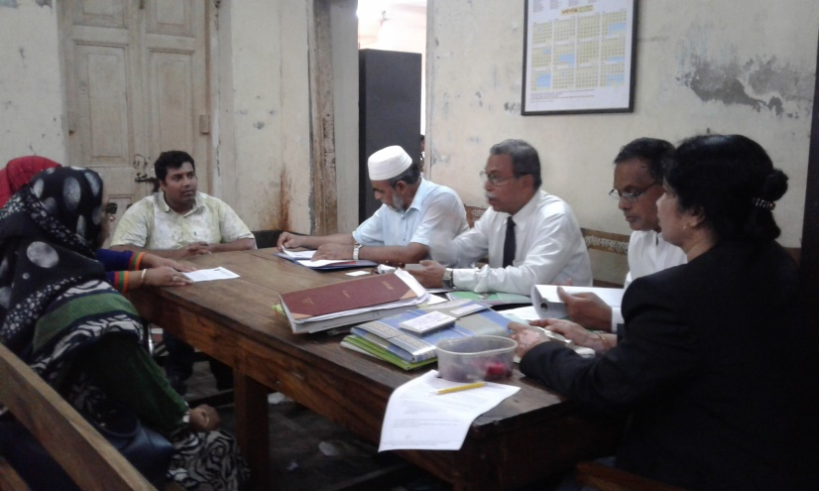Ashrafun Nahar, Executive Director, WDDF on behalf of the representatives of WDDF submitted a few proposals and Shirin Akhter discussed about the complexity of Women with Disabilities in access to justice along with the inaccessibility in Court building and call upon his solidarity to this issue. Bijon Krisna Mandal, Secretary of Khulna Bar association was very cordial and cooperative to us and he expressed his commitment to adopt required initiative to reduce these challenges of Persons specially Women with Disabilities access to justice.

B) Discussion meeting with the representatives of Bogra Bar Association:

A Discussion meeting was being organized with the representatives of WDDF as well as the representatives of Bogra Zila Bar Association at 3.00 PM, on 23rd August 2017 in Court building. Shirin Akhter, Chairperson, Ashrafun Nahar, Executive Director and Md. Hasanuzzaman, Program Coordinator of WDDF attended in the above mentioned meeting.

Ashrafun Nahar, Executive Director, WDDF on behalf of the representatives of WDDF submitted a few proposals and Shirin Akhter discussed about the complexity of Women with Disabilities in access to justice along with the inaccessibility in Court building and call upon his solidarity to this issue. President and Secretary of Bogra Zila Bar association were very cordial and cooperative to us and they expressed their commitment to adopt required initiative to reduce these challenges of Persons specially Women with Disabilities access to justice.

C) Discussion meeting with the representatives of Sylhet Bar Association:

A Discussion meeting was being organized with the representatives of WDDF as well as the representatives including President, Vice President, Secretary and other members of Sylhet Bar Association at 3.00 PM, on 9th August 2017 in Court building. Shirin Akhter, Chairperson, Ashrafun Nahar, Executive Director and Md. Hasanuzzaman, Program Coordinator of WDDF attended in the above mentioned meeting.

Md. Hasanuzzaman, Program Coordinator, WDDF facilitated the meeting and Shirin Akhter, Chairperson; WDDF explicated the purpose and importance of organizing this discussion meeting in her welcome speech.

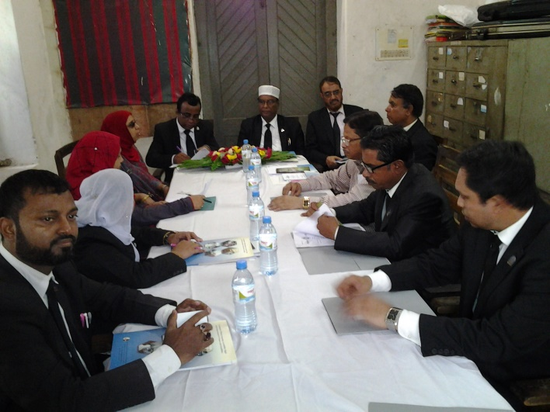Ashrafun Nahar, Executive Director, WDDF presented a keynote paper including a few proposals and Shirin Akhter discussed about the complexity of Women with Disabilities in access to justice along with the inaccessibility in Court building and call upon solidarity of bar association members to this issue.

The representatives of Sylhet Bar association were very cordial and cooperative to us and they expressed their commitment to adopt required initiative to reduce these challenges of Persons specially Women with Disabilities access to justice.

* 10. Supporting programs for a Girl with Intelectual Disability:

A number of activities in order to protect Takiya, a Girl with Intelectual Disability and her family from the persecution of Union Parisad Chairman and village people, have been adopted and accomplished by WDDF in this reporting year, are as follows:

A) Visit Takiya’s mother: WDDF representatives include Shirin Akhter, Chairperson, Ashrafun Nahar, Executive Director, Khadija Akter, General Council Member and Hasanuzzaman, Program Officer of WDDF have gone to visit Takiya’s mother at 10 A.M, on 2nd April 2017 in Khulna city; while she was in her relative’s house after getting released from hospital. It would be noted that, Takiya, a 13 years Girl with Intelectual Disability, Vill: Charkushla, 3 Chaklada unions, Tha: Terokhada, Dist: Khulna was raped by a Sixty years man in January 2016 and gave birth to a boy baby. On behalf of the offender Union Parisad Chairman proposed the victim girl’s family to resolve the incident of this rape through sum compensation but Takiya’s family hasn’t agree with this proposal and file a case. In order to taking revenge of this incident, on 26th March 2017, Din Islam, Chairman, 3 Chaklada union, Terokhada, Khulna ordered his flatterers to strike Takiya’s mother with sharp instrument on her head and even after having she fell down on the ground they’re beatting her with heavy sticks cruelly until she became senseless. It was very heartrending scenery, while a group of men with the order of a union parisad Chairman were beating a helpless woman lie down on the ground but nobody has anything to do. After having stopped their beating, it was seen that, Takiya’s mother lied down on the ground losing sense, became injured seriously and nonstop bleeding from her head. Her relatives admitted her in hospital and thirteen stitches had to put on her head. At the time of WDDF representatives visit, she was seriously ill, even she couldn’t walk and her whole body grasped with the spot of injury. We were counseling her, suggested her to be patient and assured her that, we are always with you; we’ve already informed about this shocking incident to the relevant authorities of Dhaka and now we’ll report to the local government, media and law inforcement agency of Khulna to handle this issue rightly, seriously as well as to protect your family from this type of in humanitarian torture.

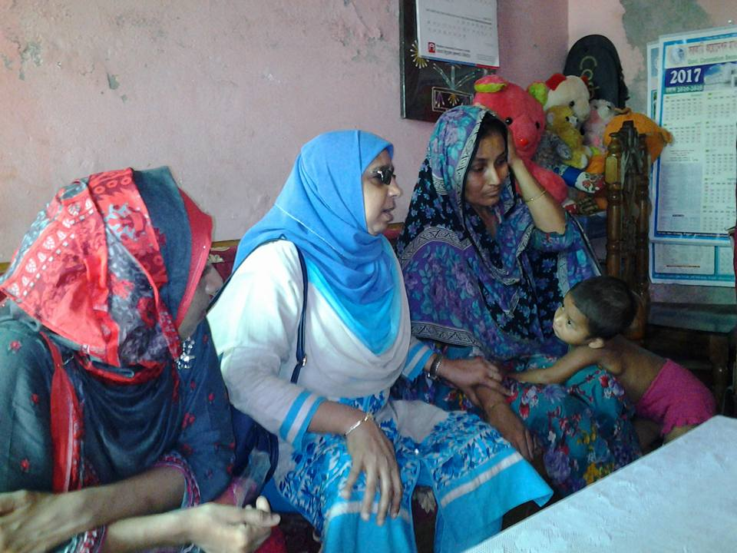B) Chotomonir Nibas visit:

WDDF representatives visited Chotomonir Nibas on 2nd April 2017 in order to discuss about the issue of Takiya’s baby with the authority of Chotomonir Nibas as well as seeking information about physical along with health condition of this baby. WDDF representatives organized a meeting with Kazi Ibrahim, Chief of Chotomonir Nibas including superintendent and discussed about the incident of Takiya’s baby elaborately. Simultaneously, we sought out the information about food and living standard of these children of Chotomonir Nibas. We met with Takiya’s baby, the baby is very cute suffering from mal nutrition by birth. So, the baby is very weak and thin.

C) Collect short VDO of Takiya’s baby:

A visit was being organized with the initiative of WDDF and the representatives of ATN Bangla in order to collect a number of VDOs of Takiya’s baby including the children of Khulna Chotomonir Nibas at 5.00 PM, on 4th April 2017.

The authority of Chotomonir Nibas was very cordial and cooperative to us and we collected the VDOs spontaneously in order to preserving information about the existing situation of Takiya’s baby.

D) Visit Takiya’s village:

A day long visit at Takiya’s village was being organized with the initiative of WDDF in order to observe the situation of Takiya and her family including existing torture is continuously happening to them along with counseling Takiya’s neighbours through notifying them the real incident as well as the on going activities of WDDF regarding this issue on 5th April 2017.

The representatives of WDDF, representatives of electronic and print media, lawyers and Government officials were participated in this visit. We visited Takiya’s home and noticed that, all the family members are scared and frustrated; they’re totally deprived and isolated from the society. We discussed the whole issue with Takiya’s family members, shared all the initiatives we’ve taken for their security simultaneously counseling their neighbours to cooperate them continuously. Media representatives have collected interviews of Takiya along with her parents, simultaneously we’ve visited offender’s home and collected interview from his wife along with his neighbours.

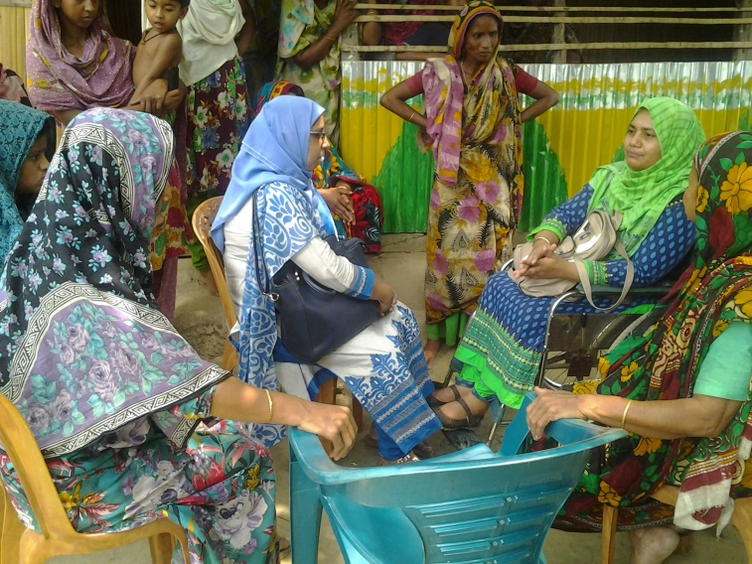(It would be noted that, WDDF organized a number of programs to protect this girl and her family including the abovementioned programs which have been included in another part of this report).

11. Roundtable discussion on “Political Rights and Participation of Women With Disabilities”:

A roundtable conference on “Political Rights and Participation of Women With Disabilities” is being organized with the initiative of seven organizations Women with Disabilities Development Foundation (WDDF), Access Bangladesh Foundation, Visually Impaired Peoples Society (VIPS), Disabled Child Foundation (DCF), Disabled Welfare Society (DWS), National Council of Disabled Women (NCDW), Turning Point Foundation, from 9.30 AM to 1 PM, on Wednesday 19th April 2017, at VIP Lounge,National Press club, on the issue of Women With Disabilities are excluded from their equal rights including political rights and participation” We Urge for an inclusive, antidiscriminatory and Women With Disabilities friendly society for all”. These Seven Organizations led by Women with Disabilities having united and working as collective force for their participation in mainstream of the society. The keynote paper was jointly being presented by Shikha Khatun, Capacity Building officer, Turning Point Foundation and Morjina Ahmed, Executive Director, Disabled Welfare Society (DWS). In this paper they mentioned that the estimated number of Women with Disabilities (WWDs) in Bangladesh, is around 12 million people (According to the “World Report on Disability” June2011), which constitutes 7.5 % of total population. This large number of girls and Women with Disabilities in Bangladesh are one of the most vulnerable and disadvantaged segment of the society. They are always discriminated based on gender, disabled and all too often, poorest of the poor. They are frequently subjected to discrimination both directly and indirectly and also negative attitudes. WWDs are deprived from practicing and enjoyment of political rights and participation though UNCRPD Article-29 ’Participation in political and public life’ noted that, states parties shal guarantee to PWDs political rights and the opportunity to enjoy them on an equal basis with others. In the consequence of our continuous advocacy and voice raising, ‘National Action Plan’ on ‘Women Advancement Policy2011’ has been mentioned Two reserve seats for WWDs in National Parliament but no initiative has been adopted to implement or actualize this decision.

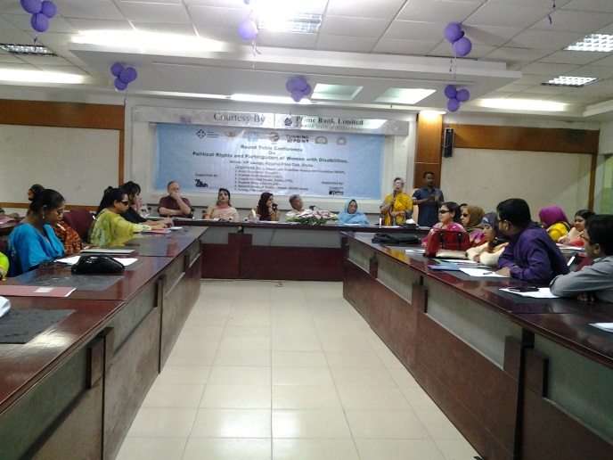In the light of realizing this situation, the seven women led organizations have organized this roundtable Conference due to advancing forward with this issue. The participants of the open discussion have clearly been stated that, without having been enjoyed political rights and participation, all types of Women with Disabilities haven’t been included in the mainstream of development and in this consequence; national development will extremely be interrupted.

M.A Mannan MP, State Minister, Ministry of Finance was attended as Chief Guest in the program. Besides, Zebunnasa Afroz, Member of Parliament, National Parliament, Quazi Rosy, Member of Parliament, National Parliament,

Prof. Momtaz Begum Advocate, (Former MP) Chairman Jatiya Mahila Sangstha and Zakia K Hassan, President Women for Women were present as Special Guest and Mr. Julian Francis, Coordinator; British Women Association was present as Honourable Guest in this roundtable Conference. The Chief Guest, M. A Mannan MP, State Minister, Ministry of Finance, supported our issue very cordially and spontaneously. He has already informed through open discussion that, Women with Disabilities are participating in Local Government election and after having won they carried out their responsibilities as Upazila Vice-Chairman and Woman member for reserve seat of Union Parisadhe successfully. Besides, Nasima Akter, President, NCDW participated in Union Parisad election but she couldn’t win only for 34 votes. So, Mr. M.A Mannan MP expressed his interest to go to Mithapukur, Union of Nasima to cooperate in her election proclamation on behalf of her. Zebunnasa Afroz MP also cordially supported our issue and expressed her commitment to discuss the issue with the Prime Minister in the upcoming Parliamentarian session. Prof. Momtaz Begum, Advocate, Zakia K Hassan and Julian Francis supported our issue very cordially as well as expressed their commitment that they will always be cooperative with us to become successful in this issue. Besides, This Roundtable Conference is moderated by Ashrafun Nahar Misti, Executive Director, and Women with Disabilities Development Foundation (WDDF). Welcome Speech is being delivered by Nasima Akter, President, National Council of Disabled Women (NCDW). Closing speech and vote of thanks is delivered by Mohua Pal, Chairperson of Roundtable Discussion and Vice Chairperson Access Bangladesh Foundation.

12. “Ananna Top Ten” Award Achievement:

An award distribution ceremony to bestow a number of courageous, determined and qualified women, on the occasion of Reward “Ananna Top Ten” Women was being organized by Ananna on 6th May at the auditorium of Krishibid Institute.

A number of enlightened and self determined women from diverse background and perspective have been selected by Ananna, for their respective enterprise along with success for award in Ten categories. These categories include Diplomat, Horse Runner, Football player, Researcher and writer, Founder Women University, Actress, Small Entrepreneur, Indigenous leader and Founder of organization for Indigenous women, Politician and Human rights activists. 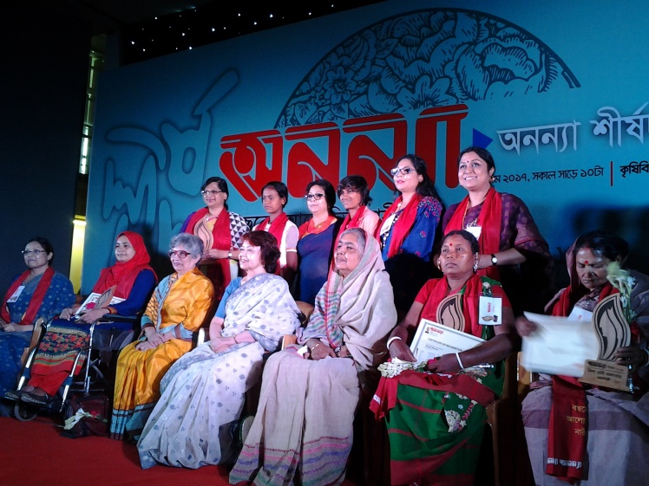

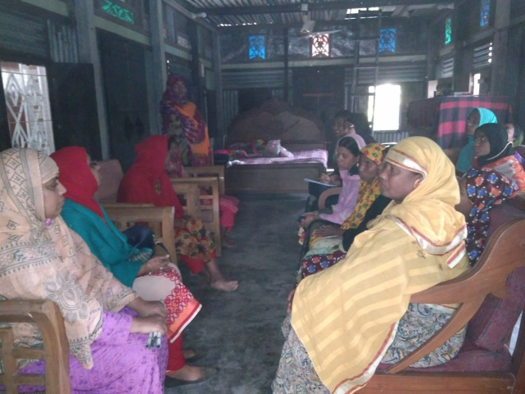As a human and Women With Disabilities (WWDs)rights activist, Ashrafunnahar, Executive Director, WDDF has achieved “Ananna Top Ten” award for her contribution to the society along with country for her strong endeavor in order to establish an inclusive society for Women with disabilities through establishing an organization of and by WWDs after having been faced multifaceted challenges in her own life. All staffs of WDDF were participated in this Award distribution ceremony.

13. Grassroot Committee meeting of Women with Disabilities:

With the initiative of WDDF, Eight Grassroot Women with Disabilities committees have been formed in Three unions of Daudkandi, Comilla,Three unions of Bogra and Three unions of Pabna as well as Eight Grassroot Women with Disabilities committee meetings were being organized in Daudkandi in this reporting year.

The aims of forming these grassroot Women with Disabilities committees in remote areas of different districts are as follows:

I) To introduce Women with Disabilities of the same union with each other as well as to establish a friendly relation among them through regular communication appearing in monthly meetings.

II) To encourage and motivate Women with Disabilities and their parents through reducing their negative attitude about disability.

III) To make Women with Disabilities self conscious about their basic rights, contribution and self dignity in family and society through enhancing their self confidence.

IV) To build leadership capacity of Women with Disabilities through enhancing awareness among them.

V) To provide information about disability related Government initiatives, documents along with facilities including NGOs as well as make them experienced on how to obtain these facilities through advocacy in different level.

VI) To adopt required initiative in order to include Women with Disabilities in local level including women related development process through their regular and active participation.

VIII) To create space in order to share multifaceted challenges in their daily lives , sufferings as Women with Disabilities including success E.G family conflict or discrimination, family/social violence, any type of torture/harassment and adopting the strategy of reducing these challenges and sufferings.

Ix) To encourage Women with Disabilities to be self dependent mentally and financially through identifying their hidden capability as well as providing need based technical and financial support E.G training, assistive devise, and financial support for small Income Generating Program. 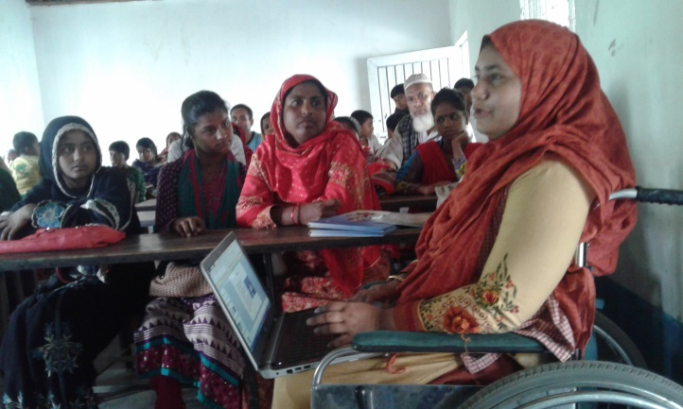

A) The first discussion meeting with the Grassroot Women with Disabilities Committee of ‘Gouripur’ and ‘Baropara’ Doudkandi, Comilla was being organized by WDDF, at Mukul Niketan of Gouripur Union on 8th May 2017.

This meeting is presided over Shirin Akhter, Chairperson. Masuma Akter, Vice Chairperson and Md. Hasanuzzaman, Program Coordinator of WDDF were present in this discussion meeting. In accordance with the decision of all the members of grassroot Women with Disabilities committee Nila Akter has been selected as president and Bethi Akter has been selected as Secretary of this committee.

The discussed issues of this meeting were:

I) Introductory session, significance of organizing and participation in this meeting.

II) President and Secretary of this committee selection.

III) Name and activities of WDDF as well as Name and activities of this grassroot committee.

IV) Entitlement of different types of Persons with Disabilities and their existing situation.

V) Consciousness and responsibilities of parents to make their Daughters with Disabilities active and self dependent through reducing discrimination against them.

VI) Clear speaking and introduce a Woman with Disability her self without any hesitation.

VII) Fixing the date of next meeting and so on.

B) The second discussion meeting with the Grassroot Women with Disabilities Committee of ‘Daudkandi Uttar’ and ‘Baropara’ Doudkandi, Comilla was being organized by WDDF, at Mukul Niketan of Gouripur Union on 9th May 2017.

This meeting is presided over Shirin Akhter, Chairperson. Masuma Akter, Vice Chairperson and Md. Hasanuzzaman, Program Coordinator of WDDF were present in this discussion meeting. In accordance with the decision of all the members of grassroot Women with Disabilities committee Asma Akter has been selected as president and Sima Akter has been selected as Secretary of this committee.

The discussed issues of this meeting were:

I) Introductory session, significance of organizing and participation in this meeting.

II) President and Secretary of this committee selection.

III) Name and activities of WDDF as well as Name and activities of this grassroot committee.

IV) Entitlement of different types of Persons with Disabilities and their existing situation.

V) Consciousness and responsibilities of parents to make their Daughters with Disabilities active and self dependent through reducing discrimination against them.

VI) Clear speaking and introduce a Woman with Disability her self without any hesitation.

VII) Fixing the date of next meeting and so on.

C) The Third discussion meeting with the Grassroot Women with Disabilities Committee of ‘Gouripur’ and ‘Baropara’ Doudkandi, Comilla was being organized by WDDF, at Mukul Niketan of Gouripur Union at 10.00 AM, on 12th June 2017.

This meeting is presided over Nila Akter, president of grassroot Women with Disabilities Committee and facilitated by Bethi Akter, Secretary of this committee with the observation and cooperation of Masuma Akter, Vice Chairperson and Md. Hasanuzzaman, Program Coordinator of WDDF.

The discussed issues of this meeting were:

I) Introductory session, significance of organizing and participation in this meeting.

II) Discussion of last meeting minutes and approved.

III) Review the name of WDDF and the name of committee.

IV) Sharing on going problems with each other and discussion about the solutions.

V) Importance of using assistive device.

VI) Consciousness and responsibilities of parents to make their Daughters with Disabilities active and self dependent through reducing discrimination against them.

VII) Clear speaking and introduce a Woman with Disability her self without any hesitation.

VIII) Fixing the date of next meeting and so on.

D) The Fourth discussion meeting with the Grassroot Women with Disabilities Committee of ‘Daudkandi Uttar’ and ‘Baropara’ Doudkandi, Comilla was being organized by WDDF, at Mukul Niketan of Gouripur Union at 3.00 PM, on 12th June 2017.

This meeting is presided over Asma Akter, president of grassroot Women with Disabilities Committee and facilitated by Sima Akter, Secretary of this committee with the observation and cooperation of Masuma Akter, Vice Chairperson and Md. Hasanuzzaman, Program Coordinator of WDDF.

The discussed issues of this meeting were:

I) Introductory session, significance of organizing and participation in this meeting.

II) Discussion of last meeting minutes and approved.

III) Review the name of WDDF and the name of committee.

IV)Sharing on going problems with each other and discussion about the solutions.

V) Importance of using assistive device.

VI) Consciousness and responsibilities of parents to make their Daughters with Disabilities active and self dependent through reducing discrimination against them.

VII) Clear speaking and introduce a Woman with Disability her self without any hesitation.

VIII) Fixing the date of next meeting and so on.

E) The Fifth discussion meeting with the Grassroot Women with Disabilities Committee of ‘Gouripur’ and ‘Baropara’ Doudkandi, Comilla was being organized by WDDF, at Mukul Niketan of Gouripur Union at 10.00 AM, on 31st July 2017.

This meeting is presided over Nila Akter, president of grassroot Women with Disabilities Committee and facilitated by Bethi Akter, Secretary of this committee with the observation and cooperation of Shirin Akhter, Chairperson, Masuma Akter, Vice Chairperson and Md. Hasanuzzaman, Program Coordinator of WDDF.

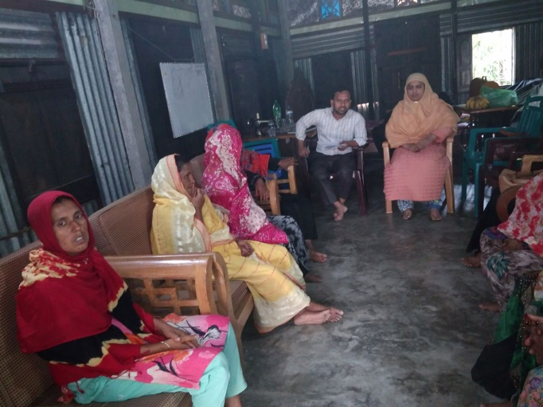The discussed issues of this meeting were:

I) Introductory session, significance of organizing and participation in this meeting.

II) Discussion of last meeting minutes and approved.

III) Review the name of WDDF and the name of committee.

IV) Sharing on going problems with each other and discussion about the solutions.

V) Discussion about types of Disabilities and their problems considering these types.

VI) Consciousness and responsibilities of parents to make their Daughters with Disabilities active and self dependent through reducing discrimination against them.

VII) Clear speaking and introduce a Woman with Disability her self without any hesitation.

VIII) Fixing the date of next meeting and so on.

F) The Sixth discussion meeting with the Grassroot Women with Disabilities Committee of ‘Daudkandi Uttar’ and ‘Baropara’ Doudkandi, Comilla was being organized by WDDF, at Mukul Niketan of Gouripur Union at 10.00 AM, on 1st August 2017.

This meeting is presided over Asma Akter, president of grassroot Women with Disabilities Committee and facilitated by Sima Akter, Secretary of this committee with the observation and cooperation of Shirin Akhter, Chairperson, Masuma Akter, Vice Chairperson and Md. Hasanuzzaman, Program Coordinator of WDDF.

G) The Seventh discussion meeting with the Grassroot Women with Disabilities Committee of ‘Daudkandi Uttar’ and ‘Baropara’ Doudkandi, Comilla was being organized by WDDF, at House of Masuma Akter, Vice Chairperson, WDDF of Kanora, Gouripur Union on 26th December 2017.

This meeting is presided over Asma Akter with the observation and cooperation of Shirin Akhter, Chairperson, Masuma Akter, Vice Chairperson and Md. Hasanuzzaman, Program Coordinator of WDDF.

The discussed issues of this meeting were:

I)Introductory session, significance of organizing and participation in this meeting.

II) To review the discussed issues of last meeting.

III) Discussion about day observation.

IV) Discussion about International Day of Persons with Disabilities.

V) Discussion about theme of International Day of Persons with Disabilities.

VI) Understanding about basic rights of human bing and Persons with Disabilities.

1. Discussion about rights of Persons with Disabilities in light of “Persons with Disabilities rights and Protection Act 2013”.

VIII) Fixing the date of next meeting and so on.

H) The Second discussion meeting with the Grassroot Women with Disabilities Committee of ‘Gouripur’ and ‘Baropara’ Doudkandi, Comilla was being organized by WDDF, at House of Masuma Akter, Vice Chairperson, WDDF of Kanora, Gouripur Union on 27th December 2017.

This meeting is presided over Nila Akter, president of grassroot Women with Disabilities Committee and facilitated by Bethi Akter, Secretary of this committee with the observation and cooperation of Shirin Akhter, Chairperson, Masuma Akter, Vice Chairperson and Md. Hasanuzzaman, Program Coordinator of WDDF.

The discussed issues of this meeting were:

I)Introductory session, significance of organizing and participation in this meeting.

II) To review the discussed issues of last meeting.

III) Discussion about day observation.

IV) Discussion about International Day of Persons with Disabilities.

V) Discussion about theme of International Day of Persons with Disabilities.

VI) Understanding about basic rights of human bing and Persons with Disabilities.

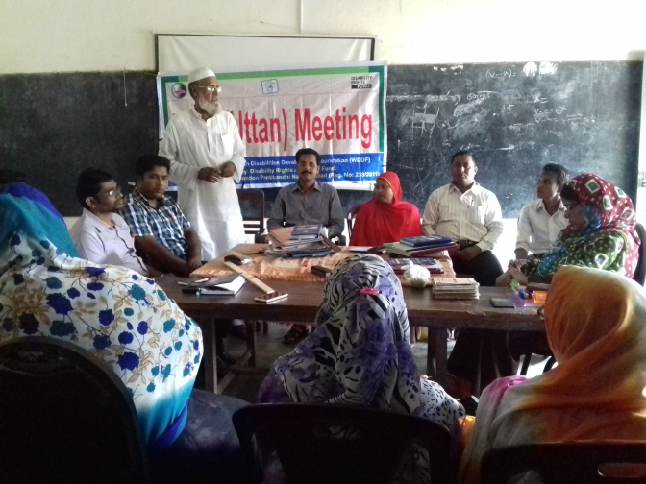VII)Discussion about rights of Persons with Disabilities in light of “Persons with Disabilities rights and Protection Act 2013”.

1. Fixing the date of next meeting and so on.

(Besides, with the initiative of WDDF, 72 Grassroot Women with Disabilities committee meetings were being organized in three unions of Bogra Sadar Upazila and 72 Grassroot Women with Disabilities committee meetings were being organized in Three unions of Pabna Sadar Upazila in this reporting year).

14. A) Yard Meeting (Namuza, Bogra):

A yard meeting with the school teachers in order to create accessibility of Students with Disabilities in educational institutions of Bogra including this school was being organized by WDDF with the local cooperation of Bogra Zila Spandon Protibandhi Nari Parisad, on 24th May 2017, in Bamunpara High School, Namuza Union.

The meeting was moderated by Md. Hasanuzzaman, Program Coordinator, WDDF. and welcome speech was being delivered by S.M Saifur Rahman, Project Manager, WDDF and Executive Director, Protik Mohila O Sheshu Sangstha (PMSS). Keynote paper is being presented by Ashrafun Nahar, Executive Director, WDDF. In this keynote paper she mentioned about the difficulties of Students with Disabilities have to face in this school and how they’re incorporated in education with the cooperation of teachers and non disabled students of this school through reducing these difficulties. Besides, Shirin Akhter, Chairperson, WDDF mentioned in her speech that, disability shouldn’t be barrier for education for the Students with Disabilities and with sincerity, sensitivity and proper cooperation of school authority including teachers and non disabled students , all types of Students with Disabilities should be incorporated in education. In this consequence, Students with Disabilities will be benefited, the purpose of this school will be fulfilled; the name and fame of this school will be spread far away and ultimately society and nation will be enriched.

The program is presided over Rebeka Akter, President, Bogra Zila Spandon Protibandhi Nari Parisad.

B) Yard meeting in Dhaka:

A yard meeting on ‘Disability and development’ was being organized by Women with Disabilities Development Foundation (WDDF), in the Conference room of Duksu, on 23rd December 2017.

Infact, it was an orientation meeting for the Students with Disabilities and Non Disabled Students of different educational institutions E.G. University, colleges BUET and so on. The purpose of this meeting is:

I) To enrich the students about different types of Persons with Disabilities , their needs and reasonable accommodation for effective participation and inclusion.

II) to enrich the students through disseminating disability related legislations, policies and Convention among them in order to involve them in advocacy of designing inclusive institutions.

Welcome speech is being delivered by Shirin Akhter, Chairperson, WDDF.

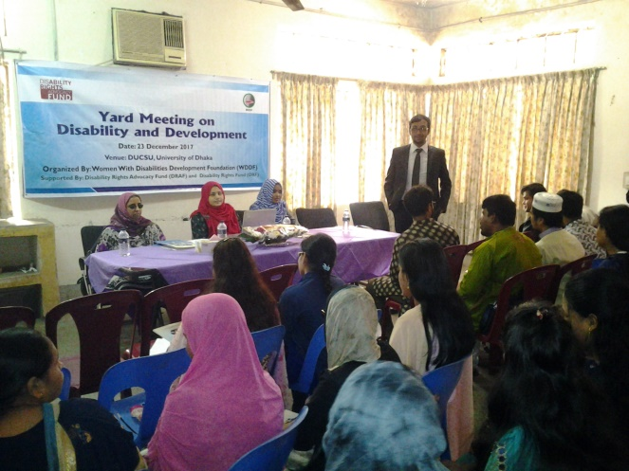Disability related legislations , policies and convention are being briefly discussed by Ashrafun Nahar, Executive Director , WDDF. She illustrated that, how Disability related legislations , policies and convention relate the rights of Students with Disabilities and how Non Disabled Students may contribute for the proper actualization of these national and international instruments. In her discussion, in order to enlighten clear conception about disability, Persons with Disabilities , accessibility and reasonable accommodation she discussed Two analytical questions.

1. How a (Disabled without Wheel Chair User/Non Disabled )person will speak with a Wheel Chair User?
2. How a Non Disabled person will pass a day with a Visual Impaired Person?

Discussion and solution of these questions were very practical and realistic examples of realizing the challenges of different types of Persons with Disabilities.

The session of Ashrafun Nahar has also included ‘Persons with disabilities rights and protection Act 2013’, ‘UN Convention on rights of Persons with Disabilities’, ‘Sustainable Development Goals (SDGs)’, different declarations and policies.

In the next session, Shirin Akhter, Chairperson, WDDF has discussed about ‘Disability and development’.

Her topic has included:

1. The linkage between disability and development,
2. II) The linkage between disability and inclusiveness

III) Difference between equality, equity and non discrimination,

IV) Challenges of Women with Disabilities for being gender and disability and

V) difference between disability and barrier.

She discussed Four analytical questions in her discussion.

1. How to design an accessible transport for all including Persons with Disabilities?
2. II) How to design an accessible book for all including Persons with Disabilities?

III) How to design an inclusive building for all including Persons with Disabilities?

IV) How to design an accessible IT instrument for all including Persons with Disabilities?

Dr. Mr. Istiak Ahmed, Professor, Wels University USA was present as discussant.

Vote of thanks is being delivered by Suraiya Akter Bably, Treasurer, Women with Disabilities Development Foundation (WDDF).

(Besides, with the initiative of WDDF, 11 Yeard meetings were being organized in Three unions of Bogra Sadar Upazila and 12 Yard meetings were being organized in Three unions of Pabna Sadar Upazila in this reporting year).

15. Discussion meetings with representatives of Local Government:

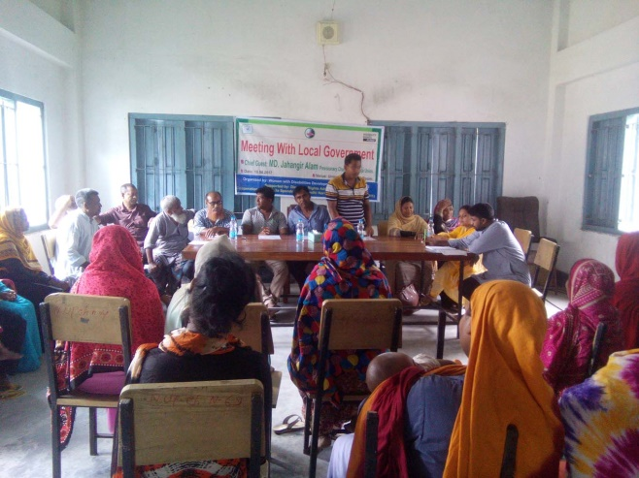A Discussion meeting was being organized with the representatives of WDDF along with Bogra Zila Spandon Protibandhi Nari Parisad as well as the representatives of Bogra Local Government at 11.00 AM, on 23rd May 2017 in the auditorium of Children Voice School. Shirin Akhter, Chairperson, WDDF, S.M Saifur Rahman, Project Manager, WDDF and Executive Director, Protik Mohila O Sheshu Sangstha (PMSS) are discussed about existing barriers and challenges in accessibility of Persons with Disabilities specially, Women with Disabilities in Road, footpath, public transport, public buildings, education, working institutions, health facilities including government services and violence against Women with Disabilities, security and justice related institutions and their potentialities, in this meeting. Simultaneously, it has also been clearly pointed out through the discussion meeting that, how the national development has been interrupted due to the inaccessibility of Persons with Disabilities in all aspects of the society.

Executive and general council members of Bogra Zila Spandon Protibandhi Nari Parisad, representatives of disability related organizations, Chairman, Zila Parisad, Officer Youth Department were participated in this discussion meeting.

The program is being presided over Rebeka Akter, General Secretary, Bogra Zila Spandon Protibandhi Nari Parisad.

(Besides, with the initiative of WDDF, 3 discussion meetings were being organized in Three unions of Bogra Sadar Upazila and 4 discussion meetings with representatives of Local Government were being organized in Three unions of Pabna Sadar Upazila in this reporting year).

**16. National Sharing of a study report on Women with Disabilities and discussion about the barriers to get justice for them:**

A National Sharing of a study report on The overall situation of Women with Disabilities of Dhaka city and **discussion about the barriers to get justice for them”** is being organized with the initiative of Women with Disabilities Development Foundation (WDDF), at A F Mahmud Seminar hall**, the Daily Star Bhaban,** on Sunday, 21st May 2017, from 10 AM to 2 PM. in order to create Women with Disabilities inclusive institutions and justice and how their human rights are being violated due to inaccessible institutions and long procedures in justice system. So, we urge for an inclusive, anti discriminatory and Women with Disabilities friendly society for all. WDDF run and led by Women with Disabilities has been working as collective force with the Government, policy makers, representatives of civil society and media for the inclusion of Women with Disabilities in mainstream development process through reducing their challenges and discrimination in the issue of infrastructural and informational accessibility in all aspects including justice system. The study report is being presented by Dr. Harun or Rashid, Chairman, Centre for Social Programs and Research (CSPR). The study report shows that women with disabilities have very limited access to education, (79%) respondents of this 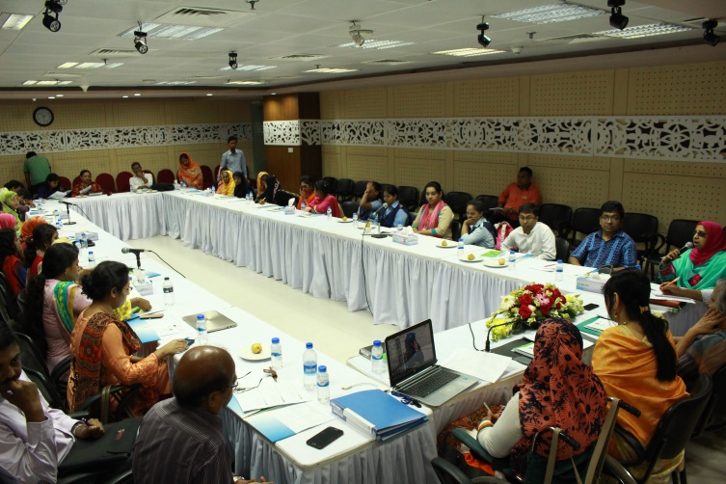study report have no access and (31%) are facing challenges to have enrolled. (47%) Women with Disabilities are mostly tried to obtain health services from Government health services due to low cost but service providers have no any training to handle them though in some cases, they are positive. The The rate of unemployment among Women with Disabilities indicates high (78%) and those who are engaged in employment, most of them get less payment compared to their Colleagues without Disabilities. Marital status of Women with disabilities is very low (25%) and only (18%) Women with Disabilities are obtained inherit property. Two thirds (67%) are deprived from family rights and become victim of negative attitude from family members and society, the rest of Women with Disabilities have to face physical abuse and mental violence. Any transportation is not disabled friendly and non cooperative to provide the transport service to women with disabilities. due to the situation most of the Women with disabilities haven’t opportunity to use public transport. The National sharing was being moderated and keynote paper was being presented by AshrafunNahar, Executive Director, Women with Disabilities Development Foundation (WDDF). In this paper she mentioned about the constitutional and legal rights of Girls and Women with disabilities. Most of the litigations, at the time of witness adopting procedures in Court, sign language interpreter aren’t being used for the victim girls or women with Speech and Hearing or intellectual impairments. Police officers and medical officers aren’t cooperative to file the litigations of victim girls or women with Disabilities and legal institutions aren’t disabled friendly.Most of Women with Disabilities (WWDs) are suffering from inaccessible justice system and deprived from their equal citizen rights. In spite of having been arrived in the 21st Century, there are no accessibilityin Judge courts, District courts, even in Supreme Court for Persons with Disabilities. Most of the laws are formulated and enacted without the inclusion and participation of Persons with Disabilities.So, the scenario of the sufferings of Women with disabilities in the ongoing legal support and services is extremely vulnerable in the existing situation. Though UNCRPD Article-13 ’Access to justice’ noted that, States Parties shall ensure effective access to justice for persons with disabilities on an equal basis with others, including through the provision of procedural and age-appropriate accommodations, in order to facilitate their effective role as direct and indirect participants, including as witnesses, in all legal proceedings, including at investigative and other preliminary stages. The panel discussants of this program shared their challenging experiences and complexity to get justice of Women with Disabilities. They also stated that, though ‘Persons With Disabilities Rights and protection Act 2013 and UNCRPD mentioned the issue of getting justice for Persons with Disabilities with very significance, With the strong advocacy and voice raising of Women with disabilities Rights activists, only Three legal aid support providing organizations BLAST, BRAC and BNWLA have come forward with their extensive hand to provide legal services for Women with Disabilities. Without having been enjoyed basic human rights including accessibility right in justice system along with participation, SDGs won’t be achieved properly.In the light of realizing this situation, WDDF has organized this program due to advancing forward with this issue.

The participants of the open discussion have clearly been stated that, Without having been enjoyed basic rights including accessibility right in justice system along with equal participation, all types of Women With Disabilities haven’t been included in the mainstream of development and in this consequence, national development will extremely be interrupted.

Zebunnasa Afroz, Member of Parliament, House of Nation was present as Chief Guest in the program. Besides, Khushi Kabir, Executive Director, Nijera Kori, Dr. Sanzida Akhter, Assistant Professor, Women and Gender Studies Department, Dhaka University, Ranjan Karmaker, Executive Director, Steps Towards Development (STD) were present as special guests as well as a number of lawyers of Judge Court and Supreme Court were present as Panelists in the abovementioned program. The program is

Presided over Shirin Akhter, Chairperson, Women with Disabilities Development Foundation (WDDF).

**17. T.V and Radio Talk show:**

WDDF organized Three Talk show about “Universal Accessibility and Access to justice of Persons with Disabilities” in this reporting year.

**A) The First talk show** entitled “Power Talkshow” about “Universal Accessibility of Persons With Disabilities” was beingorganized by WDDF in collaboration with ATN Bangla,is being recorded at 7.30 PM, on 9th May 2017, and broadcasted at 12 AM, on 10th May 2017. The allocated time for the program is One hour and the speakers of this talk show were Ms. Shirin Akhter, Chairperson, Women with Disabilities Development Foundation (WDDF), Sajeda Rahman Danny, President, Parents Forum of Autistic Children and Mohammad Zillar Rahman, Secretary, Social Welfare Ministry. In the speech of the conversessionalists, the Defination of Persons with Disabilities, their potentialities, existing barriers and challenges in accessibility of Persons with Disabilities specially, Women with Disabilities in Road, footpath, public transport, public buildings, education, health facilities including government services and violence against Women with Disabilities are enlightened to the audience. Simultaneously, it has also been clearly pointed out through the discussion of the conversessionalists that, how the national development has been interrupted due to the inaccessibility of Persons with Disabilities in all aspects of the society.

The speakers are also discussed the complexity Women with Disabilities always have to face, the cause and their uninterrupted sufferings due to such existing inaccessible environment for them. Simultaneously, it is demonstrated that, the initiatives have been adopted by WDDF in order to include Women with Disabilities in mainstream development through reducing this complexity of inaccessibility as well as it also has mentioned about the importance of allocation and proper utilization of national budget on behalf of Government for reducing the barriers in the areas of basic needs and rights. Besides, Speakers are also discussed about national and international legislations, documents and declarations in order to ensure the Universal Accessibility for Persons with Disabilities and how the Women with severe Disabilities have been deprived from national development process due to existing inaccessible environment.

Mentioning about the Government initiatives speakers said that, despite of having number of Government declarations and orders for creating Universal Accessibility but no one of those has been implemented properly. Most of the public buildings, roadss, footpaths overbridges education institutions, health centres and working institutions, shopping centres are being designed and constructed as well as all types of transports are being exported without considering the needs and demands of Persons with Disabilities.

Simultaneously, mentioning that, WDDF is enthusiastic to provide technical suggestion and cooperation in this ground. Concurring all the challenges and barriers, Mohammad Zillar Rahman, Secretary, Social Welfare Ministry mentioned that, government is very positive and sincere towards Persons with Disabilities and in the consequence of government’s sincerity, Two legislations have already been passed by the House of Nation in order to protect the rights of Persons with Disabilities. On behalf of Social Welfare Ministry, they’ve taken a number of programs and initiatives to reduce these challenges of Persons with Disabilities but it isn’t possible in one day, it will take time. Finally, It is also urged in this talk show to the policy makers, Government along with the related and responsible authorities of creating Universal Accessibilities to adopt time required and proper initiatives to reduce this dilemma considering the types along with the requirements of Persons with Disabilities. Otherwise, due to unproductivity, ineffectiveness, backwardness and social exclusion of almost 24 million Persons with Disabilities, the dream of poverty free Bangladesh will ultimately be interrupted.

**The Second** Talkshow entitled “Power Talkshow”, on “Access to Justice of Persons with Disabilities” was being organized by WDDF in collaboration with ATN Bangla, is being recorded at 7.30 PM, on 16th October 2017, and broadcasted at 12 AM, on 17th October 2017. The allocated time for the program is One hour and the speakers of this talk show were Ms. Shirin Akhter, Chairperson, Women with Disabilities Development Foundation (WDDF), MS. Sultana Kamal, Chairperson, We Can, Former Adviser, Caretaker Government and Kazi Reazul Hoque, Chairman, National Human Rights Commission Bangladesh (NHRCB). In the speech of the conversessionalists, existing barriers and challenges of Persons with Disabilities specially, Women with Disabilities in access to justice, violence against Women with Disabilities, way forward and role of stakeholders are enlightened to the audience. Simultaneously, it has also been clearly pointed out through the discussion of the conversessionalists that, how the human rights of Persons with Disabilities are being violated due to the inaccessibility of Persons with Disabilities in all aspects of justice system.

The speakers are also discussed the complexity Women with Disabilities always have to face, the cause and their uninterrupted sufferings due to such existing inaccessible environment for them. Simultaneously, it is demonstrated that, the initiatives have been adopted by WDDF in order to include Women with Disabilities in mainstream development through reducing this complexity of inaccessibility in different institutions as well as it also has mentioned about the importance of allocation and proper utilization of national budget on behalf of Government for reducing the barriers in the areas of promoting and preserving human rights. Besides, Speakers are also discussed about national and international legislations, documents and declarations in order to ensure the Universal Accessibility for Persons with Disabilities and how the Women with severe Disabilities have been deprived from national development process due to existing inaccessible environment.

Mentioning about the Government initiatives speakers said that, despite of having number of Government declarations and orders for creating Universal Accessibility but no one of those has been implemented properly. Pointed out the reference of a case study of victim Girl with Intelectual Disability, Shirin Akhter stated that, inspite of having Two legislations for promotion and protection of rights of Persons with Disabilities; a 13 years Girl with Intelectual Disability, named Takiya Khatun, Vill: Charkushla, 3 Chaklada union, Tha: Terokhada, Dist: Khulna was raped by a Seventy years man in January 2016 and gave birth to a boy baby. On behalf of the offender Union Parisad Chairman proposed the victim girl’s family to resolve the incident of this rape through sum compensation but Takiya’s family hasn’t agree with this proposal and with the support of WDDF, file a case. In order to taking revenge of this incident, on 26th March 2017, Din Islam, Chairman, 3 Chaklada union, Terokhada, Khulna ordered his flatterers to strike Takiya’s mother with sharp instrument on her head and even after having she fell down on the ground they’re beatting her with heavy sticks cruelly until she became senseless. It was very heartrending scenery, while a group of men with the order of a union parisad Chairman were beating a helpless woman lie down on the ground but nobody has anything to do. After having stopped their beating, it was seen that, Takiya’s mother lied down on the ground losing sense, became injured seriously and nonstop bleeding from her head. Her relatives admitted her in hospital and thirteen stitches had to put on her head. At the time of WDDF representatives visit, she was seriously ill, even she couldn’t walk and her whole body grasped with the spot of injury. We were counseling her, suggested her to be patient and assured her that, we are always with you; we’ve already informed about this shocking incident to the relevant authorities of Dhaka and now we’ll report to the local government, media and law inforcement agency of Khulna to handle this issue rightly, seriously as well as to protect your family from this type of in humanitarian torture.

However, in the consequence of strong advocacy of WDDF and with the cooperation of National Human rights Commission Bangladesh (NHRCB), law inforcement agency and Local Government we rescued the family to some extent and protected from continuous threats and torture.

DNA test report is positive and now we’re waiting for judgment.

Simultaneously, She also mentioned that, ‘United Nations Convention on Rights of Persons with Disabilities (UNCRPD)’, ‘Persons with Disabilities Rights and Protection Act 2013’ and ‘Sustainable Development Goals (SDGS)’ ensured the duties of state parties to get justice for Persons with Disabilities and WDDF is enthusiastic to provide technical suggestion and cooperation in this ground. Concurring all the challenges and barriers, Kazi Reazul Hoque, Chairman, National Human Rights Commission Bangladesh (NHRCB) mentioned that, government is very positive and sincere towards Persons with Disabilities and in the consequence of government’s sincerity, Two legislations have already been passed by the House of Nation in order to protect the rights of Persons with Disabilities. We’ve already submitted National Action Plan of ‘Persons with Disabilities Rights and Protection Act 2013’ to the Social Welfare Ministry, Possibly it will be approved soon. Besides, on behalf of Social Welfare Ministry, they’ve taken a number of programs and initiatives to reduce these challenges of Persons with Disabilities. Finally, It is also urged in this talk show to the policy makers, Government along with the related and responsible authorities of creating Universal Accessibilities to adopt time required and proper initiatives to reduce this dilemma considering the types along with the requirements of Persons with Disabilities. Otherwise, due to unproductivity, ineffectiveness, backwardness and social exclusion of almost 24 million Persons with Disabilities, the dream of poverty free Bangladesh will ultimately be interrupted.

C) The Third Talk show was a Radio Talkshow on “eliminate Women Torture” is being organized at 4.00 PM, on 3rd December 2017, on ‘Radio FM Colour’. The speakers of this talkshow were Ashrafun Nahar, Executive Director, Women with Disabilities Development Foundation (WDDF), Barister Nawmi Naj Chowdhury and Fariya Ahamed, representative, BLAST and Rokeya Begum, representative, Voice and Views.

The discussing issue of this Talk show is violence against Women with Disabilities. In the speech of the conversessionalists, existing barriers and challenges of Women with Disabilities in access to justice, violence against Women with Disabilities, way forward and role of stakeholders are enlightened to the audience. Simultaneously, it has also been clearly pointed out through the discussion of the conversessionalists that, how the human rights of Persons with Disabilities are being violated due to the inaccessibility of Women with Disabilities in all aspects of justice system.

The speakers are also discussed the complexity Women with Disabilities always have to face, the cause and their uninterrupted sufferings due to such existing inaccessible environment for them. Simultaneously, it is demonstrated that, the initiatives have been adopted by WDDF in order to include Women with Disabilities in mainstream development through reducing this complexity of inaccessibility in different institutions as well as it also has mentioned about the importance of allocation and proper utilization of national budget on behalf of Government for reducing the barriers in the areas of promoting and preserving human rights. Besides, Speakers are also discussed about national and international legislations, documents and declarations in order to ensure the Universal Accessibility for Persons with Disabilities and how the Women with severe Disabilities have been deprived from national development process due to existing inaccessible environment. Mentioning about the Government initiatives speakers said that, despite of having number of Government declarations and orders for creating Universal Accessibility but no one of those has been implemented properly. Pointed out the reference of a case study of victim Girl with Multiple Disability, Ashrafun Nahar stated that, inspite of having Two legislations for promotion and protection of rights of Persons with Disabilities; a 23 years Girl with Multiple Disability, named Mohsina Khatun of Nilfamari, was raped by a Forty five years man in 2005 and gave birth to a girl baby. On behalf of the offender village leaders paid only Seven Thousand Taka as compensation to victim woman through shalish and her family isolated her through grasping the money from her. After that, with the support of WDDF, this rape case has filed. It was a very heartrending scenery, while a 23 years pregnant Woman with Multiple Disability without shelter, food and any type of support was crying alone. At that time, WDDF representatives visited and noticed that, she was seriously ill, even she couldn’t walk. We (WDDF representatives) were counseling her, suggested her to be patient and assured her that, we are always with you; we’ll adopt required initiative to inform this incident to the relevant authorities of Dhaka and now we’ll report to the local government, media and law inforcement agency of Nilfamari to handle this issue rightly and seriously.

However, in the consequence of strong advocacy of WDDF and with the cooperation of law inforcement agency and Local Government we would be able to file the litigation and ensured her accommodation in Rajshahi shelter home.

Subsequently, offender and his family decided to marry Mohsina Khatun in order to suspend the litigation temporarily and Mohsina got marry with the offender with the instruction of court through a number of conditions; he has also provided a plot of land to Mohsina for her security and she gave birth to a girl baby. But due to negligence, mental and physical torture, her one year baby has died and Mohsina couldn’t live in her home even her husband hasn’t provide any maintainance cost or hasn’t take any responsibility.

Ashrafun Nahar also mentioned that, 96% Women with Disabilities become victim of physical, mental torture and sexual harassment as well as less than 1% female children with Disabilities get opportunity of going to school. Effective initiatives have yet not been adopted for their skill development and creating employment. Though the issue of stopping social discrimination and torture to the Persons with Disabilities in law and policy has been mentioned but specific initiative hasn’t been adopted to actualize these law and policy. Most of Women with Disabilities (WWDs) are suffering from inaccessible justice system and deprived from their equal citizen rights. In spite of having been arrived in the 21st Century, there are no accessibilityin Judge courts, District courts, even in Supreme Court for Persons with Disabilities. Most of the laws are formulated and enacted without the inclusion and participation of Persons with Disabilities. So, the scenario of the sufferings of Women with disabilities in the ongoing legal support and services is extremely vulnerable in the existing situation.

So, the speakers urged that, relevant authorities of Government, legal and human rights activists, NGOs and DPOs should have to adopt required initiatives to protect Women with Disabilities from all types of violence. Otherwise, the dream of inclusive society will ultimately be interrupted due to unproductivity, ineffectiveness, backwardness and social exclusion of almost 12 million Women with Disabilities.

**18.** Training of Women with Disabilities on different Legislations, treaty and policy documents:

WDDF organized Three Trainings of Women with Disabilities on ‘United Nations Convention on Rights of Persons with Disabilities (UNCRPD)’ and ‘Sustainable Development Goals (SDGs)’ in Bogra, Pabna and Dhaka in this reporting year. 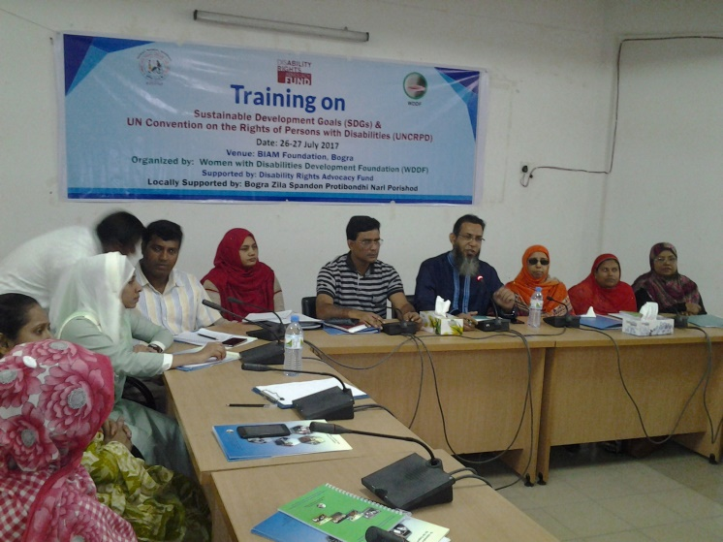

The First day long training with the participation of 24 different types of Women with Disabilities, on ‘United Nations Convention on Rights of Persons with Disabilities (UNCRPD)’ (Article 13, 15, 16) and ‘Sustainable Development Goals (SDGs)’ (Goal 16) in order to create easy access to justice was being organized with the initiative of Women with Disabilities Development Foundation (WDDF), **Locally Supported by Bogra Zila Spandon Protibandhi Nari Parisad,** at Surjomukhi hall, Biam Foundation Bogra**,** on Wednesday, 26th July 2017.

This training was divided in to two parts:

A. Inaugural session and B. Core session.

There was One fascilitator and One Co-facilitator to conduct the training theoretically and practically for the Women with Disabilities properly. The representatives from local government were present as Chief Guest and Special Guests in this training.

The inaugural session of this training is being started at 10.00 AM, 26th July 2017, with the welcome remarks of Shirin Akhter, Chairperson, WDDF. After welcome speech, an introductory session of all the participants is being conducted by Ashrafun Nahar and all the participants are introduced with each other in this session. After having introductory session been finished, Ashrafun Nahar, Executive Director of WDDF is being requested to deliver her speech on Significance, purpose including the required information and expected learnings/aims of this training. Then, S. M. Saifur Rahman, Executive Director, Protik Mohila O Sheshu Sangstha (PMSS) is being requested to deliver his speech about the gaps and challenges of Persons specially Women with Disabilities in the issue of access to justice. Followed by the speech of facilitator, Taslima Akter, Program Officer, Women Affairs Department, Bogra and Md. Sahidul Islam Khan, Deputy Director, Social Service Department, Bogra are being requested to deliver their speeches as special Guests about the initiatives have been adopted for Persons with Disabilities as well as their responsibilities and duties to them on behalf of Government to make our activities easy and helpful. After that, Md. Ali Azgar Talukdar Hena, Chairman, Upazila Parisad, Chief Local Government representative in Sub district level is being requested to deliver his speech as Chief Guest. He is very sincere, responsible and also very glad to be invited in this program. He said that, he is agreed with the existing barriers of Persons specially Women with Disabilities in Bogra but with the cooperation of government they are trying to reduce these challenges step by step. He expressed his farm commitment to provide all types of financial and technical cooperation to improve the situation of Women with Disabilities through this organization and he declared Fifty thousand Taka as donation instantly but commited to provide more donations in future.

This inauguration program is being presided over Rebeka Akter, President of Bogra Zila Spandon Protibandhi Nari Parisad.

Core session of the training:

It is noted that, since most of the Women with Disabilities are from very grassroot level and they’re participating in this type of training for the first time; So, the core session is being divided in to Three sessions:

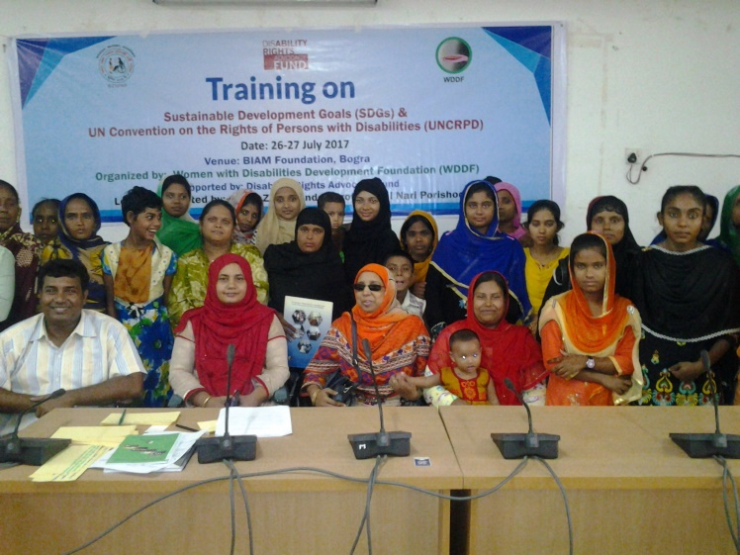A. Initial discussion, B. 1st session and C. 2nd session.

A. Initial discussion: In initial discussion, purpose and importance of this training for Women with Disabilities are being discussed by Ashrafun Nahar, Executive Director, WDDF and Facilitator of this training.

Followed by this discussion, S. M. Saifur Rahman,Executive Director, Protik Mohila O Sheshu Sangstha (PMSS) and Co-facilitator of this training discussed a number of instructions for the training participants and request them to follow these instructions strictly at training period in order to make this training effective. After that, participants are requested to express their expectation from this training, one expectation per participant to analyse their understanding level

1st session:

This session is being facilitated byAshrafun Nahar, Executive Director of WDDF and Facilitator of this training.

The topic of this session is “United Nations Convention on Rights of Persons with Disabilities (UNCRPD)”

(Article 13) “Access to justice”, (Article 15 **“‘Freedom from torture or cruel, inhuman or degrading treatment or punishment”** and (Article 16)”**Freedom from exploitation, violence and abuse”.**

This topic includes:

I) what is UN CRPD?

II) What is Access? And what is justice?

III) Key speeches of these articles.

IV) Why are these articles important to know for us?

V) What is the connection between article 13, 15, 16 and obtaining justice?

2ndsession:

This session is being facilitated byS. M. Saifur Rahman, Executive Director, Protik Mohila O Sheshu Sangstha (PMSS) and Co-facilitator of this training.

The topic of this session is “Sustainable Development Goals (SDGs)”

(Goal 16 “Promote peaceful and inclusive societies for sustainable development, provide access to justice for all and build effective, accountable and inclusive institutions at all levels”)

This topic includes:

I) What is SDGs?

II) What is Inclusive? And what is Institution?

III) Key speech of this Goal.

IV) Why is this goal important to know for us?

V) What is the connection between goal 16 and obtaining justice?

The facilitators suggested to the participants that, everybody should have proper conception and knowledge about these treaty and document concurrently they should have try to use the specific reference of these treaty and document for utilizing in required area. In case of any requirement, WDDF will always take proper initiative to cooperate to the Women with Disabilities through legal aid service providing organizations. Otherwise, it will be very difficult for them to enjoy their rights through the implementation of these treaty and documents properly.

From the responses of all the participants, it would be noted that, this is an effective and time required training for them. Most of the participants haven’t any idea about these treaty and document and they aren’t aware about the basic rights for Persons with Disabilities are mentioned in these treaty and document. The participants are also pointed out that, Persons especially Women with Disabilities of remote areas are deprived from Government services and facilities and due to lack of accurate information they are always left behind. So, considering the susceptibility of Persons especially Women with Disabilities, this type of training should be organized in divisional and district level regularly.

B) The Second day long training with the participation of 25 different types of Women with Disabilities including their parents almost total 40, on “United Nations Convention on Rights of Persons with Disabilities (UNCRPD)” (Article 13, 15, 16) and “Sustainable Development Goals (SDGs)” (Goal 16) in order to create easy access to justice was being organized with the initiative of Women with Disabilities Development Foundation (WDDF), Locally Supported by Protik Mohila O Sheshu Sangstha (PMSS) Pabna,at Conference hall, PCCS Bazar,Police Line,Pabna,on Tuesday, 26th September 2017.

This training was divided in to two parts:

A. Inaugural session and B. Core session.

There was One fascilitator and One Co-facilitator to conduct the training theoretically and practically for the Women with Disabilities properly. The representatives from local government and corporate sector were present as Chief Guest and Special Guests in this training.

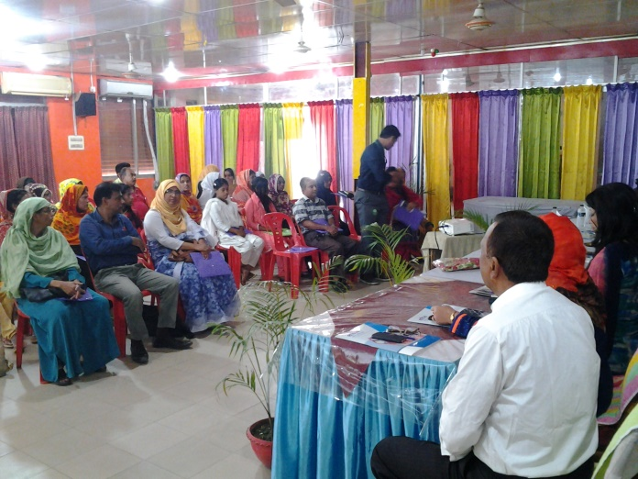The inaugural session of this training is being started at 10.00 AM, 26th September 2017, with the welcome remarks of Mamataj Parvin, Vice Chairperson, PMSS. After welcome speech, an introductory session of all the participants is being conducted by Ashrafun Nahar and all the participants are introduced with each other in this session. After having introductory session been finished, S. M. Saifur Rahman, Executive Director, Protik Mohila O Sheshu Sangstha (PMSS) is being requested to deliver his speech about the significance, purpose including the required information, expected learnings/aims of this training, gaps and challenges of Persons specially Women with Disabilities in the issue of access to justice. Followed by the speech of facilitator, Tafajjal Hossain Tultul, Managing Director, Path Finder Computer Centre, Md. Moen Uddin, Manager, Prime Bank Pabna Branch, Md. Rafikul Islam Umar, Chairman, Bus owners Association along with SWID Bangladesh Pabna,

Md. Harun AR Rashid, Officer, Department of Social Service Pabna and Sawal Biswas,Vice Chairman Pabna Sadar Upazila Parisad are being requested to deliver their speeches as special Guests about the initiatives have been adopted for Persons with Disabilities as well as their responsibilities and duties to them on behalf of Government to make our activities easy and helpful. After that, Md. Mahabubul Alam Mukul, Senior Vice Chairman, Pabna Chamber of Comerce and Industries, is being requested to deliver his speech as Chief Guest. He is very sincere, responsible and also very glad to be invited in this program. He said that, he is agreed with the existing barriers of Persons specially Women with Disabilities in Pabna but they are thinking to reduce these challenges step by step. He expressed his farm commitment to include a number of Persons with Disabilities with small and medium industry but the list of interested candidates with disabilities should be provided by this organization. Besides, Tafajjal Hossain Tultul, Managing Director, Path Finder Computer Centre, expressed his commitment to provide computer training for Persons with Disabilities free of cost and Seven hundred taka will be paid as training allowance; simultaneously, he will try to manage job for these trainees but Persons without Disabilities have to pay Five thousand (5000) taka per month for receiving the same training.

This inauguration program is being presided over Shirin Akhter, Chairperson, Women with Disabilities Development Foundation (WDDF).

Core session of the training:

It is noted that, since most of the Women with Disabilities are from very grassroot level and they’re participating in this type of training for the first time; So, the core session is being divided in to Three sessions:

A. Initial discussion, B. 1st session and C. 2nd session.

A. Initial discussion: In initial discussion, purpose and importance of this training for Women with Disabilities are being discussed by Ashrafun Nahar, Executive Director, WDDF and Facilitator of this training.

Followed by this discussion, S. M. Saifur Rahman, Executive Director, Protik Mohila O Sheshu Sangstha (PMSS) and Co-facilitator of this training discussed a number of instructions for the training participants and request them to follow these instructions strictly at training period in order to make this training effective. After that, participants are requested to express their expectation from this training, one expectation per participant to analyse their understanding level.

1st session:

This session is being facilitated byAshrafun Nahar, Executive Director of WDDF and Facilitator of this training.

The topic of this session is “United Nations Convention on Rights of Persons with Disabilities (UNCRPD)”

(Article 13) “Access to justice”, (Article 15 **“Freedom from torture or cruel, inhuman or degrading treatment or punishment”** and (Article 16)”**Freedom from exploitation, violence and abuse”.**

This topic includes:

I) what is UN CRPD?

II) What is Access? And what is justice?

III) Key speeches of these articles.

IV) Why are these articles important to know for us?

V) What is the connection between article 13, 15, 16 and obtaining justice?

2ndsession: This session is being facilitated byS. M. Saifur Rahman, Executive Director, Protik Mohila O Sheshu Sangstha (PMSS) and Co-facilitator of this training.

The topic of this session is “Sustainable Development Goals (SDGs)”

(Goal 16 “Promote peaceful and inclusive societies for sustainable development, provide access to justice for all and build effective, accountable and inclusive institutions at all levels”)

This topic includes:

I) what is Sustainable Development Goals (SDGs)?

II) What is Inclusive? And what is Institution?

III) Key speech of this Goal.

IV) Why is this goal important to know for us?

V) What is the connection between goal 16 and obtaining justice?

The facilitators suggested to the participants that, everybody should have proper conception and knowledge about these treaty and document concurrently they should have try to use the specific reference of these treaty and document for utilizing in required area. In case of any requirement, WDDF will always take proper initiative to cooperate to the Women with Disabilities through legal aid service providing organizations. Otherwise, it will be very difficult for them to enjoy their rights through the implementation of these treaty and documents properly.

From the responses of all the participants, it would be noted that, this is an effective and time required training for them. Most of the participants haven’t any idea about these treaty and document and they aren’t aware about the basic rights for Persons with Disabilities are mentioned in these treaty and document. The participants are also pointed out that, Persons especially Women with Disabilities of remote areas are deprived from Government services and facilities and due to lack of accurate information they are always left behind. So, considering the susceptibility of Persons especially Women with Disabilities, this type of training should be organized in divisional and district level regularly.

C) The Third Training:

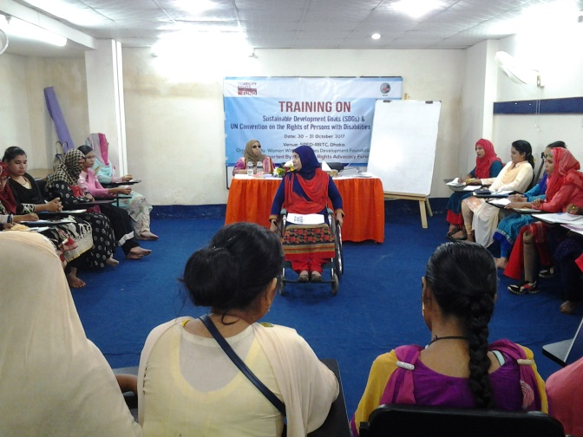A Two days training with the participation of 28 different types of Women with Disabilities including their parents almost total 38, on “United Nations Convention on Rights of Persons with Disabilities (UNCRPD)” (Article 13, 15, 16) and “Sustainable Development Goals (SDGs)” (Goal 16) in order to create easy access to justice was being organized with the initiative of Women with Disabilities Development Foundation (WDDF), from 30th to 31st October 2017, in the Auditorium of Society for Participatory Education and Development (SPED), Road-6, House-75, Munsurabad.

This training was divided in to three parts:

A. Inaugural session, B. Core session on the articles of UNCRPD and C. Core session on Goal-16 of SDGS.

Two core sessions are being discussed in Two days and there was One fascilitator and Two Co-facilitators to conduct the training theoretically and practically for the Women with Disabilities properly. The representatives from government and corporate sector were present as Chief Guest and Special Guest in this training.

The inaugural session of this training is being started at 11.00 AM, 30th October 2017, with the welcome remarks of Suraiya Akter Bably, Treasurer, WDDF. After welcome speech, an introductory session of all the participants is being conducted by Md. Hasanuzzaman and all the participants are introduced with each other in this session. After having introductory session been finished, Shirmin Akter Dolon (Crutch user) General Member, WDDF is being requested to share her challenging experiences as a student of Honors (2nd year) in English of Rajshahi College and

Rounak Jahan Usha (Wheel Chair User), General Member, WDDF is being requested to deliver her speech about her challenging experiences as a student of Masters (Final year) in Sociology of Eden University. Followed by the speech of participants, Md. Shafiqur Rahman, Manager, Shyamali Branch, Rupali Bank Limited,

Is being requested to deliver his speech as special Guest about his experience, responsibilities and duties for Persons with Disabilities on behalf of Corporate Sector to make our activities easy and helpful. He is very sincere, responsible and also very glad to be invited in this program. After that, K M Shahidujjaman, Officer, City Social Service Office (Circle-6), Department of Social Service, is being requested to deliver his speech as Chief Guest. He said that, he is agreed with the existing barriers of Persons specially Women with Disabilities; Government is very positive towards Persons with Disabilities and on behalf of Social Welfare Ministry along with Department of Social Service they’ve adopted a number of initiatives to reduce these challenges step by step.

This inauguration program is being presided over Shirin Akhter, Chairperson, Women with Disabilities Development Foundation (WDDF).

Core sessions of the 1st day training:

It is noted that, since most of the Women with Disabilities are from very grassroot level and they’re participating in this type of training for the first time; So, the core session of 1st day is being divided in to Three sessions:

A. Initial discussion, B. 1st session and C. 2nd session.

A. Initial discussion: In initial discussion, purpose and importance of this training for Women with Disabilitiesincluding the required information, expected learnings/aims of this training, gaps and challenges of Persons specially Women with Disabilities in the issue of access to justice. Are being discussed by Shirin Akhter, Chairperson, WDDF and Co-facilitator of this training.

Followed by this discussion, Md. Hasanuzzaman, Program Coordinator, WDDF and Co-facilitator of this training discussed a number of instructions for the training participants and request them to follow these instructions strictly at training period in order to make this training effective. After that, participants are requested to express their expectation from this training, one expectation for each participant to analyse their understanding level.

1st session:

This session is being facilitated byAshrafun Nahar, Executive Director of WDDF and Facilitator of this training.

The topic of this session is “United Nations Convention on Rights of Persons with Disabilities (UNCRPD)”

(Article 13) “Access to justice”, (Article 15 **“‘Freedom from torture or cruel, inhuman or degrading treatment or punishment”** and (Article 16)”**Freedom from exploitation, violence and abuse”.**

This topic includes:

What are United Nations and UN CRPD?

II) What is Access? And what is justice?

II) Key speeches of these articles.

IV) Why are these articles important to know for us?

V) What is the connection between article 13, 15, 16 and obtaining justice?

2ndsession:

This session is being facilitated by Shirin Akhter, Chairperson along with Md. Hasanuzzaman, Program Coordinator, WDDFand Co-facilitators of this training.

A number of topics closely related with this training are being discussed in the second session.

The topics include:

I) Connection between ‘Persons with Disabilities Rights and Protection Act 2013’ and ‘UNCRPD’.

II) What is Disability and barrier?

III) Types of disability (In light of question of the participants).

IV) Relation of Equality, equity and non discrimination.

V) Duties of Local Government for getting justice in light of ‘Persons with Disabilities Rights and Protection Act 2013’ and ‘UNCRPD’.

Core session of the 2nd day: The key topic of this day is “Sustainable Development Goals (SDGs)”

(Goal 16 “Promote peaceful and inclusive societies for sustainable development, provide access to justice for all and build effective, accountable and inclusive institutions at all levels”)

The core session of the 2nd day is divided in to two sessions.

A. 1st session and B. 2nd session.

These sessions are being facilitated by Ashrafun Nahar, Executive Director and Shirin Akhter, Chairperson, WDDF along with Facilitator and Co-facilitator of this training.

A. 1st session includes:

I) recap the discussing issues of 1st Day.

II) What is Accessibility?

III) What is Reasonable accommodation?

2nd session includes:

I) what is Sustainable Development Goals (SDGs)?

II) What is Inclusive? And what is Institution?

III) Key speech of this Goal.

IV) Why is this goal important to know for us?

V) What is the connection between goal 16 and obtaining justice?

The facilitators suggested to the participants that, everybody should have proper conception and knowledge about these treaty and document concurrently they should have try to use the specific reference of these treaty and document for utilizing in required area. In case of any requirement, WDDF will always take proper initiative to cooperate to the Women with Disabilities through legal aid service providing organizations. Otherwise, it will be very difficult for them to enjoy their rights through the implementation of these treaty and documents properly.

From the responses of all the participants, it would be noted that, this is an effective and time required training for them. Most of the participants haven’t any idea about these treaty and document and they aren’t aware about the basic rights for Persons with Disabilities are mentioned in these treaty and document. The participants are also pointed out that, Persons especially Women with Disabilities of remote areas are deprived from Government services and facilities and due to lack of accurate information they are always left behind. So, considering the susceptibility of Persons especially Women with Disabilities, this type of training should be organized in divisional and district level regularly.

19. Training on ‘Reproductive health Rights of Women With Disabilities’:One Training on ‘Reproductive Health Rights of Women with Disabilities’ was being organized in this reporting period:

Training on ‘Reproductive Health Rights of Women with Disabilities’ was being held on 19th August 2017

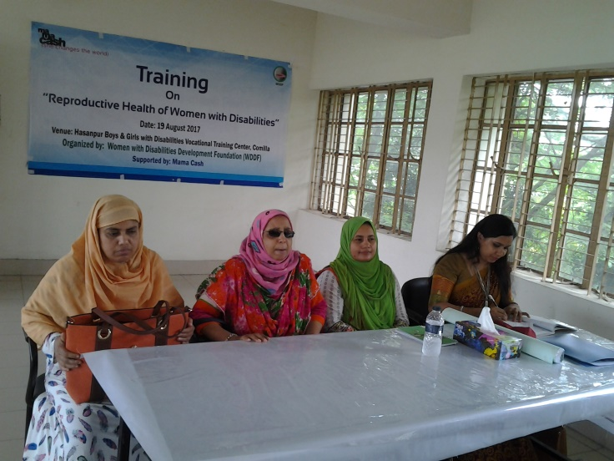This training with the participation of 24 different types of Women with disabilities of Three unions (Gouripur, Baropara and Daudkandi Uttar) of Daudkandi, Comilla is being organized by Women with Disabilities Development Foundation (WDDF) in the auditorium of Hasanpur Boys and Girls Vocational Training Centre, Daudkandi. There was One resource person and Chairperson, Vice Chairperson, Executive Director, along with Program Coordinator of WDDF facilitated to conduct the training theoretically and practically for the Women with Disabilities properly. A constructive and illustrative presentation on different parts of human body regarding reproductive health is being delivered by the resource person of this training, Nargis Akter Lipy, Centre Manager (Expert on Reproductive Health Rights) Young Power in Social Action (YPSA) was present in the abovementioned training.

This training is being started at 10.00 AM, on 19th August 2017, with the welcome remarks of Shirin Akhter, Chairperson and Ashrafun Nahar, Executive Director of WDDF including the required information and expected learnings/aims of these trainings. After that, an introductory session of all the participants is being conducted by Ashrafun Nahar and all the participants are introduced with each other in this session

After having introductory session been finished, the resource persons started her presentation on ‘Reproductive Health Rights of Women with Disabilities’ and this presentation includes:

What is reproductive health?

II) Importance of reproductive health for Women with Disabilities.

III) What is periodic cycle?

IV) What type of physical and mental changes is being felt and visible in the body of both female and male in their adolescence period?

V) Which parts of female and male body are specially considered under reproductive health? What are these parts?

VI) What type of initiatives for caring and consciousness we should follow at the time of ministration?

VII) What is sexual relation? How does a woman become pregnant through sexual relation of Two persons?

VIII) What types of complexity women have to face through the interruption of prevention of women disease and protection of reproductive health?

IX) What are sexualorgans?

X) Which sexual organs are being used for maintaining sexual relation? 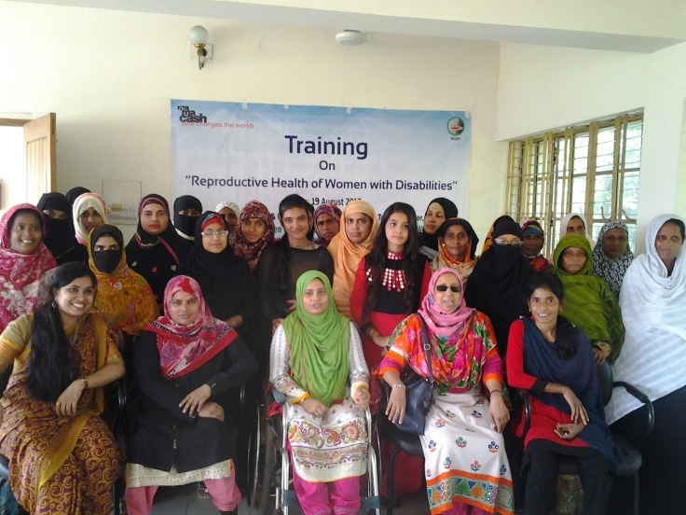

Besides, many important issues about reproductive health are discussed elaborately in the question answer session.

Learnings of these trainings: in the closing speech the participants pointed out that, their learnings from these trainings are as follows:

I) As Women with Disabilities, they obtained opportunity for the first time to discuss about reproductive health openly as well as to be acquainted with the secret and hidden parts/issues of human body.

II) As most of the women are unmarried, they’ve no idea about sex along with sexual relation. So, they got opportunity to gain knowledge about the internal parts and to identify the external parts of (Men and Women) humanbody practically. Hence, this training is immensely important for them.

III) Hygienic practise at the periodic time.

IV) How to maintain periodic cycle and how to save them selves from unexpected pregnancy.

V) Required information about taking care and safety of reproductive health.

VI) Reproductive health is as equally important for Women with Disabilities and they should have consciousness regarding this issue like non disabled women.

Finally, it is mentioned that, All The participants recommended that this training environment is very friendly for them where they’ve got opportunity to discuss every issue openly and elaborately. Simultaneously, they’ve learned many important issues about reproductive health. So, they’ve agreed that it is an effective training for them & they are interested to continue this training subssequently and for long time in district along with divisional level.

20. Supporting programs for Human Rights (Rohingya)violation in emergency situation:

Visit the situation of Rohingya refugees with Disabilities of Cox’sbazar from 16 to 18 September 2017:

I) a number of initiatives have been adopted in order to reduce the sufferings of the Rohingya refugees with disabilities by WDDF are as follows:

II) Dry food and cloths distribution among Rohingya refugees;

Sending recommendation letter including seven recommendations to the relevant authorities of Government in order to take some special measures for the Rohingya refugees with Disabilities;

Organize discussion meetings with Union Nirbahi Officer (UNO) of Ukhia Upazila and District Commissioner (DC)/Additional District Commissioner (ADC) General of Cox’sbazar. 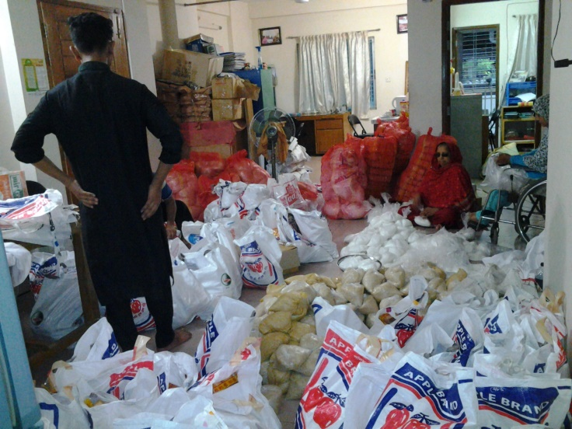

In order to accomplish the activities, WDDF representatives started for Cox’sbazar on 16th September 2017. We distributed relief among Rohingya refugees of Shah Pari Island and Ukhia, Kutupalang refugee shelter centre of Cox’sbazar and submitted recommendation letter to Union Nirbahi Officer (UNO) of Ukhia Upazila of Cox’sbazar on 17th September 2017.

A discussion meeting was being organized with the Additional District Commissioner (ADC) General of Cox’sbazar, on 18th September 2017.

It would be noted that, all these activities have been accomplished by the local contribution (Executive Council Members, staffs of WDDF along with their family members) of WDDF.

Following recommendations about Rohingya refugees with Disabilities have been submitted from WDDF.

Recommendations of WDDF about Rohingya refugees:

The representatives of WDDF has submitted a number of recommendations to the relevant authorities of Government including District Commissioner (DC) and Additional District Commissioner ( ADC) General of Cox’sbazar in order to making easy lives of Rohingya Nationals with Disabilities including aged people, traumatized women and children. The recommendations are as follows:

1. A column on disability issue should be included in the Biometric registration form of Rohingya National registration process, led by The Department of Immigration and Passport under Home Ministry, Government of The Peoples Republic of Bangladesh and types of disability should be mentioned clearly which will immensely be helpful to go back the Rohingya refugees in Myanmar as well as to rehabilitate them in their own country.
2. The toilets of Rohingya refugee camp should be accessible for Rohingya refugees specially, Wheel chair and Crutch users Women with Disabilities.
3. Relief equipments such as medicine, food and other need based equipments should be distributed to the Persons with Disabilities including women on the basis of privilege at the time of relief distribution among Rohingya refugees.
4. Assistive device/disability related equipments such as White Cane, Wheel Chair, Crutch, Hearing Aid and other need based devices should be distributed according to the types and accurate measurements of Persons with Disabilities for leading their easy lives in 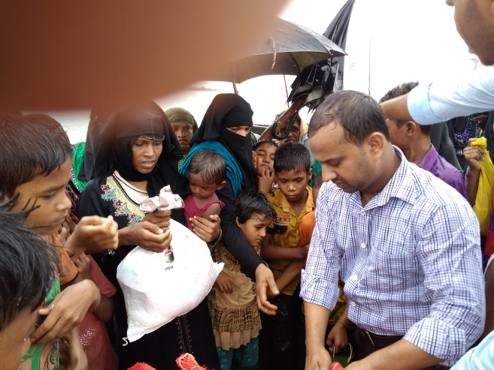refugee camp.
5. Supportive initiatives should be adopted for rehabilitation of Persons with Disabilities including aged peoples of refugee camp with the cooperation of the Social Service Department officers; such as short orientation on using assistive devices along with encouraging them to lead easy and natural life. Simultaneously, counseling service should be provided for the oppressed, victim of sexual violence, traumatized and injured persons specially women and children of refugee camp.
6. A data of the victim of oppression, disability, trauma and injury persons specially women and children of refugee camp should be prepared which will immensely helpful for
7. Government to make advocacy with international communities to pressurize for sending back the Rohingya refugees in their own country.

8. The family of Persons especially Women with Disabilities should be replaced in the camp in plain land area after having collected data.

21. Participation in International programs:

The representatives of WDDF have participated in the following international programs in this reporting year.

Annual South Asia Women’s Fund (SAWF) Regional Convergence with the participation of partners of South Asia Region was being organized by South Asia Women’s Fund (SAWF) from 14 to 16 July 2017, at Soaltee Crowne Plaza hotel, Kathmandu, Nepal.

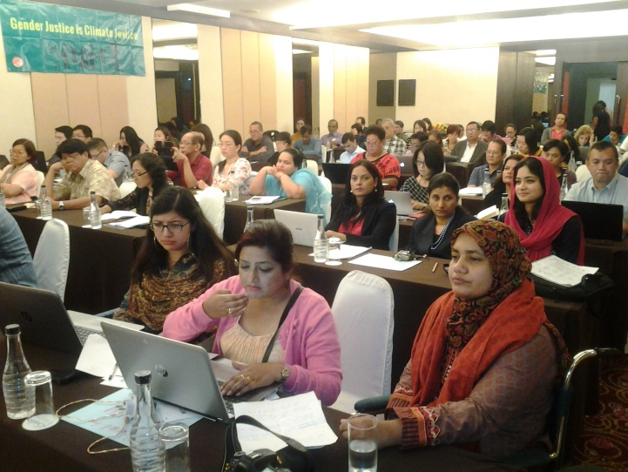A number of presentations on the challenging issues and success of women in different parts of South Asia were present in the different sessions of three days regional convergence. The agenda of this convergence are as follows:

1. The Current global and regional political climate andits impact on women’s and trans* rights and organising:

A) Understand “right wing” positioning/politics, in all its nuances and shades;

B) Lay out the strengths and challenges of identity politics: particularly from

Understanding the minority, marginalized and oppressed communities; as well as building

Of the exaggerated nationalist discourse;

C) Examine and understand the participation of women in the above and its impact on

Feminist work in the region.

2. Strengthening feminist voices:

A) Building Inclusive movement/s;

B) Sustaining feminist women’s rights work;

3. Environment Justice and Women’s Rights.

4. Movement and labour:

A) Reaffirming labour rights of women workers in the unorganised sectors.

B) The importance to engage normative standards as a strategy to claim rights.

5. Autonomy, Decisions and Sexual Rights:

A) Consent and Decision-making.

B) Understanding sexual rights - Going beyond SRHR.

C) Autonomy and Sexuality in an environment of radicalization.

D) Family laws in South Asia.

E) Access to justice.

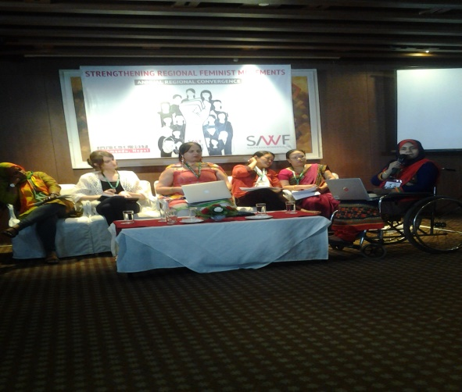F) Collective reflection.

Shirin Akhter, Chairperson and Ashrafun Nahar, Executive Director, WDDF participated in this regional Convergence. As Women with Disabilities rights activist of Bangladesh and speaker of the convergence, Ashrafun Nahar discussed in a session how the movement of Women with Disabilities has been included with the mainstreaming women movement and discussed the situation of Women with disabilities in the light of abovementioned agenda.

B) International program from 6 to 12 September 2017:

I) Program of Asia Pacific Feminist Forum (APFF)

A program of Asia Pacific Feminist Forum was held in Thailand.

A workshop entitled “Women with Disabilities and development justice” was being held in order to create a linkage of Women with Disabilities and Feminist Forum in this program. This workshop is being facilitated by Ashrafun Nahar, Executive Director, WDDF-Bangladesh in join collaboration with Abia Akram from STEP-Pakistan, Rama Decle and Tika from NFDN-Nepal.

II) Annual meeting of Asia Pacific Women with Disabilities United (APWDU):

An annual meeting of Asia Pacific Women with Disabilities United (APWDU) under Asia Pacific Women Law and Development (APWLD) partners was being held at the time of this program.

Part B

Participation in different Governmental and Non-Governmental programs/events:

The officials as well as staffs of WDDF participated in different Governmental/Non-governmental programs/events. Viz:

* 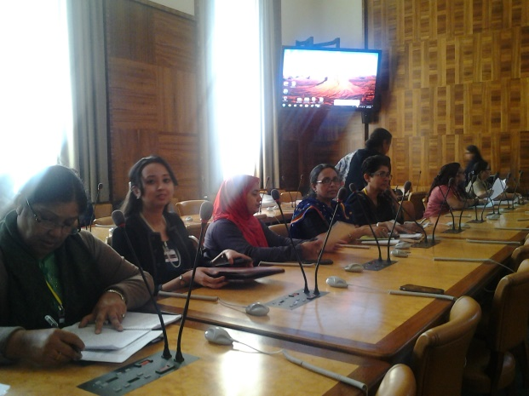Discussion Meeting/ Experience sharing meeting:

WDDF participated in 32 Discussion Meetings/ Experience sharing meetings in this reporting period.

A) National Sharing Meeting on CEDAW:

A National Sharing meeting of Citizen’s Initiatives on CEDAW, Bangladesh (CIC-BD) on the experience of 8th CEDAW Shadow Report sharing in 65th CEDAW session in Geneva, Switzerland was being organized on 15th January 2017 at CIRDAP Auditorium.

Ashrafun Nahar, Executive Director, and Md. Hasanuzzaman, Accounts Coordinator of WDDF were participated in this National Sharing meeting.

B) Discussion meeting of working committee on “Action plan of Persons with Disabilities Rights and Protection Act 2013”:

A discussion meeting of working committee on “Action plan of Persons with Disabilities Rights and Protection Act 2013”was being organized by National Forum of Organizations Working with the Disabled (NFOWD), in its office, at 3.00 PM, on 5th February 2017. This is the 1st meeting of this working committee. An action plan of the working committee in order to prepare the “Action plan of Persons with Disabilities Rights and Protection Act 2013” is being outlined in this meeting. Shirin Akhter, Chairperson, WDDF was present in the abovementioned discussion meeting.

C) Sharing meeting about the participation in the Sixty-First Session of the Commission on the Status of Women (CSW2017):

A sharing meeting about the participation in the Sixty-first session of the Commission on the Status of Women was being organized by Ministry of Women and Children Affairs (MOWCA), in Pan Pacific Sonargaon Hotel, on 26th February 2017. Ashrafun Nahar, Executive Director, WDDF was participated in this meeting and she urged to the State Minister and the Secretary of MOWCA that, information about Women with Disabilities should be included in the submitted report of the Commission on the Status of Women properly.

D) Discussion meeting:

A discussion meeting on the “Significance of ratification Marracash treaty in perspective of Bangladesh”, was being organized by Visually Impaired Peoples Society (VIPS), at Roundtable Auditorium Dhaka Reporters Unity, at 3 PM, on 4th March 2017. Shirin Akhter, Chairperson, WDDF was present in this discussion meeting. Shirin Akhter mentioned that, the number of accessible books for the Persons with Visual Impairments and Print Disabilities are very limited in Bangladesh; in this consequence, they are deprived from obtaining information and knowledge as well as it is a great difficulty for them to access in education and employment. So, her urge to the Government in order to open the door of study for the Persons with Visual Impairment and Print Disabilities, it is immensely important to ratify the Marracash treaty as soon as possible.

E) Preparation meeting for organizing Conference:

A preparation meeting in order to organize a youth Conference on “Value Co-creation” was being organized by United Nations Voluntary Fund (UNV) in its office, IDB Bhaban, Agargaon Dhaka, at 11 AM, on 5th March 2017.

Shirin Akhter, Chairperson and Md. Hasanuzzaman, Project Officer, WDDF were present in this preparation meeting. Shirin Akhter proposed a number of recommendations on how to ensure accessibility of Persons with Disabilities in the conference.

F) Working Committee meeting on “Action plan of Persons with Disabilities Rights and Protection Act 2013”:

A Working Committee meeting on “Action plan of Persons with Disabilities Rights and Protection Act 2013”was being organized by National Forum of Organizations Working with the Disabled (NFOWD), in its office, at 10.00 AM, on 6th March 2017. This is the 2nd meeting of this working committee and Shirin Akhter, Chairperson, WDDF was present in this meeting. A number of decisions have been adopted in the abovementioned Working Committee meeting are as follows:

I) At first, a number of Working Committee members including WDDF will collect recommendations from the grassroot Persons with Disabilities and after that, the day long workshop of Disabled Peoples Organizations will be organized in Dhaka.

II) NFOWD will prepare the guideline of collecting recommendations from the grassroot Persons with Disabilities, with the opinions of the working committee members. Besides, NFOWD will also accumulate the relevant documents of the government with the action plan including disability related documents according to the list prepared in this meeting and send to all the working committee members through internet.

III) Working Committee member Zahidul Kabir from Worldvission will request to the Working committee member Rafiq Zaman from PNSP to review the previously prepared “gap analysis paper” on the action plan.

IV) After having discussed with CDD, date and venue of the working committee members’ workshop will be fixed.

G) Thematic Committee on “Persons with Disabilities Rights and Autism” Meeting:

A Thematic Committee on “Persons with Disabilities Rights and Autism” Meeting was being organized by National Human Rights Commission (NHRC) in its office on 19th March 2017. NHRC has formed a Thematic Committee on “Persons with Disabilities and Autism” in order to monitor the issue of human rights violation of this marginalized group and it was the first meeting of this Thematic Committee. The representatives from disability related NGOs, DPOs, parents forum and Social Welfare Ministry were participated in this meeting and on the basis of discussing the existing Scenario of human rights of Persons with Disabilities and Autism a small committee including Six members is being formed to draft a “Road map” of the activities of NHRC on this issue.

Shirin Akhter, Chairperson and Ashrafun Nahar, Executive Director of WDDF as members of this thematic committee were present in this meeting.

H) Discussion meeting on National Budget:

A discussion meeting on National Budget 2017-18 organized by Access Bangladesh Foundation in its office on 29 March 2017. Ashrafun Nahar, Executive Director, WDDF was present in this discussion meeting. The issue of fixing a budgetary allocation for Persons with Disabilities in the National Budget of fiscal year 2017-18 is discussed elaborately in the abovementioned discussion meeting.

Discussion meeting of Nari Nirapatta jote:

I) A discussion meeting of Nari Nirapatta jote was being organized by We Can in it’s office, on 5th April, 2017. In this meeting, the representatives of women and human rights organizations discussed about taking initiatives on how to reduce violence against women at the time of Bangla Nababarsha celebration. Jesmin Ara, Accounts Coordinator, WDDF was participated in the abovementioned discussion meeting.

**J)** Focus Group Discussion:

A Focus Group Discussion in order to preparing Voluntary National Report (VNR) on Sustainable Development Goals (SDGs) was being organized by National Forum of Organizations Working with the Disabled (NFOWD) in its office, on 27th April 2017.

Ashrafun Nahar, Executive Director, WDDF was participated in this program and discussed about the challenges to include Women with Disabilities in actualization of SDGs and how to reduce these challenges.

K) Discussion meeting on National Budget:

A Discussion meeting on National Budget was being held on 4th May 2017, in Cirdap Auditorium. This program is being organized by Access Bangladesh Foundation.

Ashrafun Nahar, Executive Director, WDDF was participated in this discussion meeting. She said that, National budget should be allocated considering the needs and demand of Persons specially Women with Disabilities. Only budget allocation for Persons with Disabilities has included under social safety net; this budget won’t be considered as disability inclusive budget. She also pointed out that, gender responsive budget is being declared in every fiscal year but Women With Disabilities are excluded from this gender responsive budget and without disability inclusive budget proper development of the state including Sustainable Development Goals (SDGs) achievement will extremely be interrupted.

**L)** Discussion meeting:

A discussion meeting on existing challenges to preserve Human Rights and submission of the rules on “Child Marriage Resistance Act”, was being organized by National Human Rights Commission Bangladesh (NHRCB), on 15 May 2017 in the conference room of NHrCB. The representatives of Non Government Organizations, Civil Society Organizations, and Disability related Organizations along with Social Welfare Ministry of Government are participated in this discussion meeting. Shirin Akhter, Chairperson and Md. Hasanuzzaman, Program Coordinator of WDDF were participated in the above mentioned discussion meeting.

Shirin Akhter, Chairperson, WDDF stated that, human rights of Persons with Disabilities specially, Women with Disabilities are always being violated due to infrastructural and informational accessibility in all aspects of the society as well as the issue of Women with Disabilities should be incorporated in all the laws which are being formulated and which are under consideration of review or amendment including the rules on “Child Marriage Resistance Act”.

**M)** Consultation meeting on Universal Periodic Report:

A consultation meeting on Universal Periodic Report was being organized by National Human Rights Commission Bangladesh (NHRCB), on 26th May 2017, in Pan Pacific Sonargaon Hotel.

Ashrafun Nahar, Executive Director, WDDF participated in this consultation meeting. She emphasized on the emerging challenges of Women with Disabilities in education, employment including self employment, housing and health due to infrastructural and informational inaccessibility and insecurity. She also mentioned about violence against Women with Disabilities and the limitation of access to justice for them.

N) Consultation meeting on Universal Periodic Report:

A consultation meeting on Universal Periodic Report was being organized by National Human Rights Commission Bangladesh (NHRCB), on 27th May 2017, in CIRDAP Auditorium.

Ashrafun Nahar, Executive Director, WDDF participated in this consultation meeting. She emphasized on the emerging challenges of Women with Disabilities in education, employment including self employment, housing and health due to infrastructural and informational inaccessibility and insecurity. She also mentioned about violence against Women with Disabilities and the limitation of access to justice for them.

**O)** Discussion meeting on information dissemination about disability and climate change:

A Discussion meeting on information dissemination about disability and climate change as well as sharing a concept paper of conducting a research about the abovementioned issue was being organized by Centre for Services and Information Dissemination (CSID), at 3 PM, on 7th June 2017, in the Auditorium of Impact Foundation Bangladesh.

Shirin Akhter, Chairperson and Md. Hasanuzzaman, Program Coordinator of WDDF were present in this discussion meeting. Shirin Akhter proposed to include the dilemmas have to face by Women with Disabilities at the time of their periodic circle, the problems of female Children with Disabilities as well as the challenges of diverse group of Women with Disabilities at the time of different types of disaster.

**P)** Consultation about National Action Plan on ‘Persons with Disabilities Rights and protection Act 2013’:

A consultation meeting about National Action Plan on ‘Persons with Disabilities Rights and protection Act 2013’ was being organized by National Human Rights Commission Bangladesh (NHRCB), at 11 AM, on 15th June 2017, in ‘Brack In Centre’. Shirin Akhter, Chairperson and Md. Hasanuzzaman, Program Coordinator were present in this consultation meeting. Shirin Akhter, expressing immense frustration said that, Women with Disabilities are becoming victim of violence and torture frequently; Speech and Hearing Impaired Persons along with Visual Impaired Women are depriving from proper education. National Action Plan has been submitted on behalf of NGOs and DPOs in March 2017 and now it is June but this document hasn’t yet been reviewed even there is no any initiative on behalf of government to approve this document. So, we are very frustrated to think that, after how many days this National Action Plan will be approved? How often will Persons with Disabilities be able to enjoy good effect of this document? Still now it is completely uncertain.

**R)** Discussion meeting:

A discussion meeting about existing barriers and challenges of Women with Disabilities was being organized by Sight Savors’ International (SSI), on 5th July 2017, in the Auditorium of SSI. Shirin Akhter, Chairperson and Md. Hasanuzzaman, Program Coordinator of WDDF were present in this discussion meeting.

Multifaceted barriers and challenges have to face by Women with Disabilities in their daily lives such as infrastructural and informational inaccessibility in all aspects of the society. Besides, appropriate plans and programs in education, health and employment sectors haven’t been adopted considering the needs and demands of Women with Disabilities. Due to inaccessible public transport and lack of proper social security a large number of Women with Disabilities are being excluded from social participation and social development. So, the overall situation of Women with Disabilities and the ways of reducing their sufferings are being discussed in this meeting elaborately.

S) Thematic committee on ‘Rights of Persons with Disabilities and Autism’ meeting:

A Thematic committee on ‘Rights of Persons with Disabilities and Autism’ meeting in order to review National Action Plan on ‘Persons with Disabilities Rights and protection Act 2013’ was being organized by National Human Rights Commission Bangladesh (NHRCB), at 4.00 PM, on 9th July 2017, in the Conference room of NHRCB. Ashrafun Nahar, Executive Director and Md. Hasanuzzaman, Program Coordinator of WDDF were present in this discussion meeting. Actually, this committee formed a working committee in order to formulating a National Action Plan comprising Ten National Action Plans prepared by Ten organizations.

**T)** Consultation about National Action Plan on ‘Persons with Disabilities Rights and protection Act 2013’:

A consultation meeting about National Action Plan on ‘Persons with Disabilities Rights and protection Act 2013’ was being organized by National Human Rights Commission Bangladesh (NHRCB), at 10 AM, on 30th July 2017, in the Auditorium of NHRCB. Shirin Akhter, Chairperson and Md. Hasanuzzaman, Program Coordinator were present in this consultation meeting. Actually, it was a review meeting of draft National Action Plan.

U) Consultation about National Action Plan on ‘Persons with Disabilities Rights and protection Act 2013’:

A consultation meeting about National Action Plan on ‘Persons with Disabilities Rights and protection Act 2013’ was being organized by National Human Rights Commission Bangladesh (NHRCB), at 10 AM, on 2nd August 2017, in the Auditorium of NHRCB. Shirin Akhter, Chairperson and Md. Hasanuzzaman, Program Coordinator were present in this consultation meeting. Actually, it was a review meeting of draft National Action Plan.

V) Discussion meeting of thematic group on Women Rights:

A discussion meeting of thematic group on Women Rights was being organized by National Human Rights Commission Bangladesh (NHRCB), at 10 AM, on 21st August 2017, in the Auditorium of NHRCB.

Shirin Akhter, Chairperson and Samira Haque, Accounts Coordinator, WDDF participated in this discussion meeting. On behalf of Women with Disabilities WDDF has been included in the thematic group on Women rights.

Another important agenda of this discussion meeting was reviewing the recommendations of Universal Periodic Review (UPR) about women rights. Shirin Akhter emphasized to include the issue of Women with Disabilities Rights in the women rights issue of UPR report as well as the accessibility issue of Women with Disabilities.

W) Consultation on Universal Periodic Review (UPR):

A consultation in order to share draft stakeholders report on child rights of Universal Periodic Review (UPR) was being organized by Child Rights Advocacy Coalition with the secretarial assistance of Ain O Salish Kendra (ASK) in the auditorium of CIRDAP on 12 September 2017.

Shirin Akhter, Chairperson and Samira Haque, Accounts Coordinator of WDDF were present in this program. Shirin Akhter stated that, education system and facilities for Children with Disabilities is very limited and due to infrastructural and informational inaccessibility most of the Children with Disabilities aren’t being included in education system properly. They’re suffering from mal nutrition and it is necessary to arrange a lunch for children in educational institutions and budget should be allocated for all types of children in national budget.

X) Sharing meeting on Universal Periodic Review (UPR):

A sharing meeting in order to share Universal Periodic Review (UPR) was being organized by Human Rights Forum of Bangladesh (HRFB) with the secretarial assistance of Ain O Salish Kendra (ASK) in the auditorium of CIRDAP on 28 September 2017.

Md. Hasanuzzaman, Program Coordinator, WDDF was present in this program. Md. Hasanuzzaman stated that, education system of Children with Disabilities is very limited and due to infrastructural and informational inaccessibility most of the Children with Disabilities aren’t being included in education system properly. Besides, education curriculum also should be modified for Children with Disabilities; they’re suffering from mal nutrition and it is necessary to arrange a lunch for children in educational institutions. Women with Disabilities should have right to obtain inherit property and due to disability they should not deprive from this right. Women with Disabilities are becoming svictim of physical and mental torture regularly and due to disability they’ve to face these types of torture and deprivation more and more times; even they’ve no proper acces to justice. Budget should be allocated for Persons with Disabilities not only under ‘social safety net’ but also in specific areas of national budget.

Y) Consultation on Universal Periodic Review (UPR):

A consultation in order to share draft stakeholders report of Universal Periodic Review (UPR) was being organized by National Human Rights Commission Bangladesh (NHRCB) in the auditorium of Bangabandhu International Conference Centre (BICC) on 2nd October 2017.

Shirin Akhter, Chairperson and Md. Hasanuzzaman, Program Coordinator of WDDF were present in this program. Shirin Akhter stated that, education system of Women with Disabilities is very limited and due to infrastructural and informational inaccessibility most of the Girls with Disabilities aren’t being included in education system properly. Besides, public transports aren’t disability friendly as well as Women with disabilities are always depriving from obtaining justice due to inaccessibility. Budget should be allocated for Persons with Disabilities not only under ‘social safety net’ but also in specific areas of national budget.

Z) Discussion meeting with World Bank:

A discussion meeting on disability inclusion in World Bank with civil society was being organized by Worldbank on 4th October 2017 in the Auditorium of World Bank office.

Ashrafun Nahar, Executive Director, and Samira Haque, Accounts Coordinator, WDDF were present in this program. Ashrafun Nahar mentioned that, disability issue is being included only in disability related legislations and policy but not in all legislations and policy properly; as a result all legislations and policy are not being disability inclusive. E.G in draft ‘Road safety and Transport Act 2017’, disability inclusive transport was being mentioned as invalid carriage. Then we on behalf of WDDF organized a discussion meeting with the secretary of Road and Bridge Ministry and took permission in order to review the act for including disability issue properly within one week. After that, we organized a workshop with the participation of a number of DPOs, review the Act and submit according to the assigned date and then disability issue is being included. So, most of the time, it is very challenging for us.

A1) Consultation:

A consultation on “Challenges faced by Women in work places; Way forward and role of stakeholders” was being organized buy National Human Rights Commission Bangladesh (NHRCB), in Pan Pacific Sonargaon Hotel on 15 October 2017.

Shirin Akhter, Chairperson and Md. Hasanuzzaman, Program Coordinator of WDDF were present in this consultation. Shirin Akhter stated that, Women with Disabilities have to face multifaceted challenges in work places. The mentionable challenges are as follows:

II) Inaccessible roads and public transport;

II) Infrastructural and informational inaccessibility in work places;

III) Discriminatory attitude to the Women workers with Disabilities along with lack of reasonable accommodation;

IV) Only Women with mild Disabilities (Mild Disability in one hand or one leg)are getting job but Women with severe Disabilities (Wheel Chair user, Visual Impaired, Speech and Hearing Impaired, without hand) are being deprived from getting job and Persons with Disabilities, specially Persons with Visual Impairment aren’t being allowed in Judicial Service Commission (JSC) exam;

V) Though 1% quota has been declared in First class job but not enlisted in gadget;

VI) Ten% quota has been allocated for orphan and Persons with Disabilities jointly and in most cases, Persons with Disabilities are being deprived.

A2. Consultation:

A Consultation on ‘Gender Diagnostics and Policy of Social Protection issues of National Social Security Strategy’, organized by Cabinet Division and General Economic Division in Bangabandhu International Conference Centre (BICC), on 26th October 2017.

Ashrafun Nahar, Executive Director, and Samira Haque, Accounts Coordinator, WDDF were present in this consultation. Ashrafun Nahar has submitted following recommendations on disability issue for inclusion in National Social Security Strategy (NSSS):

I)Accessible road and transport,

II) Need based and required assistive device distribution,

III) Life insurance,

IV) Care giver allowance for elder Women and Women with Disabilities,

V) Disability allowance for poor and incapable Persons with Disabilities,

VI) Abstaining Persons with Disabilities from begging and include them in employment through need based training,

VII) Ensure inclusion of Persons with Disabilities in all parts of NSSS,

VIII) Disability identification from 0 to 4 years children and ensure their inclusion in education,

IX) ensure infrastructural and informational accessibility for Students with Disabilities in educational institutions,

X) Enhancing consciousness about reproductive health among adolescence Girls with Disabilities.

A 3)Discussion meeting:

A discussion meeting on ‘Integrated National Strategy’ was being organized by NGO Affairs Bureau in the Auditorium of its office, on 30th October 2017.

Ashrafun Nahar, Executive Director, and Samira Haque, Accounts Coordinator, WDDF were present in this discussion meeting. The issues of transparency and accountability of Non Government Organizations (NGOs) are being discussed in this meeting. Ashrafun Nahar said that, we, the NGOs are responsible for ensuring their transparency and accountability but we expect that, as an inclusive institution NGO Affairs Bureau will ensure its responsibility and accountability through ensuring its universal service providing opportunity. The office of NGO Affairs Bureau should be accessible for all types of Persons with Disabilities. We, on behalf of WDDF have submitted proposal on accessibility issue and it was assured us that, this office will be completely accessible. But it is seen that, lift is inaccessible for the Persons with Visual Impairment and wash rooms aren’t accessible for the Persons with Wheel Chair users. So, we would like to request to ensure universal accessibility in this office premises.

A 4. Discussion meeting on Reproductive Health Rights of Women with Disavilities:

A discussion meeting in order to include the recommendation on Reproductive Health Rights of Women with Disabilities in National Action Plan on Reproductive Health Rights of Government, organized by Turning point Foundation in its office, at 10 A.M, on 30th November 2017.

Shirin Akhter, Chairperson and Md. Hasanuzzaman, Program Coordinator of WDDF participated in this discussion meeting.

Shirin Akhter stated that, we’ve to include Women with Disabilities need based recommendations; E.G. Proper sanitation, Menstrual regulation, Cleanliness of at the time of menstruation, safe period of not having unintended pregnancy ETC.

Besides, our recommendation should be issue based; we’ve to review the National Action Plan on Reproductive Health Rights of Government and include the issue of Women with Disabilities otherwise this initiative won’t be effective.

A 5. Discussion meeting on Universal Periodic Review (UPR):

A discussion meeting on Universal Periodic Review (UPR) was being organized by StepsTowards Development (STD) in the auditorium of its office, at 3.00 PM, on 30th November 2017.

Shirin Akhter, Chairperson and Samira Haque, Accounts Coordinator of WDDF were present in this program. Shirin Akhter stated that, most of the public buildings including education institutions are infrastructurally inaccessible and education facilities for Women with Disabilities are very limited and due to infrastructural and informational inaccessibility most of the Girls with Disabilities aren’t being included in education system properly. Besides, public transports aren’t disability friendly as well as Women with disabilities are always depriving from obtaining justice due to inaccessibility. Budget should be allocated for Persons with Disabilities not only under ‘social safety net’ but also in specific areas of national budget.

A6. Discussion meeting with Women rights activists:

A Discussion meeting with Women rights activists was being organized by UN Women-Bangladesh at 3.00 PM, on 5th December 2017.

Ashrafun Nahar, Executive Director, and Samira Haque, Accounts Coordinator, WDDF were present in this discussion meeting.

Discussing about overall situation of Women with Disabilities of Bangladesh, Ashrafun Nahar mentioned that, disability issue has been controlled by Ministry of Social welfare but this Ministry even Ministry of Women and Children Affairs (MOWCA) doesn’t have any special initiative for Women with Disabilities.

She also urged to the Country Director of UN Women that, at the time of her interaction with the relevant authorities of Government on behalf of UN Women, whether she would like to know about the adopted initiatives and plans for Women with Disabilities and deliver her suggestions; It will certainly bring a positive impact for Women with Disabilities.

2. Workshop/Human Chain/Round table discussion/Seminar/Training/Conference/Interactive dialogue:

A. 1stWorkshop on Reproductive Health Rights of Women with Disabilities:

A Workshop on Sexual and Reproductive Health Rights (SRHR) of Women with Disabilities was being organized by Share-net Bangladesh in ICDDRB, on 25th January 2017. Shirin Akhter, Chairperson and Mst. Habiba Khatun, Project Officer of WDDF were present in this meeting. Shirin Akhter mentioned that, SRHR is immensely an important issue for Women with Disabilities but they are totally deprived from this issue due to their disability. WDDF has already organized a number of training on SRHR of Women with Disabilities in order to grow their awareness on this issue and it is seen that, SRHR issue is completely a secret and an alien issue to the Women with Disabilities but they’re always suffering different types of physical complexity including various types of female diseases because of this unidentified issue to them. So, it is very essential for Women with Disabilities to lead productive, healthy and disease free lives through having the opportunity of practicing Reproductive Health Rights of them as well as the information, articles and equipments about SRHR should be accessible and easily achievable for all types of Women with Disabilities.

B. 2nd workshop on “Action plan of Persons with Disabilities Rights and Protection Act 2013:

Two days workshop on “Action plan of Persons with Disabilities Rights and Protection Act 2013” was being organized by National Forum of Organizations Working with the Disabled from 27 March to 28 March 2017 in Apon Uddog Foundation.

An action plan of “Persons with Disabilities Rights and Protection Act 2013” with the participation of networking organizations, Women with Disabilities Organizations,DPOs, NGOs, Donor Organizations in the light of ‘Seventh Five years plan’, ‘Sustainable Development Goals’, ‘National Action Plan of National Women Advancement Policy 2011’, ‘Incheon Strategy’ has been formulated and submitted to Jatiya Protibandhi Unnayan Foundation (JPUF) under Social Welfare Ministry.

Shirin Akhter, Chairperson, Ashrafun Nahar, Executive Director and Hasanuzzaman, Program Officer of WDDF were present in this workshop.

C. 3rdworkshop on ‘Strength and weakness of women’s organizations as well as develop a future action to remove the barrier in order to contribute in greater women’s movement’ was being organized by Manusher Jonno Foundation (MJF), on 16th August 2017, in the Auditorium of MJF.

Shirin Akhter, Chairperson, WDDF participated in this workshop.

Ten Women’s organizations were participated in this workshop. As an organization of Women with Disabilities, the strength, weakness, background of connecting with mainstream women movement, experience of making advocacy in national and international level and success of WDDF are being discussed elaborately.

**D. 4th**International workshop on ‘Better mobility of Persons with Disabilities’:

An international workshop on ‘Better mobility of Persons with Disabilities’ was being organized by World Bank in Pan Pacific Sonargaon Hotel, on 8th October 2017.

Ashrafun Nahar, Executive Director, and Samira Haque, Accounts Coordinator, WDDF were present in this workshop. The Scenario of accessibility of Persons with Disabilities in roads and transports of developed and developing countries are being presented. Ashrafun Nahar stated that, inaccessible footpath, under pass and over bridges is an enormous barrier for mobility of Persons with Disabilities. So, in order to reduce these barriers, WDDF has adopted a number of initiatives and in the consecutiveness of these initiatives, we make advocacy with the Mayors of South and North city corporations with a number of proposals about accessible Under pass and Over bridges of roads including making ramps with footpaths and setting up Braille block. Though at first they couldn’t understand but finally they agreed with us. Now it is seen that, ramps are made with very small number of footpaths but these ramps are surrounded by pillars; Braille block has been setting in footpaths but light post, police box and pillars for telephone line are in the middle of footpath. So, barriers aren’t removed for us finally.

E. fifthworkshop on “Justice Needs and Satisfaction in Bangladesh”:

A workshop entitled“Justice Needs and Satisfaction in Bangladesh”was being organized by Bangladesh Rural Advancement Committee (BRAC), on 29th November 2017, in the Conference hall of BRAC IN Centre.

Shirin Akhter, Chairperson and Md. Hasanuzzaman, Program Coordinator of WDDF participated in this workshop.

The methodology, goals, survey result and data of a study on access to justice for violence and land rights violation of population are being discussed *with the presence of the representatives of Civil Society Organizations (CSO) and a diverse group of justice practitioners*.

It would be noted that, unfortunately, marginalized groups E.G. Disability, Indigenous, Trans gender including other marginalised groups haven’t included in this study.

So, Shirin Akhter, raised strong voice that, this study hasn’t considered as an inclusive study as this study hasn’t included any marginalised group. 15% of the total population of Bangladesh is Persons with Disabilities, so, the number of Population with Disability is approximately 24 million and without their inclusion, actualization of Sustainable Development Goals (SDGS) will extremely be interrupted. So, I would like to emphasize that, all types of projects, plans, programs, study/research adopted by donor organizations, NGOs, CSOs and Government should be inclusive and accessible for all including all types of marginalized population.

**F) H**uman chain of Persons with Disabilities:

A human chain of Persons with Disabilities on the occasion of observing 4 years of enacting ‘Persons with Disabilities Rights and Protection Act 2013’ was being organized by the self initiative of Persons with Disabilities entitled Disabled Citizens Unity infront of National Pressclub, at 10.30 AM,

On 9th October 2017. Ashrafun Nahar, Executive Director, Shirin Akhter, Chairperson, Md. Hasanuzzaman, Program Coordinator and Samira Haque, Accounts Coordinator of WDDF were present in this Human Chain with more than Six hundred (600) Persons with Disabilities. Ashrafun Nahar and Shirin Akhter mentioned in their speeches that, Already Four years have passed of enacting ‘Persons with Disabilities Rights and Protection Act 2013’ but mentionable initiative hasn’t been visible for implementing this legislation. As a result, fundamental rights of Persons with Disabilities are extremely being violated in many cases. So, through this Human Chain, we, Persons with Disabilities would like to submit our demands to the Government and country people that, we’re the citizens of this country, we would like to contribute in development process. It is immensely important to consider our demands for inclusive development and without inclusive development SDGs won’t be achieved and in this consequence national development will extremely be interrupted.

**G)** Roundtable Discussion:

A Roundtable discussion on “Invisible contribution of women in development and its background story”, was being organized by Bangladesh National Human Rights Commission (NHRCB), at Samakal Conference Hall, on 2nd March 2017. Ashrafun Nahar, Executive Director, and Jesmin Ara, Accounts Coordinator, WDDF were present in the abovementioned roundtable discussion. Ashrafun Nahar mentioned that, we should recollect the hidden story of women contribution which will immensely be helpful to encourage the marginalized and helpless women as well as motivated them to lead their lives as self confident along with self independent women in society through their contribution.

**H)** Seminar:

A. Seminar on Business and human rights:

A seminar on Business and human rights was being organized buy National Human Rights Commission Bangladesh (NHRCB), in Pan Pacific Sonargaon Hotel on 11 October 2017.

Ashrafun Nahar, Executive Director, and Samira Haque, Accounts Coordinator, WDDF were present in this seminar. Ashrafun Nahar recommended that:

I) on going institutional cooperation for job considering Corporate Social Responsibility (CSR) is charity based Thinking for Persons with Disabilities but at present they’re ready for doing job in managerial position.

II) government should rebate tax due to accomodate Persons with Disabilities in the working institutions of Corporate sector through reasonable accomodation otherwise they’ve to pay an amount of subsidy to the Government which will be utilised in the benefit of Persons with Disabilities.

III) We should think about equity with equality and Government should take necessary initiative for implementing National Building Code (NBC), UN CRPD and SDGs.

B. Seminar‘Sustainable Development Goals (SDGs) and Disability’:

A Seminar on ‘Sustainable Development Goals (SDGs) and Disability was being organized by Disability Alliance on SDGs, in the Auditorium of CIRDAP, on 16th November 2017.Ashrafun Nahar, Executive Director and Samira Haque, Accounts Coordinator of WDDF participated in this seminar. Ashrafun Nahar stated that, inclusion means right based inclusion. Persons with Disabilities should be included in all types of activities and engagements of the state otherwise SDGs won’t be achievable. She also noted that, Disability allowance is needed for the poor, unemployed or unable to work, elder Persons with Disabilities and Persons with severe Disabilities but a large number of Persons with Disabilities including me are engaging or preparing to engage in different types of job. So, Disability allowance doesn’t need for all Persons with Disabilities but society and environment should be prepared for them on the basis of equity and cooperate them to be contributive in building nation and country.

C. Seminar on “Transformation Towards Sustainable and resilient Society for all”:

A seminar on “Transformation Towards Sustainable and resilient Society for all” was being organized by Physically Challenged Development Foundation (PDF), in the Conference hall of Management Department, Dhaka University on 4th December 2017.

Ashrafun Nahar, Executive Director, and Samira Haque, Accounts Coordinator, WDDF were present in this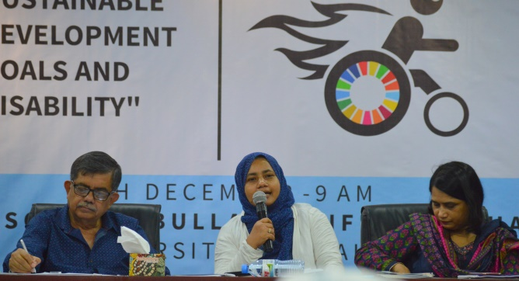 seminar.

Ashrafun Nahar stated that, accessibility is an immense important issue for transforming the lives of Persons with Disabilities. In spite of having directives on accessibility in national along with international legislation, convention along with different policies E.G Schedule of “Persons with Disabilities Rights and Protection Act 2013”, Article-9 of “United Nations Convention on Rights of Persons with Disabilities (UNCRPD)”, Article-64 of “Bangladesh National Building Code (BNBC)” and Goal-11 of “Sustainable Development Goal (SDGs)”; But none of these directives has been implemented properly and as a result Persons with Disabilities become inactive due to having barrier in accessibility and they are considered as burden of their family, these burdens will be turned in to social burden.

So, there is no alternate without creating accessibility for persons with Disabilities through actualizing these legislation, convention and policies; Otherwise the goal of inclusive society will extremely be interrupted.

**D. seminar on ‘Violence against Women and female children with disabilities, barriers in justice system and duties’:**

A seminar titled ‘Violence against Women and female children with disabilities, barriers in justice system and duties’ was being organized by National Council of the Disabled Women (NCDW) in the Auditorium of Bangla Academy, on 17th December 2017.

Ashrafun Nahar, Executive Director and Samira Haque, Accounts Coordinator, WDDF were present in this seminar.

Ashrafun Nahar mentioned that, 96% Women with Disabilities become victim of physical, mental torture and sexual harassment as well as less than 1% female children with Disabilities get opportunity of going to school. Effective initiatives have yet not been adopted for their skill development and creating employment. Though the issue of stopping social discrimination and torture to the Persons with Disabilities in law and policy has been mentioned but specific initiative hasn’t been adopted to actualize these law and policy. Police officers of Thana aren’t become cooperative to the Women with Disabilities, They are disagreed to file any complain about violence against Women with Disabilities even they’ve no experience to handle them due to not having clear conception and training on disability issue. Most of Women with Disabilities (WWDs) are suffering from inaccessible justice system and deprived from their equal citizen rights. In spite of having been arrived in the 21st Century, there are no accessibilityin Judge courts, District courts, even in Supreme Court for Women with Disabilities. Most of the laws are formulated and enacted without the inclusion and participation of Women with Disabilities. So, the scenario of the sufferings of Women with disabilities in the ongoing legal support and services is extremely vulnerable in the existing situation.

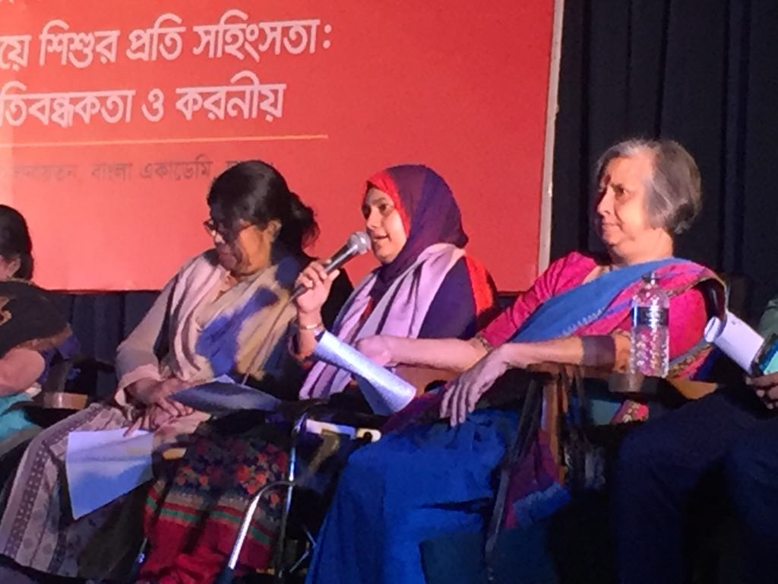So, she urged that, ‘Women and Children repression prevention Act 2000-2003’ should be amended and a chapter considering the types and needs of Women with Disabilities should be included in this Act. Initiatives and information about protection from violence should be accessible and available for all classes of people. The rate of violence against Women with Disabilities is not lower than Non Disabled Women but due to lack of disability related information and awareness of the relevant authorities, the incidents of violence haven’t been published properly.

Infact, relevant authorities of Government, legal and human rights activists, NGOs and DPOs should have to adopt required initiatives to protect Women with Disabilities from all types of violence. Otherwise, the dream of inclusive society will ultimately be interrupted due to unproductivity, ineffectiveness, backwardness and social exclusion of almost 12 million Women with Disabilities.

**I) Training “Age and Disability Inclusion in Humanitarian Response”:**

A. A Three day training on “Sphere, Age and Disability Inclusion in Humanitarian Response” was being organized by Center for Disability in Development (CDD) in collaboration with DRR, cbm, Foundation for Disaster Forum, Handicap International, HelpAge International and Arbeiter-Samariter –Bund (ASB) in the Training Centre of CDD, Ganda, Savar, Dhaka, from 26 to 28 November 2017. Trainers were: Axcel Schmidt, Emergency Response Capacity Building Manager and Annie Sloman, Program Development Manager, Arbeiter-Samariter-Bund (ASB), Sinduharjo, Ngaglik, Sleman, Yogyakarta, Indonesia.

Twelve (12) (2 participants from Disabled Peoples Organizations (DPOs), 3 participants from International Non Government Organizations and 7 participants from Non-Government Organizations) including Md. Hasanuzzaman, Program Coordinator of WDDF participated in this training program.

The topics of 1st day include: What is the Sphere Project?

The Sphere Project and its Handbook is well known for introducing consideration of quality and accountability of Humanitarian response. Sphere project has been initiated in 1997 by a group of humanitarian non-government organizations (NGOs) and International Red Cross and Red Crescent Movement. Their aims were to improve the quality of their actions during disaster response and to be held accountable for them. The Humanitarian Charter and the minimum Standards are published together as Handbook. At first this handbook has published in 2000, revised in 2003 and next revised version has published in 2009-2010.

While has this Handbook started to use?

Focusing the period of humanitarian response the sphere standards cover activities which meet the urgent survival needs of disaster-affected populations. The handbook is important for both disaster preparedness and early recovery phases which conceptually ‘frame’ humanitarian response but in reality need to be considered at the same time.

Cross cutting issues are being discussed in the training such as Children, Disaster risk reduction, Environment, Gender, HIV/AIDS, Older people, Persons with Disabilities and Psychosocial support. The responsibilities of Sphere are to ensure the following rights:

* The right to receive humanitarian assistance
* The right to life with dignity

The right to protection and security

There are four protection principles of sphere Guideline.

* Avoid exposing people to further harm as a result of your actions
* Ensure people’s access to impartial assistance
* Protect people from physical and psychological farm or due to violence
* Assist with rights claims, access to remedies and recovery from abuse.

There are some core standards describes processes that the essential to achieving all the minimum standards. The core standards are also linked to other key accountability initiatives promoting unity and reinforcing a shared commitment to accountability. The core standards are as follows

* People centered humanitarian response
* Coordination and collaboration
* Assessment
* Design and response
* Performance, transparency and learning
* Aid worker performance,

In 2nd day, Gawher Nayeem Wahra, Founder member secretary, Foundation for Disaster Forum and Professor, Adjunct Faculty, Institute of Disaster Management & Vulnerability Studies, Dhaka University was our guest trainer.

He discussed about the situation of Rahingya Refugee and sharing the observation and experience of different types of disaster affected people at different times. He has also discussed how to ensure minimum standards for disaster affected population from Bangladesh perspective. He said that the minimum standards describe the conditions that must be achieved in any humanitarian response for disaster affected populations to survive and recover in stable conditions with dignity through ensuring not only quantity but also quality and accountability.

In the open discussion, representatives of different organizations said that, Persons with Disabilities have to face discrimination and challenges due to inaccessible environment simultaneously service providers are not aware about basic needs of different types of Persons specially women with disabilities and that’s why people with Disabilities aren’t be able to receive assistance at the time of disaster period. Besides, Women with Disabilities are also deprived from obtaining equal rights due to not having proper consciousness of relevant authorities about the rights of Persons with Disabilities.

After that, Axcel Schmidt summarized previous discussion. He also divided the participants in to Two groups and organized a group work between these groups, nicely facilitated the group discussion. After this session, he discussed about the minimum standards in water supply, sanitation and hygiene promotion, minimum standards in Food security and nutrition, minimum standards in shelter, settlement and non-food items elaborately. After lunch, Two project proposals are being prepared and presented by Two groups. Simultaneously closing of the second day is being declared.

Annie Sloman has provided training in last day and in her session she has discussed about the minimum standards of health programs and documents of the humanitarian charter. After having been completed the training session of Annie Sloman, all participants shared their feelings along with learnings. After that, Training Experience Certificates have been distributed among all trainees along with completion of the abovementioned training has been declared.

**B. Training on “7th Five year plan and Disability”:**

A Two day training on “Seventh Five year plan and Disability” was being organized by Center for Disability in Development (CDD), in the Training Centre of CDD, Ganda, Savar, Dhaka, from 25 to 26 December 2017.

Ashrafun Nahar, Executive Director, WDDF participated in this training.

Inclusion of disability issue in Seventh Five year plan, working areas for DPOs to actualize the Seventh Five year plan, procedure of preparing national budget and the procedures of inclusion a new issue in national budget through advocacy with relevant Government authorities ETC are being discussed in this training elaborately.

**J) Change makers National Assembly 2017:**

A National Assembly of ‘Change makers’ on prevention Women torture and violence from family and society was being organized by We Can in collaboration with BLAST, BRAC, in Bangla Academy, on 17th October 2017.

Shirin Akhter, Chairperson and Md. Hasanuzzaman, Program Coordinator of WDDF were present in this program. Shirin Akhter said that, Women with Disabilities become victim of rape and violence due to their disabilities and most of the times they’ven’t get justice due to inaccessibility in justice system. So, we should include this issue and make strong advocacy to reduce the challenges of getting justice for Women with Disabilities.

**K) Conference:**

**A. Youth Conference:**

A Youth Conference entitled “Value Co-creation”was being organized by United Nations Development Program (UNDP) and United Nations Voluntary Fund (UNV) in join collaboration, at 3.00 PM, on 13 March 2017 at Senate Bhaban, Dhaka University. Shirin Akhter, Chairperson, Ashrafun Nahar, Executive Director and Md. Hasanuzzaman, Project Officer, WDDF were participated in this conference. Ashrafun Nahar participated as Panel discussant on behalf of Women with Disabilities and in her discussion she mentioned that, Youth with disabilities are an integral part of youth and without their inclusion the advancement of youth will be interrupted. It is immensely important to mention that, infrastructural and informational accessibility are the most important issue for ensuring the participation of Persons specially Women with Disabilities in all aspects of the society.

So, in order to incorporate the Persons especially Women with Disabilities in the mainstream of development, it is massively important to adopt each initiative considering equity not only equality.

For instance, due to inaccessible stage (stage without Ramp) of the Conference hall, Senate Bhaban, Dhaka University, as a panelist, the opportunity wouldn’t be create for her to sit with the other panelists on the stage and it is certainly inequity.

B. National Conference:

A National Conference on “Making an inclusive City: Searching the Right to Shelter and Livelihood” was being organized by Bangladesh Legal Aid Services and Trust (BLAST), on 18th March 2017, in BRAC-in Centre.

Shirin Akhter, Chairperson and Jesmin Ara, Accounts Coordinator, WDDF were participated in this National Conference. Shirin Akhter said that, city should be inclusive and universally accessible for all including Persons with Disabilities. So, for building inclusive city, the opinions and suggestions of Persons with Disabilities are being considered on the basis of priority. Otherwise, Persons with Disabilities will be deprived from all types of facilities of inclusive city and ultimately this city will never be considered as inclusive city excluding this large number of population with disabilities.

**C. Conference:**

A Three day conference entitled “Urban Thinkers Campus UTC Dhaka 2017”, was being organized by lead partner International Union of Architects (UIA) and host partner Institute of Architects Bangladesh (IAB). Working partners were Women with Disabilities Development Foundation (WDDF) on behalf of Persons with Disabilities and Disabled Peoples Organizations (DPOs) along with other NGOs in the Auditorium of Institute of Architect Bangladesh (IAB) from 9 to 11 November 2017.

Shirin Akhter, Chairperson, Ashrafun Nahar, Executive Director, Md. Hasanuzzaman, Program Coordinator and Samira Haque, Accounts Coordinator were present in this conference.

The conference was being arranged with Inauguration ceremony, Agenda Setting and Keynote Speech, Roundtable discussion in 4 Parallel Sessions, workshop, half day site visit, adoption of Dhaka declaration and closing ceremony.

1st day of conference started with inauguration ceremony includes evening welcome, agenda setting and keynote speech.

2nd day of conference divided in to Two parts : 1. Roundtable discussion in four parallel sessions:

a. Session1- Good Governance & Capacity Building

b. Session 2- Climate, Resilience & Infrastructure

c. Session 3- Compact Development & Urban-Rural Linkage

d. Session 4-Sense of Identity

**2. A Workshop on base plan methodology derived by UNICEF and UIA of Town planning moderated by an international expert engaging multi-stakeholders and**

**Public participation.**

Ashrafun Nahar, Executive Director, WDDF delivered her speech as discussant in 2nd session “Climate, Resilience & Infrastructure”. In her speech she conferred that, From this conference it is our optimism that, Urben Thinkers and related authorities will design an intermediate city considering Universal Accessibility in light of Article-64 of ‘National Building Code (NBC)’, ‘Persons with Disabilities Rights and Protection Act 2013’ and Goal-11.2, 11.7 of ‘Sustainable Development Goals (SDGs)’. She urged to the city planners and designers to consider infrastructural accessibility for all at the time of city designing which will be helpful for them to come out of building the city of brick, iron and wood simultaneously to encourage them to build humanitarian city. She also notified that, this humanitarian city will not only be supportive for Persons with Disabilities but also for pregnant women, women with children, sick people and elder people. So, a city should be inclusive and resilient for all.

In 3rd day conference closed with the formal adoption of Dhaka Declaration & closing ceremony.

D. Citizen’s Conference on SDGS in Bangladesh 2017:

A Citizen’s Conference on SDGs in Bangladesh 2017 was being organized by Citizen’s Platform for SDGs, BaKrishibid Institute , on 6th December 2017.

Shirin Akhter, Chairperson, Ashrafun Nahar, Executive Director and Samira Haque, Accounts Coordinator, WDDF were present in this Citizen Conference.

In a Parallel session on ‘Women Empowerment’, mentioning the barrier of inaccessibility of Persons with Disabilities, Ashrafun Nahar said that, The key message of “Sustainable Development Goals (SDGs)” is “No one left behind”! but there is no opportunity to use toilet even in conference venue for the participants with Wheel Chair users, though there are Two accessible toilets in Ground Floor but these toilets are being used as store rooms. So, how is it possible to move forward together without addressing this emerging needs of Women with Disabilities?

(A report has been published in a Daily National News paper ‘Prothom Alo’ focusing this vital issue.

Dated: 7th December 2017).

E. International Conference on “Promoting Equality, Justice and Human dignity”: An international conference on “Promoting Equality, Justice and Human dignity” was being organized by National Human Rights Commission Bangladesh (NHRCB) in the auditorium of Bangabandhu International Conference Centre (BICC) on 10 December 2017. Samira Haque, Accounts Coordinator, WDDF participated in this conference.

L) Interactive dialogue on **‘Advocacy for practice: ‘Stop Violence against persons with neuro-developmental disabilities:'**

An interactive dialogue titled **‘Advocacy for practice: Stop Violence against persons with neuro-developmental Disabilities’ was being organized by SEID Trust, in the Auditorium of CIRDAP ,on 28th December 2017.**

**Shirin Akhter, Chairperson and Samira Haque , Accounts Coordinator, WDDF were participated in this program.**

**Shirin Akhter started her speech with a heartrending death incident of a Speech and Hearing Impaired man, died by road accident due to not having heard the Bus’s Horns.**

**She had a polite asking to the audience and Guests that, How many days Persons with Disabilities will have to be lost their lives silently?**

**Persons with Neuro-developmental Disabilities have no reasonable accomodation in transports, educational, employment and health institutions, recreation along with shopping centres and they’ve no security anywhere. Even after having become victim of violence; they’ve no access to justice in justice related agencies E.G Police stations, Judge courts, supreme court and so on. Most of professionals aren’t properly trained and responsible to handle these types of Persons with Disabilities.**

**Hence, everywhere they’ve to lead their lives with extreme insecurity.**

**So, without united and need based initiatives in light of legislations, policies, declarations and convention as well as their proper actualization; it won’t be possible to reduce challenges and discrimination against Persons with Disabilities. Consequentially, SDGs won’t be achieve and expected development of state along with nation will extremely be interrupted.**

**3. Day Observance:**

**A. International Women Day:**

A discussion meeting and a cultural program was held on 8th March 2017, on the occasion of International Women day, organized by Ministry of Women and Children Affairs (MOWCA), at Bangabandhu International Conference Centre (BICC) Vaban.

Honorable State Minister, Meher Afroz Chumki, MOWCA was present as the Chief Guest; the Secretary along with other relevant officers of MOWCA, a number of Ministers and MPs were present in this program. Besides, representatives from UN Women as well as the representatives of DPOs, GOs, NGOs and CSOs were present. GC and EC members, Ashrafun Nahar, Executive Director, Jesmin Ara, Accounts Coordinator, of WDDF were participated in the abovementioned program.

**B. World Child Labour Prevention day:**

A discussion meeting, on the occasion of World Child Labour Prevention day, was being organized in join collaboration by National Human Rights Commission Bangladesh (NHRCB), United Nations Development Program (UNDP), International Labour Organization (ILO) and Labour Ministry, The peoples Republic of Bangladesh on 20th June 2017 in the auditorium of Pan Pacific Sonargaon Hotel .

Honorable President, Adv Abdul Hamid Khan, The peoples Republic of Bangladesh was present as the Chief Guest; the Minister along with other relevant officers of Labour Ministry, a number of Ministers and MPs were present in this program. Besides, Chairman along with other officers of NHRCB, representatives from UNDP, ILO as well as the representatives of DPOs, GOs, NGOs and CSOs were present. Shirin Akhter, Chairperson and Md. Hasanuzzaman, Program Coordinator were participated in the abovementioned program.

C. 26th International Day of Persons with Disabilities and 19th National Day of Persons with Disabilities was being organized by Social Welfare Ministry of Bangladesh in collaboration with DPOs and NGOs on 3rd December, 2017 in the Auditorium of Bongobandhu International Conference Centre (BICC).

The theme of this year is : “Transformation towards sustainable and resilient society for all”.

Abul Mal Abdul Muhit, Honourable Minister, Finance Ministry was the chief guest of this program. Discussion meeting and cultural program are being organized on the occasion of the International Day of Persons with Disabilities.

Shirin Akhter, Chairperson and Md. Hasanuzzaman, Program Coordinator, WDDF were participated in this program.

4. Job Fair:

A Job Fair of Persons with Disabilities was being organized by Access Bangladesh Foundation in collaboration with international Labour Organization (ILO), on 9th December 2017, in the Auditorium of Bangladesh Garments Manufacturing Export Association (BGMEA) Bhaban.

Ashrafun Nahar, Executive Director and Samira Haque, Accounts Coordinator, WDDF were present in this Job fair. This is the first job fair where approximately, One hundred job seekers with disabilities have been appointed in different level of jobs.

**Prepared by**

**Shirin Akhter, Program Director, WDDF,**

**With the cooperation of**

**Md. Hasanuzzaman, Program Coordinator, WDDF,**

**Approved by**

**Ashrafun Nahar, Executive Director, WDDF.**